Teacher Name: Ms. Maira Arif Class: 10 Subject: Pak. Std. History Date: 7th Sept’18
This question is about India 1927–1935.

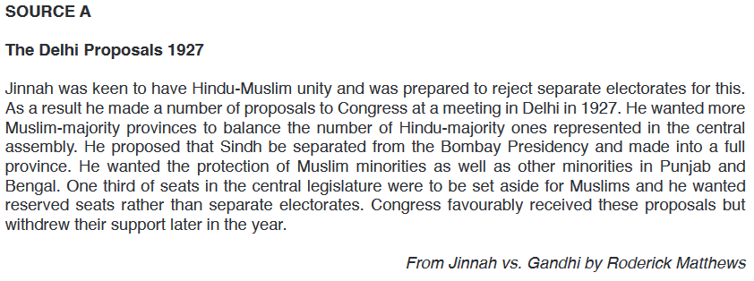
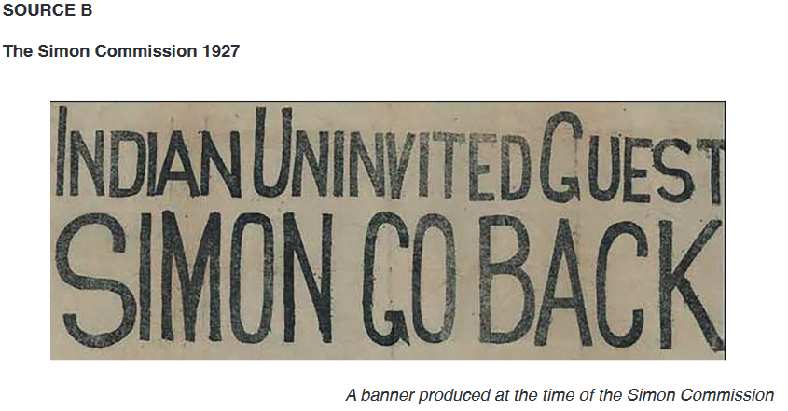
Q. Study the sources carefully and then answer the questions which follow.
(a) According to Source A, what were Jinnah’s aims in his Delhi Proposals of 1927? [3]
(b) How does Source B help us to understand Indian concerns about the Simon Commission of 1927? [5]
(c) Why was Dr Allama Muhammad Iqbal asked to chair the Muslim League at Allahabad in 1930? [7]
(d) Which of the following was the most important in the development of the Pakistan Movement? (i) Nehru Report, 1928; (ii) Jinnah’s 14 Points, 1929; (iii) Government of India Act, 1935
Explain your answer with reference to all three of the above. [10] (Do the planning only)

