Teacher Name: Amber Rabab Class: 9 Subject: History Date: 4-12-18
Descriptive questions
History 2059-01
Reinforcement worksheet
Q1:(a) Who was Titu Mir? [4]
(b) Explain why Sir Syed Ahmad Khan tried to improve relations between the Muslim community and the British. [7]
(c) Was religion the most important reason for the War of Independence in 1857? Give reasons for your answer. [14] [Total: 25]
Q2:(a) Who were zamindars? [4]
(b) Why was Robert Clive appointed the first Governor of Bengal? [7]
(c) Was the in-fighting between Aurangzeb’s successors the most important reason for the break-up of the Mughal Empire? Explain your answer. [14]
Q3:(a) Who were the Thuggee? [4]
(b) Why did the East India Company become involved in the Indian subcontinent during the seventeenth century? [7]
(c) Did Haji Shariatullah contribute more to the spread of Islam than anyone else in the subcontinent before 1850? Explain your answer. [14]
Q4: (a) Who was Warren Hastings? [4]
(b) Why were the Marathas defeated after the decline of the Mughal Empire? [7]
(c) How far was Indian resistance to British expansion in the subcontinent successful before 1850? [14]
Q5:(a) Who was Nana Sahib? [4]
(b) Why was Britain so successful in expanding its control of the sub-continent between 1750 and 1850? [7]
(c) Was the development of a western education system the greatest achievement of Sir Syed Ahmad Khan? Explain your answer. [14]
Q6:(a) Who was Tipu Sultan? [4]
(b) Why was Urdu chosen as the national language in Pakistan in 1947? [7]
(c) Was the attempt to achieve a better understanding with the British the most important contribution that Sir Syed Ahmad Khan made to the Muslim cause during the nineteenth century? Explain your answer. [14]

Q7:(a) Who was Robert Clive? [4]
(b) Why did Shah Waliullah have such a major influence on the revival of Islam in the subcontinent? [7]
(c) Were the invasions by the Persians and Afghans the main reason for the decline of the Mughal Empire? Explain your answer. [14]

Q8: (a) What was suttee? [4]
(b) Why did Sir Syed Ahmad Khan try to improve relations between the Muslims and the British? [7]
(c) “The strength of the British army was the sole reason for the failure of the War of Independence by 1858.” Do you agree? Give reasons for your answer. [14]
(b) Why the war of independence fail to meet its aims in 1857? [7]
Q9
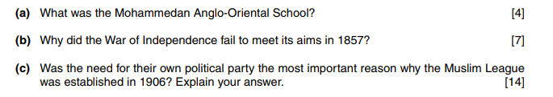
Q10
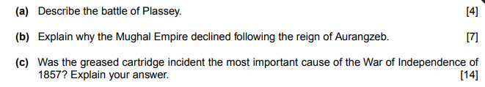
Q11
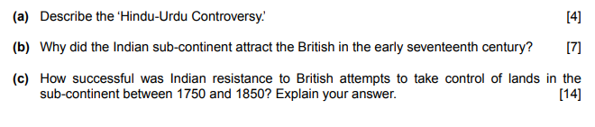

Q12
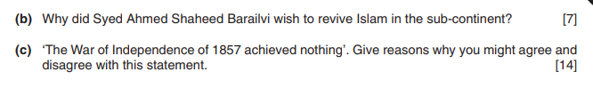
Q13
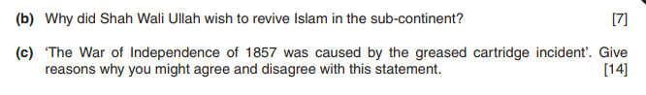
Q14
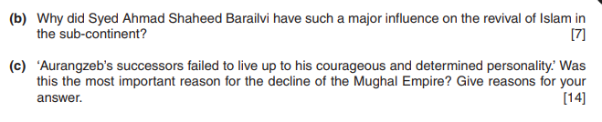
Q15
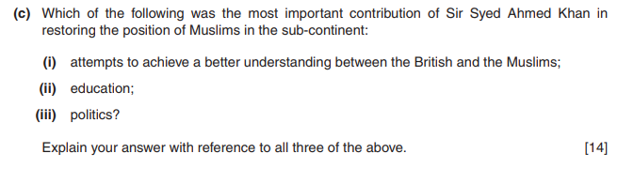
Q16
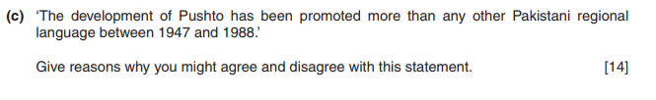

Q17
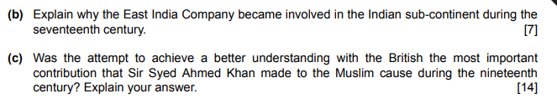

Q18

