Teacher Name: Ms. Maira Arif Class: 9 Subject: Pak. Std. History Date: 14th Sept’18
Source A
All the Creatures of God have equal rights. No man is entitled to allow one particular race of man to obtain the good things of this world; and to bar the rest from participating in them, and it is the duty of the government to observe this divine law in all in its integrity.
From the writings of Sir Syed Ahmed Khan
Q1. According to the source A how India should be governed? (3)
Source B
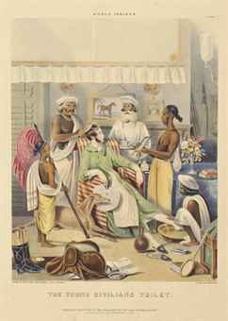
Q2. According to the source B how was the attitude of the British towards Indians? (5)
Q3. Why did the Mughal Empire decline? ( State factors)
Q4. How Aurangzeb was as an emperor of Hindustan?
Aurangzeb Alamgir
Success Areas | Failure Areas

