The City School
Nlorth Nazimabad Boys Campus
Pakistan Studies (History) 2059/01
Worksheet No.1
Term 2 (2018)
Name: _______________________ Class: 10 Sec: _______ Date: ___________ Max. Marks: 25
Q1. This question is about India during 1940-47. Study the sources carefully and then answer the questions which follow.
Source A

And now, when the Congress has given up on the government of eight provinces of its own choice and free will, what advice has the League President to offer to the Muslims? It is this that they should march toward the mosques and thank God on their deliverance from Congress ministries which preferred duty to power and have resigned not only on the issue of India's freedom but for the rights of all downtrodden peoples of the East. It is difficult to imagine any group of Muslims, howsoever at loggerheads with the Indian National Congress, would tolerate to be presented to the world in such colures.
Reaction of Maulana Abul Kalam Azad on celebration of Day of Deliverance
Source B
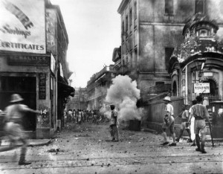
Rioting during the Quit India Movement, 1942
- What does Source A tells about the reaction of Maulana Abul Kalam Azad to the celebration of Day of Deliverance by the Muslims? [3]
- What does the Source B tells about the rioting during ‘Quit India Movement’? [5]
- Why did Cripps Mission fail? [7]
- ‘Pakistan resolution was the most eminent factor during the period of 1940-1947 that led to the establishment of Pakistan.’ Do you agree? Give reasons for your answer. [14]

