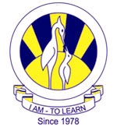
The City School
NORTH NAZIMABAD BOYS CAMPUS

ISLAMIYAT 2058
COMPREHENSIVE TEST- 2ND TERM
CLASS – 9

Attempt any four questions. Q1 and 2 are compulsory

Qno.1 Choose any two of the following passages from the Qur’an, and:
(a) Briefly describe the main theme(s) in each passage [4]
(b) Briefly explain the importance of these themes in a Muslim’s life today. [4]

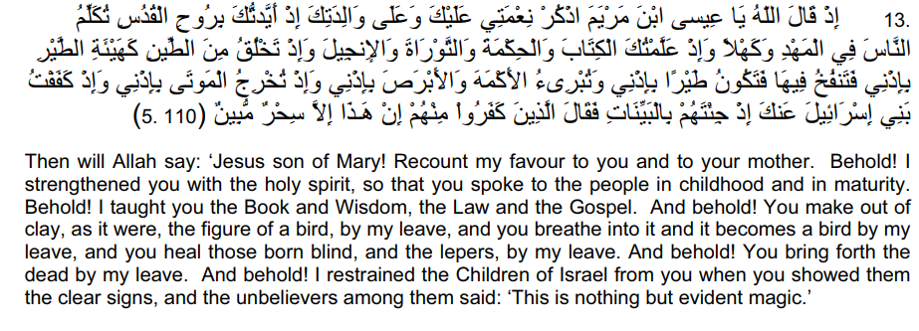

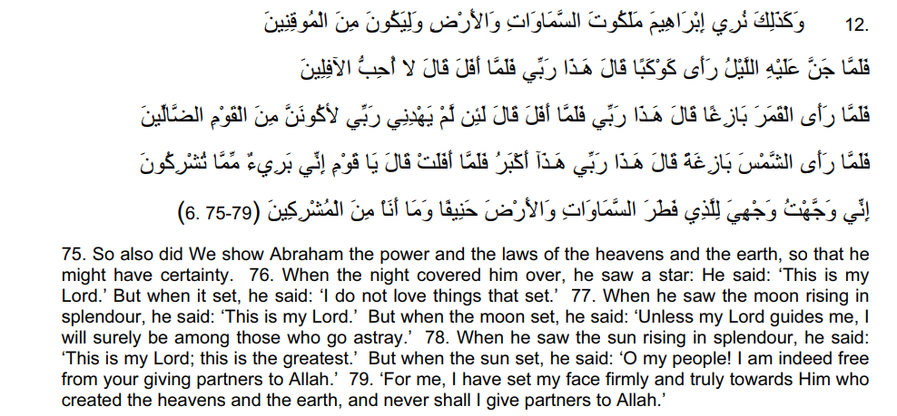

Qno.2 (a) Write and account of the ways in which Quran was revealed to Prophet Muhammad 610 between the years AD-632AD
(b) What does the Prophet’s first experience of revelation tells us about the nature of prophethood in Isalm?
Qno.3 (a) Write briefly about the conversion of islam of Hazrat AbuBakr,Hazrat Umar,Hazrat Uthman and Hazrat Ali(RA)
(b) In what ways did the conversion of Hazrat Umar help the young Muslim Community?
Qno.4 (a) The Battle of Uhad was fought in the year 625. Describe the main events of this battle.
(b) Why is it important for Muslims to show obedience to God in difficult situations?
Qno.5 (a) Write about events from the Prophet’s life that show his qualities of generosity, honesty and simplicity in action. [10]
(b) Can Muslims adopt a life of simplicity like the Prophet in current times? Give reasons for your answer.

