The City School
North Nazimabad Boys Campus
Date: 22-10-2015
Class: 11TH
Subject: Physics
Teacher: Sir Faisal

Important Notes:

Electricity:current, I

• defined as the rate of flow of electric charge
• There is electric current only when there are moving electric charges
• I = Q / t
• where Q is the amount of charge flows (in C), and t is the time taken (in s) SI unit is ampere, A
The ammeter, milli-ammeter, and micro-ammeter are current-measuring instruments and must be connected in series in the circuit
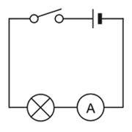

Potential difference V and electromotive force, emf

• The potential difference or voltage, V between 2 points is defined as the work done, W in taking 1 C of positive charge from the lower potential to the point of higher potential.
• In a circuit, it is the energy sources that supply energy, not the electric charges.
• The energy that drives the free electrons around the circuit is known as emf
• More than 1 cell can be connected in a circuit (series/parallel)
Cells in series
• the combined emf used to drive the electric charges is the sum of all the individual cell's emf
• with more cells, the circuit will have more power to drive the electric charge
Cell• the combined emf used to drive the electric charges is the emf of one individual cell (each cell contributes an equal amount of emf)
• with more cells, the circuit will have longer time to drive the electric charges

Potential difference = work done / charge transferred

• V = E / Q
• where V is potential difference, E is energy, Q is charges flow

Example

To transfer 2 C of charge from points X to Y in an electrical circuit 50 J of energy is needed. What is the potential difference between X and Y?

Solution

Potential difference between X and Y = 50 / 2 = 25 V

• 1 volt is defined as the potential difference between two points such that one joule of work is done in transferring 1 C of charge from one point to the other.
• The voltmeter and millivoltmeter are voltage-measuring instruments and must be connected in
parallel to the component across which the potential difference is being measured.
• The emf of an electrical source like a battery is equal to the electrical energy provided by the source for every coulomb of charge which flows round the circuit.
• The emf of an electrical source can also be defined as the potential difference across the
terminals of the source in an open circuit

Voltmeter connected in parallel
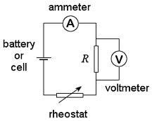

Ammeter connected in series

Ohm's Law and Resistance
• Ohm's Law states that the current I, passing through a conductor is directly proportional to the potential difference, V between its ends provided that the physical conditions and temperature of the conductor remain constant.
• a resistor is a conductor with known value of resistance. It can be used to control (reduce) the
size of current flowing in a circuit.
• Resistance, is therefore a measure of how difficult it is for the current to pass through the circuit.
• V / I = constant

The resistance is also given by the gradient of the graph V vs.I
- Conductors or resistors which obey Ohm's Law are called ohmic. Eg. pure metal, copper sulphate solution with copper electrodes, metal alloy
Those which do not obey Ohm's Law are called non-ohmic.
- The resistance, R of an electrical component is defined as the ratio of the potential difference, V
across the component to the current, I flowing through it.
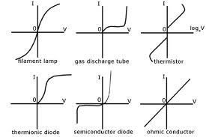

Example
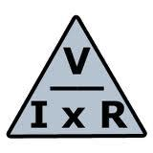

The voltage across a lamp is found to be 1.4V when the current in the lamp is 0.2A. Calculate the resistance of the lamp.

Solution

Resistance of lamp, R = V / I = 1.4 / 0.2 = 7 ohm

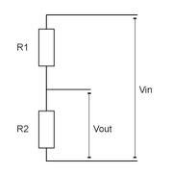

Rheostat
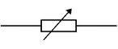
• a variable resistor used to vary the control of electric current
• A rheostat can be used to find the resistance of an unknown resistor.

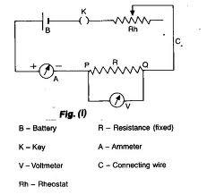
• The voltmeter is connected in parallel
• Use the rheostat to adjust the size of the current to a convenient value. Hence, record the readings shown on the ammeter and voltmeter
• adjust the rheostat to take 5 sets of readings of I and V
• Calculate the resistance from the equation R = V / I
Factors affecting resistance of a wire
1. Length
• for a wire of uniform cross-sectional area, the resistance is directly proportional to the length of the wire
• hence, the longer the wire, the higher the resistance
2. Cross-sectional area
• for a wire of fixed length, its resistance is inversely proportional to the cross-sectional area
• so, the thinner the wire, the higher the resistance

3. Material
• resistance depends on the kind of substance
• copper is a good conductor and is used for connected wires
• nichrome has more resistance and is used in the heating elements of electric heater

4. Temperature
• for metallic wires, as temperature increases, the resistance increases
• but for some materials like silicon and germanium as temperature increases, the resistance decreases
Electric Circuits
An electric circuit is a complete or closed path through which electric charges flow from one terminal of an electrical source to the other, passing through one or more circuit components.
Series circuit
• It has only one path for the current to flow.
• the sum of voltages across individual components in the circuit is equal to the voltage across the terminals of the electrical source or the whole circuit.
• Application: voltage divider

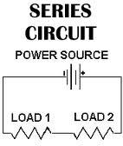

Parallel circuit

• It has more than 1 path for the current to flow
• The sum of the currents flowing in the separate branches of a parallel circuit is equal to the current from the source.
• Application: electrical household connections

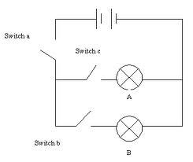

Short circuit
• A short circuit occurs when a large current flows due to the very little or negligible resistance of the circuit
• A short circuit leads to
• overheating of wires which may cause electric fires
• damage of the electrical source (egbattry) and other circuit components
To prevent short circuits, use fuse

- fuses break the circuit if the current flowing through them exceed their respective ratings.

Combined resistance of resistors in series or parallel

In Series: Effective resistance = R1 + R2 + R3
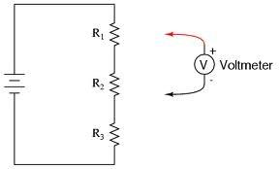

Total voltage = V1 + V2 + V3 + ...

• Application: voltage divider

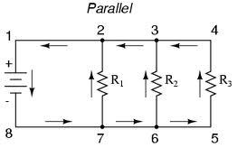

In Parallel: Effective resistance

1/RTOTAL = 1/R1 + 1/R2 + 1/R3

Total current = I1 + I2 + I3 + ...

• Application: current divider

