Important Preparation Reinforcement worksheets
For Final Examination 2019
Chemistry 5070 paper 2

Teacher Name: Uzma Amer Class: 9 Chemistry Date: 9th May ’19
Section A
A1.Tritium is an isotope of hydrogen.

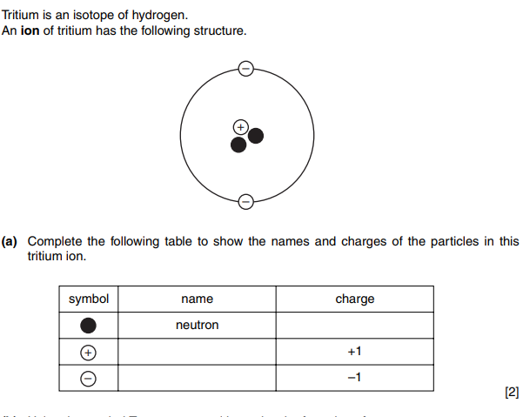
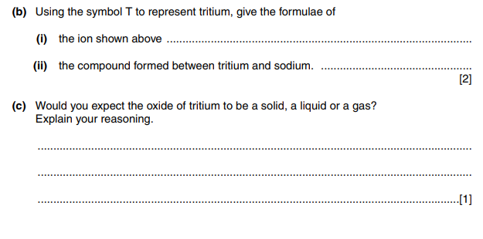

A2. The question is about making salts.
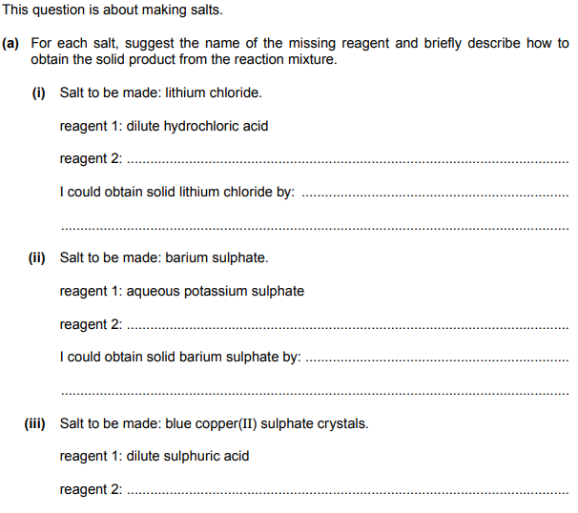
I could obtain blue copper(II) sulphate crystals by:……………………………………………………………..
…………………………………………………………………………………………………………………………………………..
Calculate the Relative molecular mass of:
- Ammonium Sulfate
- Ammonia
…………………………………………………………………………………………………………………………………………………………………………………………………………………………………………………………………………………………………………………………………………………………………………………………………………………………………………………………………………………………………………………………………………………………………………………………………………………………………………………………..[4]

A3. Choose from the following elements to answer the questions below.
Argon
Cesium
Mercury
Calcium
Sulphur
Chlorine
Sodium
Each element can be used once, more than once or not at all.
Name an element which
- React with water to produce an alkali
……………………………………………………………………………………………………………………………..
- Is a gas and forms a negative ion.
………………………………………………………………………………………………………………………………
- Reacts with oxygen to give an acidic oxide.
…………………………………………………………………………………………………………………………………………
- The most reactive metal.
……………………………………………………………………………………………………………………………..
- Forms an ion that carries positive charge.
……………………………………………………………………………………………………………………………..
- Is a noble gas.
……………………………………………………………………………………………………………………………
- Is a liquid metal at r.t. p
………………………………………………………………………………………………………………… [7]

A4. Four identical balloons are filled with different gases all at the same temperature and pressure
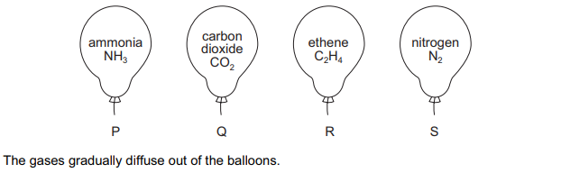
- Which gas diffuses : [4]
- First………………………………….
- Last …………………………………

- Which pair of balloons will deflate at the same rate? [2]
……………………………………………………………………………………………………………………………………………………………………………………………………………………………………………………………………………………
A5. The diagram shows the nuclei of five different atoms.
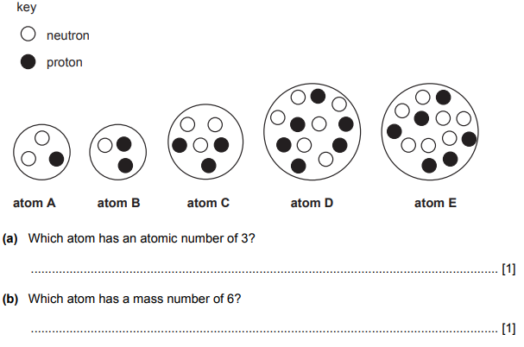
A6. AA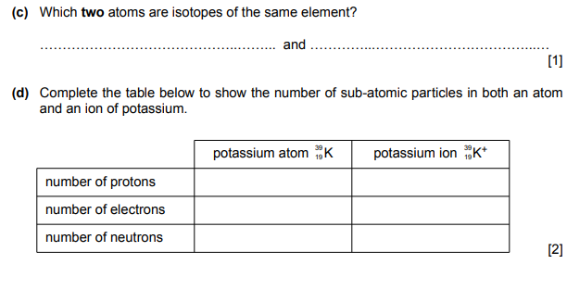
A6. Magnesium bromide and sodium oxide are both ionic compounds.
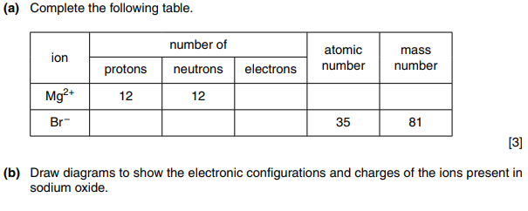

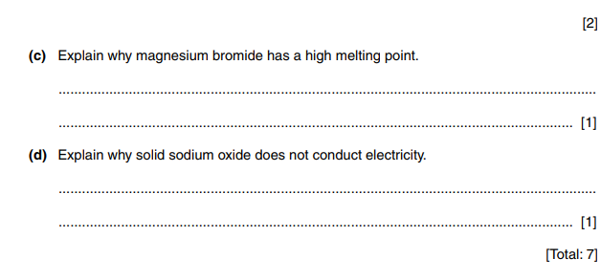
Section B
B7. Silicon is an element in group IV of the periodic table.
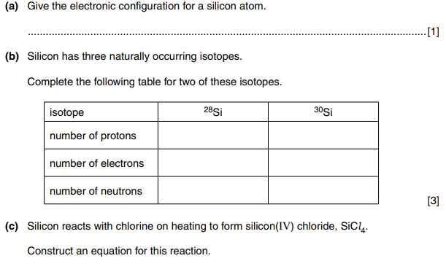
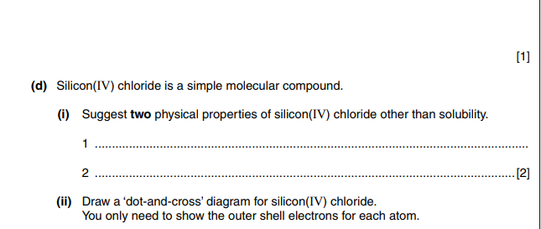

B8. Sodium and Rubidium are alkali metals.
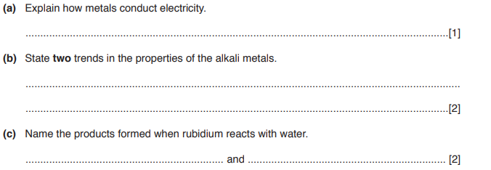
(d) The table shows some information about three gases.
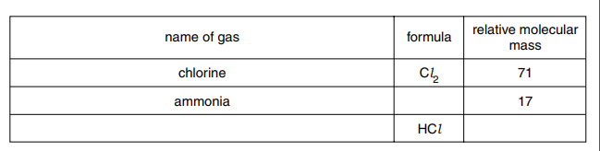
[3]

