Important Preparation Reinforcement worksheets
For Final Examination 2019
Chemistry 5070 paper 1

Teacher Name: Uzma Amer Class: 9 Chemistry Date: 9th May ’19
Q.1. Choose the best answers:
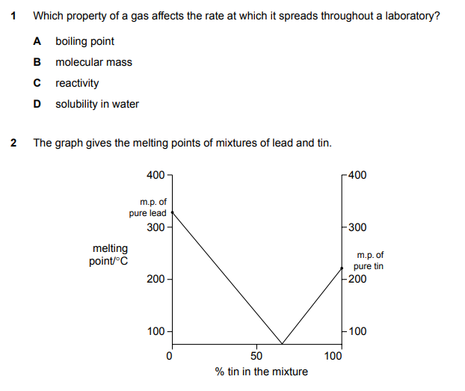

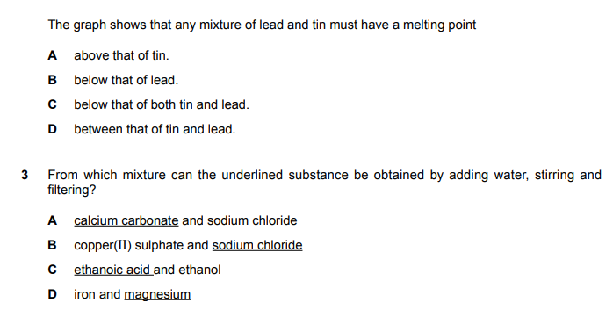
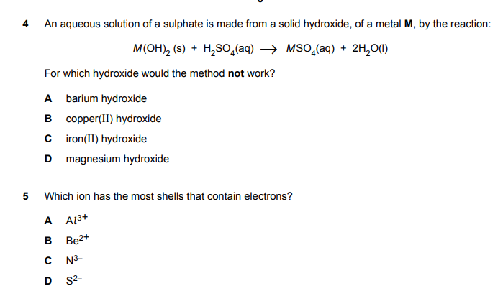

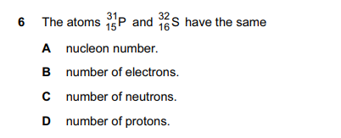

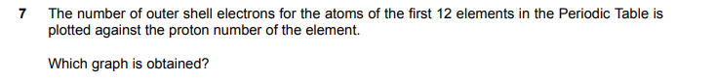
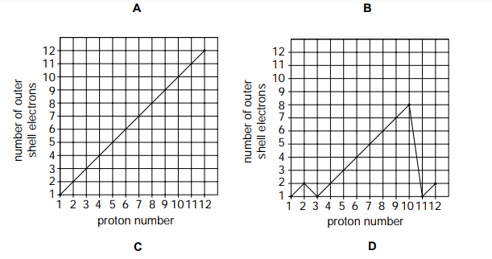
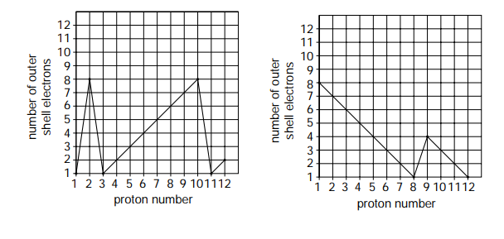
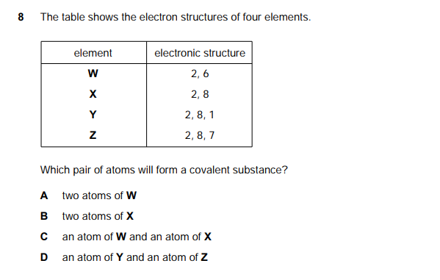
9 Which statement explains why sodium chloride, NaCl, has a lower melting point than magnesium oxide, MgO?
A Sodium chloride is covalent but magnesium oxide is ionic.
B Sodium is more reactive than magnesium.
C The attraction between Na+ and Cl − is weaker than that between Mg2+ and O2−.
D The melting point of sodium is lower than that of magnesium.
10. Which property decides the order of the elements in the periodic table?
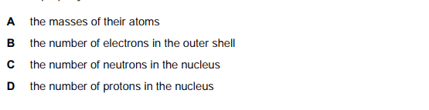
11. Which feature of a metal’s structure is responsible for it conducting electricity?
A It contains positive ions.
B It has a “sea of electrons”.
C Its ions are tightly packed together.
D Its positive ions attract electrons
12. Aqueous hydrogen peroxide undergoes catalytic decomposition as shown in the equation below.
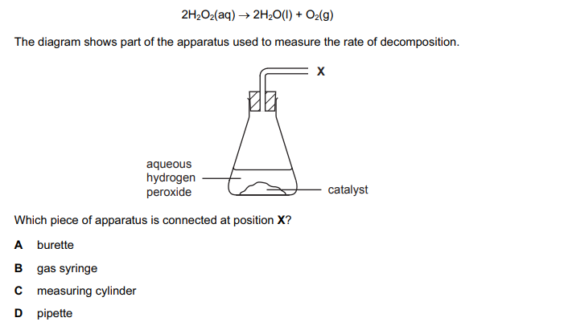
13. A mixture of two substances is spotted on to a piece of chromatography paper.
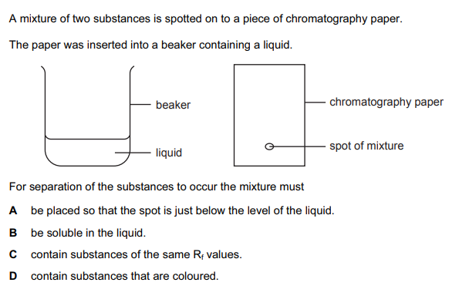
14. Which diagram represents the structure of sand, SiO2?
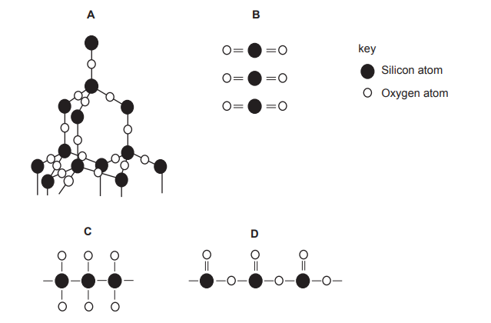

15. The table gives information about three indicators.
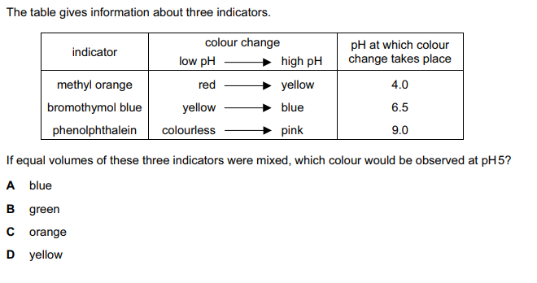
16.
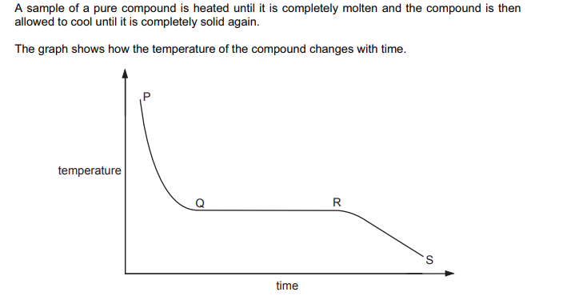
When are liquid and solid both present?
A P to Q and R to S
B P to Q
C Q to R
D R to S

17. Element X is a solid at room temperature.
It needs one electron per atom to gain the electronic structure of a noble gas.
It is the least reactive element in its group.
What is the element X?
A At
B Cs
C F
D Li
18. Element X and Y are in group VII of the periodic table.
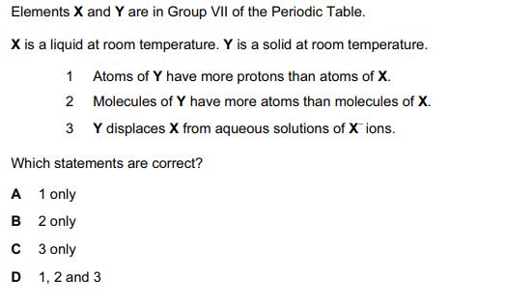
19. Substance X melts at 53 o C and boils at 100 o C. It does not dissolve in water and it does not react with water.
Which diagram shows the method most suitable for separating X from a mixture of X and water?

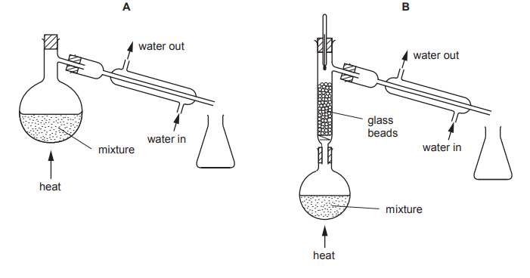
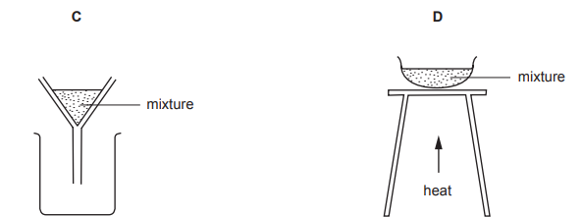
20. Metals have positive ions in a ‘sea of electrons’.
Which metal atom provides most electrons for the sea?
A aluminum
B calcium
C magnesium
D sodium
21. The diagram shows the arrangement of electrons in a molecule of compound YZ2
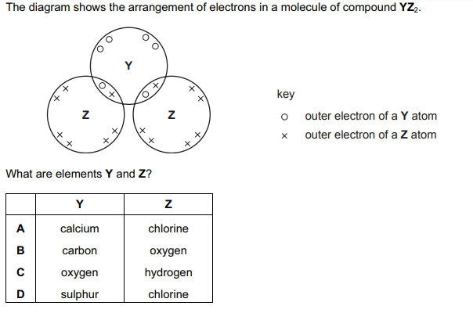
22. Which two statements about a covalent bond are correct?
1 It can be formed between two metal atoms.
2 It can be formed between two non-metal atoms.
3 It is formed by the transfer of electrons between atoms.
4 It is formed by sharing electrons between atoms.
A 1 and 3
B 1 and 4
C 2 and 3
D 2 and 4

23. In which pair of substances does each have a giant molecular structure?
A diamond, iodine
B diamond, silica (sand)
C iodine, methane
D methane, silica (sand)
24. The diagram shows a simple laboratory apparatus for the preparation and collection of dry gas.
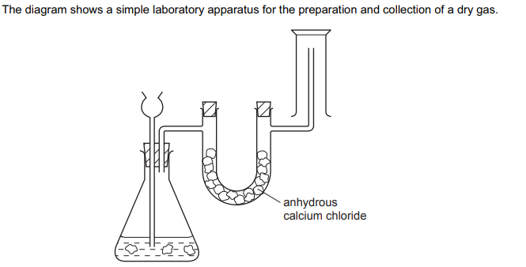
What is the gas?
A carbon dioxide
B chlorine
C hydrogen
D hydrogen chloride
25. The table shows the boiling points of the elements found in a sample of liquid air.
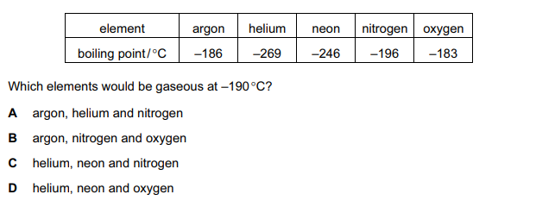
26. Naturally occurring bromine has a relative atomic mass of 80 and consists entirely of two isotopes of relative isotopic masses 79 and 81.
What can be deduced about naturally-occurring bromine from this information only?

A Bromine isotopes have different numbers of protons.
B Bromine contains the two isotopes in equal proportions.
C Bromine has different oxidation states.
D Bromine is radioactive.

27. Which property shows that a liquid is pure?
A It turns anhydrous copper(II) sulphate blue.
B It is colourless and odourless.
C It has no effect on red or blue litmus paper.
D It boils at a fixed temperature at a given pressure.
28. Which diagram represents the arrangement of particles in a gas?
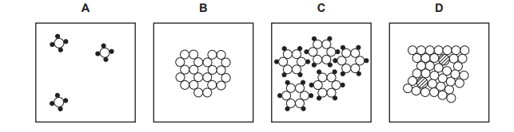
Which gas diffuses at the same rate as nitrogen gas?
A carbon dioxide
B carbon monoxide
C neon
D sulphur dioxide
29. Which statement about diamond and graphite is correct?
A Both diamond and graphite are used as abrasives.
B Diamond and graphite have different arrangements of carbon atoms.
C The carbon atoms in graphite have a different number of neutrons from those in diamond.
D The carbon atoms in both graphite and diamond have four covalent bonds.

30. Which diagram correctly shows the arrangement of the ions in solid sodium chloride?
