An input device is a hardware device, often a peripheral device, which is used as part of a computer system. Input devices allow a computer system to receive data from the real world. For instance a microphone can be used to input audio data in to a computer system.

2D and 3D Scanners
Scanners use light to make digital copies of real world objects. 2D scanners are usually used to make digital copies of documents or pictures, but can also be used to create a 2D image of other objects as well. In a flat bed scanner the document is placed on a glass plate. A light is then shone on the piece of paper and a light sensor used to detect the light which is bounced back. Wand scanners, also known as hand-held scanners, work on the same principal except that the user will move the scanner across the document manually. They can be used in conjunction with a printer to create copies of documents.
3D scanners use reflected laser light to build up a three-dimensional model of an object. They can be used in conjunction with 3D printers or fabricators to duplicate objects.
- 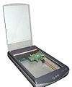
Flatbed Scanner

- 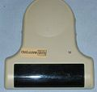
Handheld Scanner

3D Scanner

Barcode Readers
A barcode reader works in a very similar way to a 2D scanner. It uses reflected light from a laser to detect the black lines in a barcode or QR code. All barcodes use a check-digit so that the system knows when a barcode has been scanned correctly. Usually barcode scanners will emit a beep sound once a barcode has been scanned and confirmed as correct by checking the check-digit. They are often integrated in to electronic point of sale (EPOS) systems in supermarkets and stores. They are also frequently used in libraries for checking books in and out. They have applications in manufacturing to track the progress of items through the assembly line or in courier services to track packages from source to destination.
Handheld barcode reader

- 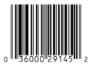
Example of a barcode

Example of a QR code

A Presentation on how 2D and 3D scanners work
https://prezi.com/lnxc9zcmxqt0/2d-and-3d-scanners/

What are barcodes used for?
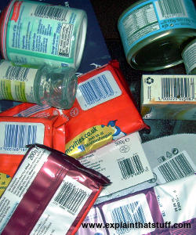
Photo: Barcodes can be used for all kinds of inventory/stocktaking work, but they're probably most familiar to us as identification codes printed on grocery store products.
If you run a busy store, you need to keep track of all the things you sell so you can make sure the ones your customers want to buy are always in stock. The simplest way of doing that is to walk around the shelves looking for empty spaces and simply refilling where you need to. Alternatively, you could write down what people buy at the checkout, compile a list of all the purchases, and then simply use that to reorder your stock. That's fine for a small store, but what if you're running a giant branch of Wal-Mart with thousands of items on sale? There are many other difficulties of running shops smoothly. If you mark all your items with their prices, and you need to change the prices before you sell the goods, you have to reprice everything. And what about shoplifting? If you see a lot of whisky bottles missing from the shelves, can you really be certain you've sold them all? How do you know if some have been stolen?
Using barcode technology in stores can help to solve all these problems. It lets you keep a centralized record on a computer system that tracks products, prices, and stock levels. You can change prices as often as you like, without having to put new price tags on all your bottles and boxes. You can instantly see when stock levels of certain items are running low and reorder. Because barcode technology is so accurate, you can be reasonably confident that any items that are missing (and don't appear to have been sold) have probably been stolen—and maybe move them to a more secure part of your store or protect them with RFID tags.
A barcode-based stock system like this has three main parts. First, there's a central computer running a database (record system) that keeps a tally of all the products you're selling, who makes it, what each one costs, and how many you have in stock. Second, there are the barcodes printed on all the products. Finally, there's one or more checkout scanners that can read the barcodes.

How barcodes represent the numbers 0-9
A barcode is a really simple idea: give every item that you want to classify its own, unique number and then simply print the number on the item so an electronic scanning device can read it. We could simply print the number itself, but the trouble with decimal numbers is that they're easy to confuse (a misprinted eight could look like a three to a computer, while six is identical to nine if you turn it upside down—which could cause all sorts of chaos at the checkout if you scanned your cornflakes the wrong way up). What we really need is a completely reliable way of printing numbers so that they can be read very accurately at high speeds. That's the problem that barcodes solve.
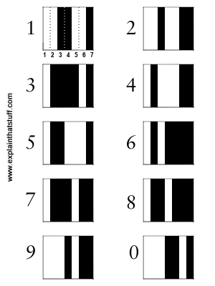
Photo: Each digit in a barcode is represented by seven equal-sized vertical blocks. These are colored in either black or white to represent the decimal numbers 0–9. Every number ultimately consists of four fat or thin black and white stripes and its pattern is designed so that, even if you turn it upside down, it can't be confused with any other number.
If you look at a barcode, you probably can't make head or tail of it: you don't know where one number ends and another one begins. But it's simple really. Each digit in the product number is given the same amount of horizontal space: exactly 7 units. Then, to represent any of the numbers from zero through nine, we simply color those seven units with a different pattern of black and white stripes. Thus, the number one is represented by coloring in two white stripes, two black stripes, two white stripes, and one black stripe, while the number two is represented by two white stripes, one black stripe, two white stripes, and two final black stripes.
You've probably noticed that barcodes can be quite long and that's because they have to represent three different types of information. The first part of a barcode tells you the country where it was issued. The next part reveals the manufacturer of the product. The final part of the barcode identifies the product itself. Different types of the same basic product (for example, four-packs of Coca-Cola bottles and six-packs of Coca-Cola cans) have totally different barcode numbers.
Most products carry a simple barcode known as the UPC (universal product code)—a line of vertical stripes with a set of numbers printed underneath it (so someone can manually key in the product number if the barcode is misprinted or damaged in the store and won't scan through the barcode reader). There is another kind of barcode that is becoming increasingly common and its stores much more information. It's called a 2D (two-dimensional) barcode) and you sometimes see it on things like self-printed postage stamps.

How does a barcode scanner work?
It would be no good having barcodes if we didn't have the technology to read them. Barcode scanners have to be able to read the black-and-white zebra lines on products extremely quickly and feed that information to a computer or checkout terminal, which can identify them immediately using a product database. Here's how they do it.
For the sake of this simple example, let's assume that barcodes are simple on-off, binary patterns with each black line corresponding to a one and each white line a zero. (We've already seen that real barcodes are more sophisticated than this, but let's keep things simple.)
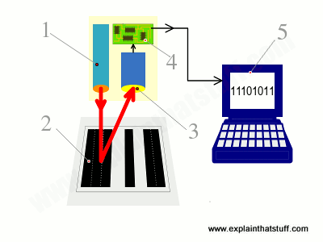
- Scanning head shines LED or laser light onto barcode.
- Light reflects back off barcode into a light-detecting electronic component called a photoelectric cell. White areas of the barcode reflect most light; black areas reflect least.
- As the scanner moves past the barcode, the cell generates a pattern of on-off pulses that correspond to the black and white stripes. So for the code shown here ("black black black white black white black black"), the cell would be "off off off on off on off off."
- An electronic circuit attached to the scanner converts these on-off pulses into binary digits (zeros and ones).
- The binary digits are sent to a computer attached to the scanner, which detects the code as 11101011.
In some scanners, there's a single photoelectric cell and, as you move the scanner head past the product (or the product past the scanner head), the cell detects each part of the black-white barcode in turn. In more sophisticated scanners, there's a whole line of photoelectric cells and the entire code is detected in one go.
In reality, scanners don't detect zeros and ones and produce binary numbers as their output: they detect sequences of black and white stripes, as we've shown here, but convert them directly into decimal numbers, giving a decimal number as their output.

Types of barcode scanner
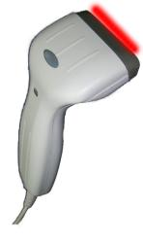
Photo: A typical wand-type barcode scanner (also called a barcode reader).
Different types of barcode scanners are available for all kinds of applications. In small, convenience stores, you'll typically find a basic wand scanner. The simplest ones look like electronic pens or giant, oversized razors. They shine red LED light onto the black and white barcode pattern and then read the pattern of reflected light with a light-sensitive CCD or a string of photoelectric cells. If you have a pen scanner, you have to run it across the barcode so it can reach each block of black or white in turn; with a wand scanner, the CCD or photocells read the entire code at once.
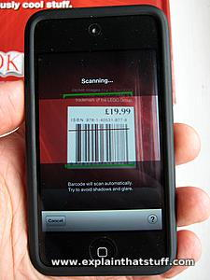
Photo: Scanning a barcode with Amazon's iPhone/iPod app. You find a product you like, scan the code, and the online store pops up with the product details automatically.
In a busy superstore, you're more likely to see a very sophisticated laser scanner. It'll be built into the base of the checkout lane, under a piece of glass, and you may be able to see the laser beam being bounced around at high-speed by a spinning wheel so it reads products (literally) in a flash. Another technology uses a small video camera to take an instant digital photograph of the barcode. A computer then analyzes the photograph, picking out only the barcode part of it and converting the pattern of black and white bars into a number. (Barcode-scanning apps that run on cellphones work this way, using the phone's built-in camera to photograph the code.) Scanners like this can accurately read dozens of products waved past them each minute and are far more accurate than old-style checkouts (where you have to key in the price of every item by hand). The best barcode scanners are so accurate that they make only one mistake in something like 70 million pieces of scanned information! (Compare that to typing on a keypad, where you're typically likely to make one error in every 100 characters you type.)
Barcode scanning technology has been around since the early 1970s but only really caught on in the 1980s and 1990s after stores started to invest in sophisticated, computerized electronic point-of-sale (EPOS) checkout terminals. Back then, store checkouts cost many thousands of dollars. Today, scanners are much more affordable. You can buy a simple, USB barcode scanner and software and hook it up to an ordinary laptop or computer for just a few dollars. Thanks to barcodes, even tiny convenience stores can run as smoothly as Wal-Mart these days!

What are QR codes used for?

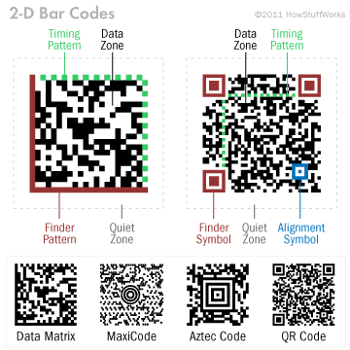
Diagram of a 2-D bar code
Let's check out of one of the most widespread types of 2-D bar codes, QR Codes, to see how its design helps bar code scanners read the data it contains. For starters, every QR Code contains a finder pattern, an arrangement of squares that help the scanner detect the size of the QR Code, the direction it's facing and even the angle at which the code is being scanned. Next, every QR Code contains an alignment pattern, another pattern of squares devised to help scanners determine if the 2-D bar code is distorted (perhaps it's placed on a round surface, for instance). QR Codes also have margins for error, meaning that even if part of the code is smudged or obscured, the code can often still be scanned.
But even a perfectly designed bar code would be nothing without sophisticated software capable of recognizing the bar code's alignment patterns and decoding the data. For instance, the scanning software used to read QR Codes has some pretty impressive capabilities. Once the smartphone's camera processes the code's image, the software goes to work analyzing the image. By calculating the ratio between the black and white areas of the code, it can quickly identify which squares are part of the alignment patterns and which squares contain actual data. Using the QR Code's built-in patterns and error correction, the software can also compensate for any distortion or obscured areas of the bar code. After the software has digitally "reconstructed" the QR Code, it examines the jumble of black and white squares in the QR Code's data section and outputs the data contained within.

What are the advantages of 2D barcodes?
If we already have barcodes, why do need something else as well? 2D barcodes are a step further, with lots of advantages:
- More information: A barcode is just a short line of black and white bars so it can't contain much information: typically just a dozen digits or so—enough to identify a box of cornflakes to a grocery store checkout, but not much more. You can't add extra information to a barcode without making it longer and more unwieldy. By contrast, a 2D barcode is a square of information running in two directions so it can efficiently pack more information into the same space. A typical 2D barcode can represent up to about 2000 characters of information.
- Fewer errors: Barcodes hold so little information that there is very little redundancy. Apart from the length of the bars (which effectively repeat the barcode's information in the vertical direction), there is no duplication of information to guard against a code being misprinted or damaged (such as when a grocery box becomes torn in the store or a parcel label smudges in the rain). But the higher capacity of 2D barcodes means they can hold the same information in different ways with sophisticated, built-in error checking systems. If a code is damaged, that's easy to detect—and it may still be possible to read some or all of the code.
- Easier to read: 2D barcodes can be read by smartphones and tablet computers using their built-in digital cameras. No special reading equipment is needed. Even though they contain more information, they can be read accurately at high speeds.
- Easy to transmit: 2D barcodes can be sent as SMS text messages between cellphones.
- More secure: It's possible to encrypt the information in 2D barcodes to protect it.
https://www.explainthatstuff.com/how-data-matrix-codes-work.html

How does a microphone work?

Microphones are a type of transducer - a device which converts energy from one form to another. Microphones convert acoustical energy (sound waves) into electrical energy (the audio signal).
Different types of microphone have different ways of converting energy but they all share one thing in common: The diaphragm. This is a thin piece of material (such as paper, plastic or aluminium) which vibrates when it is struck by sound waves. In a typical hand-held mic like the one below, the diaphragm is located in the head of the microphone.

Location of Microphone Diaphragm
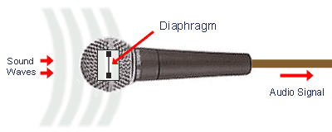
When the diaphragm vibrates, it causes other components in the microphone to vibrate. These vibrations are converted into an electrical current which becomes the audio signal.
Note: At the other end of the audio chain, the loudspeaker is also a transducer - it converts the electrical energy back into acoustical energy.

Types of Microphone
There are a number of different types of microphone in common use. The differences can be divided into two areas:
(1) The type of conversion technology they use
This refers to the technical method the mic uses to convert sound into electricity. The most common technologies are dynamic, condenser, ribbon and crystal. Each has advantages and disadvantages, and each is generally more suited to certain types of application. The following pages will provide details.
(2) The type of application they are designed for
Some mics are designed for general use and can be used effectively in many different situations. Others are very specialised and are only really useful for their intended purpose. Characteristics to look for include directional properties, frequency response and impedance (more on these later).

Mic Level & Line Level
The electrical current generated by a microphone is very small. Referred to as mic level, this signal is typically measured in millivolts. Before it can be used for anything serious the signal needs to be amplified, usually to line level (typically 0.5 -2V). Being a stronger and more robust signal, line level is the standard signal strength used by audio processing equipment and common domestic equipment such as CD players, tape machines, VCRs, etc.
This amplification is achieved in one or more of the following ways:
- Some microphones have tiny built-in amplifiers which boost the signal to a high mic level or line level.
- The mic can be fed through a small boosting amplifier, often called a line amp.
- Sound mixers have small amplifiers in each channel. Attenuators can accommodate mics of varying levels and adjust them all to an even line level.
- The audio signal is fed to a power amplifier - a specialised amp which boosts the signal enough to be fed to loudspeakers.

Microphones are loudspeakers in reverse
Microphones look very different from loudspeakers so most people never realize how similar they are. If you've read our article on loudspeakers, you'll already know how microphones work—because they're literally loudspeakers working in reverse!
In a loudspeaker, electricity flows into a coil of metal wire wrapped around (or in front of) a permanent magnet. The changing pattern of electricity in the coil creates a magnetic field all around it that pushes against the field the permanent magnet creates. This makes the coil move. The coil is attached to a big flat disc called a diaphragm or cone so, as the coil moves, the diaphragm moves too. The moving diaphragm pushes air back and forth into the room and creates sound waves we can hear.
In a microphone, there are almost identical parts but they work in exactly the reverse way.

How microphones work
How does a microphone turn sound energy into electrical energy? Like this:
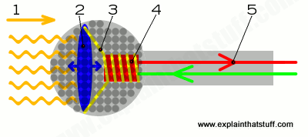
- When you speak, sound waves created by your voice carry energy toward the microphone. Remember that sound we can hear is energy carried by vibrations in the air.
- Inside the microphone, the diaphragm (much smaller than you'd find in a loudspeaker and usually made of very thin plastic) moves back and forth when the sound waves hit it.
- The coil, attached to the diaphragm, moves back and forth as well.
- The permanent magnet produces a magnetic field that cuts through the coil. As the coil moves back and forth through the magnetic field, an electric current flows through it.
- The electric current flows out from the microphone to an amplifier or sound recording device. Hey presto, you've converted your original sound into electricity! By using this current to drive sound recording equipment, you can effectively store the sound forever more. Or you could amplify (boost the size of) the current and then feed it into a loudspeaker, turning the electricity back into much louder sound. That's how PA (personal address) systems, electric guitar amplifiers, and rock concert amplifiers work.

How Resistive Touchscreens Work
The resistive touchscreen has always been the most common type used in industrial electronics. This is mostly because they’re cheaper to make and are easier to use in difficult environments.
The technology relies on resistance, meaning the pressure that’s applied to the screen itself.
This type of touchscreen is created out of two very thin layers of material, separated by a thin gap. The top layer is typically some type of clear poly-carbonate material, while the bottom layer is made up of a rigid material. Manufacturers typically use PET film and glass for these layers.
The upper and bottom layers are lined with conducting material like indium tin oxide (ITO). The conducting sides of each layer face one another.
Finally, spacers are placed in the thin gap between the two layers to prevent them from touching when the screen isn’t in use.
The diagram above is a simple guide showing how this technology works.
- 1: The top, flexible poly-carbonate layer
- 2 & 3: Thin, conductive, indium tin oxide layers
- 4: Spacer dots between the conductive layers
- 5: The rigid bottom layer, typically made of glass
- 6: Sensors that detect change of voltage when conductive layers touch
When you press your finger or a stylus against the screen, it creates a change in resistance (an increase in voltage). The sensor layer then detects this change, and the tablet or mobile phone processor calculates the coordinates of that change.

The Disadvantages of Resistive Touchscreens
Resistive touchscreens are meant to sense the location of one touch, and early generation touchscreens couldn’t respond to two-finger pinch or zoom actions.
However, later generations saw some mobile device manufacturers introducing new algorithms and other tricks that allowed for two-finger touch features.
Some other limitations include:
- Less sensitive to light touch
- In many cases can’t be used with gloves on
- Thick top layer creates less clarity for the display
- The screen material is usually more easily scratched or damaged
In most cases such touchscreens are difficult or impossible to repair.

How Capacitive Touchscreens Work
Capacitive touchscreens were actually invented almost 10 years before the first resistive touchscreen. Nevertheless, today’s capacitive touchscreens are highly accurate and respond instantly when lightly touched by a human finger. So how does it work?
As opposed to the resistive touchscreen, which relies on the mechanical pressure made by the finger or stylus, the capacitive touchscreen makes use of the fact that the human body is naturally conductive.
Capacitive screens are made of a transparent, conductive material—usually ITO—coated onto a glass material. It’s the glass material that you touch with your finger.

Surface Capacitive
In a surface capacitive setup, there are four electrodes placed at each corner of the touchscreen, which maintain a level voltage over the entire conductive layer.
When your conductive finger comes in contact with any part of the screen, it initiates current flow between those electrodes and your finger. Sensors positioned under the screen sense the change in voltage, and the location of that change.

Projected Capacitive
In a device that uses a projected capacitive setup, transparent electrodes are placed along the protective glass coating in a matrix formation.
One line of electrodes (vertical) maintain a constant level of current when the screen isn’t in use. Another line (horizontal) are triggered when your finger touches the screen and initiates current flow in that area of the screen.
The matrix formation creates an electrostatic field where the two lines intersect. This is one of the most sensitive types of touchscreens, and is how some phones can sense a finger touch even before you make contact with the screen itself.
Projected capacitive technology also allows you to use the touchscreen even when you’re wearing thin gloves.

Resistive vs. Capacitive Touchscreens
Resistive touchscreen advantages include:
- Lower cost to manufacture
- Higher sensor resolution—you can tap small buttons easier with just your fingertips
- Fewer accidental touches
- Can sense any object touching the screen hard enough
- More resistant to the elements like heat and water
Capacitive touchscreen advantages include:
- More durable
- Sharper images with better contrast
- Provide multi-touch sensing
- More reliable—will even work when the screen cracks (until you replace the touchscreen)
- More sensitive to light touch
The choice to use a capacitive or resistive touchscreen depends largely on the application for the device.

How Touchscreens Are Used
Most devices with resistive screens are used in manufacturing, ATMs and kiosks, and medical devices. This is because in most industries the users need to wear gloves when using the touchscreens.
Capacitive screens are typically used in most consumer products like tablets, laptops, and smartphones.

Infrared Touchscreen
Infrared touch uses light emitting diodes and sensors that are embedded in a bezel around the display and emit and detect rows and columns of infrared light across the face of the display. This creates an invisible grid of infrared beams and on the opposite side of the display from the emitters, photodetectors or sensors identify touch when the plane of the grid is broken by a finger touch (or other solid object). In other words, infrared touch screens operate on the basis of light-beam interruption, commonly referred to as beam break, to determine the location of touch events.

IR touch has a number of key technical and business benefits
- Scales to larger displays economically which is why it is used so extensively for large panel displays and video walls
- Supports multi-touch applications up to 32 touch points
- Accurate with short response time
- Smooth gesture recognition
- Easy to create custom sized screens, like video walls up to 500” in diagonal
- Performs in just about any indoor lighting environment (unlike many camera-based systems)
- Does not interfere in any way with image quality as the sensor is around the periphery of the display and don’t require patterned glass
- Supports 4k resolution and high pixel density displays
- Helps create thin, durable displays that don’t require frequent calibration or pressure which can damage the display
- Compatible with a finger, gloved finger, wet hand, stylus or pen

Features of Infrared technologies

- Light transmission is 100% because no film or glass needs to cover the surface. It is free of deterioration in visibility such as blurring, reflection, and lowering of luminance.
- Infrared touch screen can be operated with wet fingers or dirty gloves. Thus, it is employed for applications that require high reliability such as plant control system, factory automation and ATM.
- No physical nor electrical contacts are required for sensing method. Thus, the sensor is stress free. Thus, it is highly durable.
- Compared with other technologies, infrared technology is stronger against electrostatic and magnetic noises.
- Infrared technology can support multi-touch.
- Infrared technology is suitable for large size panel.
- Because an infrared technology uses lights for sensing, the detecting function can be affected by strong light such as direct sunlight.
- The resolution of basic infrared technology is not as good as other technologies. Thus, it is not suitable for applications that require precise inputs. On the other hand, the optical imaging technology is good at accuracy, resolution, and response speed.
- It is generally considered that infrared technology is difficult to be applied to small size panel. Recently, infrared touch screens for small sizes seem to be developed.
- Infrared technology usually requires a certain space for installation. Thus, the device tends to be large.
- Infrared technology detects anything that blocks lights. Thus, it may wrongly detect insects or dusts.
- The advantages of infrared technology are environment resistance, no limitation on input materials, and easiness of maintenance. Due to these merits, infrared touch screens are used on ATM, factory automation, plant control system, ticketing machiens, medical equipment, Kiosk, POS, interactive whiteboard, other large-size applications, and office automation.

http://www.nelson-miller.com/infrared-touchscreen-work/
https://www.dmccoltd.com/english/museum/touchscreens/technologies/BasicInfrared.asp
https://www.dmccoltd.com/english/museum/touchscreens/technologies/OpticalImaging.asp
https://www.dmccoltd.com/english/museum/touchscreens/technologies/Capacitive.asp
https://www.dmccoltd.com/english/museum/touchscreens/technologies/Resistive.asp

What is a computer mouse?
A mouse is something you push along your desktop to make a cursor (pointing device) move on your screen. So what a mouse has to do is figure out how much you're moving your hand and in which direction. There are two main kinds of mice and they do this job in two different ways, either using a rolling rubber ball (in a ball-type mouse) or by bouncing a light off your desk (in an optical mouse).

Inside a ball-style computer mouse
Traditional mice have a rubber ball inside them. Open one up and you can see the heavy ball clearly and the spring that keeps it in position.
Here's the inside of an old-style Logitech ball mouse:
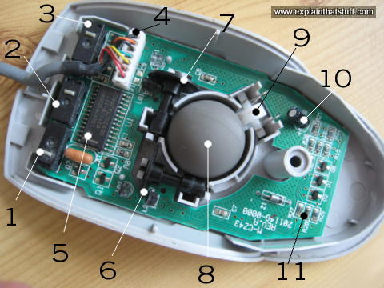
- Switch detects clicks of left mouse button.
- Switch for middle button.
- Switch for right button.
- Old-style connection to PS/2 socket on computer.
- Chip turns back-and-forth (analog) mouse movements into numeric (digital) signals computer can understand.
- X-axis wheel turns when you move mouse left and right.
- Y-axis wheel turns when you move mouse up and down.
- Heavy rubber wheel.
- Spring presses rubber ball firmly against X- and Y-axis wheels so they register movements properly.
- Electrolytic capacitor
- Resistors.

How a ball computer mouse works
How does a mouse like this actually work? As you move it across your desk, the ball rolls under its own weight and pushes against two plastic rollers linked to thin wheels (numbered 6 and 7 in the photo). One of the wheels detects movements in an up-and-down direction (like the y-axis on graph/chart paper); the other detects side-to-side movements (like the x-axis on graph paper).
How do the wheels measure your hand movements? As you move the mouse, the ball moves the rollers that turn one or both of the wheels. If you move the mouse straight up, only the y-axis wheel turns; if you move to the right, only the x-axis wheel turns. And if you move the mouse at an angle, the ball turns both wheels at once. Now here's the clever bit. Each wheel is made up of plastic spokes and, as it turns, the spokes repeatedly break a light beam. The more the wheel turns, the more times the beam is broken. So counting the number of times the beam is broken is a way of precisely measuring how far the wheel has turned and how far you've pushed the mouse. The counting and measuring is done by the microchip inside the mouse, which sends details down the cable to your computer. Software in your computer moves the cursor on your screen by a corresponding amount.
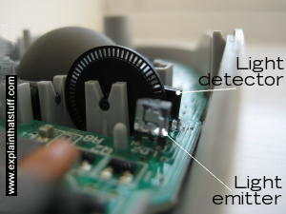
Photo: A ball mouse detects movements by using a wheel with spokes to break a light beam. On one side of the wheel, there's an LED (light emitter) that generates an infrared beam. On the other side, there's a photoelectric cell (light detector) that receives the beam. As the heavy rubber ball moves, it makes the wheel turn, so its spokes break the beam. This generates a sequence of pulses that can be used to measure how much the mouse has moved. But how do we know which direction it's moved in? There are, in fact, two emitters and two detectors side by side. As the spoked wheel rotates, it partly blocks one emitter-detector beam as it uncovers another. By comparing the order in which the two beams are blocked and unblocked, the mouse's circuitry can figure out which way your hand is moving. You can see a bigger version of this photo on our Flickr page. For more detail of how this kind of encoding works, take a look at Apple's early 1980s mouse patent US Patent 4,464,652: Cursor control device for use with display systems.
There are various problems with mice like this. They don't work on all surfaces. Ideally, you need a special mouse mat but, even if you have one, the rubber ball and its rollers gradually pick up dirt, so the x- and y-axis wheels turn erratically and make the pointer stutter across your screen. One solution is to keep taking your mouse to pieces and cleaning it; another option is to get yourself an optical mouse.

How an optical mouse works
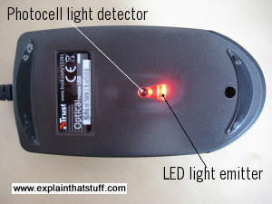
Photo: An optical mouse seen from underneath. Note how the rubber ball you'd find in a ball-wheel mouse has been replaced by the photocell and LED.
An optical mouse works in a completely different way. It shines a bright light down onto your desk from an LED (light-emitting diode) mounted on the bottom of the mouse. The light bounces straight back up off the desk into a photocell(photoelectric cell), also mounted under the mouse, a short distance from the LED. The photocell has a lens in front of it that magnifies the reflected light, so the mouse can respond more precisely to your hand movements. As you push the mouse around your desk, the pattern of reflected light changes, and the chip inside the mouse uses this to figure out how you're moving your hand.
Some optical mice have two LEDs. The first one shines light down onto the desk. The light from that is picked up by the photocell. The second LED lights up a red plastic strip along the back of the mouse so you can see it's working. Most optical mice also have a wheel at the front so you can scroll pages on-screen much faster. You can click the wheel too, so it functions like the third (center) button on a conventional ball mouse.

Inside an optical computer mouse
An optical mouse is much more hi-tech than a ball mouse. Where a ball mouse has quite a few moving parts, an optical mouse is almost entirely electronic (it has almost no moving parts).
Here's the inside of a typical optical mouse and a few of the main components. The most interesting bits are in the center (where the LED light shines down onto your desk) and at the front (where button presses are detected by switches):
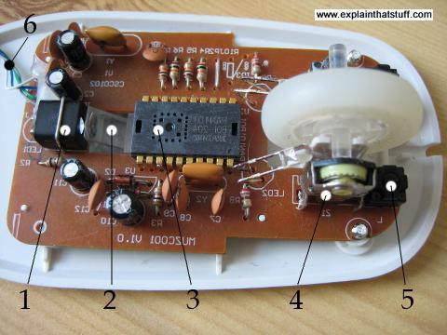
- An LED at the back generates red light and shines it horizontally, from the back of the mouse toward the front (from the left to the right of this photo).
- A plastic light guide channels the light from the LED at an angle, down onto the desk.
- A light-detector chip measures light reflected back up from the desk, converting the analog movements of your hand into digital signals that can be sent to your computer.
- The scroll wheel at the front of the mouse is mounted on a switch mechanism that detects both how much it's rotated and whether you've pressed it (it functions like the central button of a conventional mouse). Rotations of the scroll wheel can be detected in a variety of different ways. Some mice use potentiometers (broadly, variable resistors), similar to the volume control on a radio but able to turn around multiple times. Others use various kinds of rotary switches or optical (rotary) encoders to convert analog wheel movements to digital signals.
- A microswitch detects when you press the right mouse button. There's an identical switch on the other side to detect the left mouse button.
- The USB cable connection carries digital information from the mouse to your computer.
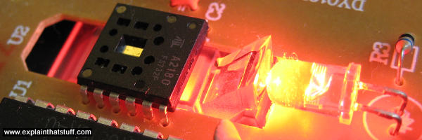
Photo: The light-guide (just the right of the black chip) carries light from the LED down to your desktop. It's a bit like a prism, but it's made from lightweight plastic and there's a small lens mounted at the very end where the guide faces the LED.

How does a wireless mouse work?

There's nothing particularly special about wireless mice. They figure out your hand movements in exactly the same way, but send the data to your computer using a wireless connection (typically Bluetooth) instead of a USB cable. USB doesn't only carry data: it also provides the power for small plug-in devices like mice.

How digital cameras work
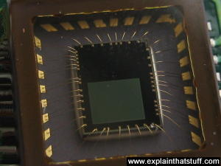
Photo: A typical image sensor. The green rectangle in the center (about the size of a fingernail) is the light-sensitive part; the gold wires coming off it connect it into the camera circuit.
Digital cameras look very much like ordinary film cameras but they work in a completely different way.
When you press the button to take a photograph with a digital camera, an aperture opens at the front of the camera and light streams in through the lens.
There is no film in a digital camera. Instead, there is a piece of electronic equipment that captures the incoming light rays and turns them into electrical signals. This light detector is one of two types, either a charge-coupled device (CCD) or a CMOS image sensor, which breaks it up into millions of pixels. The sensor measures the color and brightness of each pixel and stores it as a number. Your digital photograph is effectively an enormously long string of numbers describing the exact details of each pixel it contains. You can read more about how an image sensor produces a digital picture in our article on webcams.

How digital cameras use digital technology
Once a picture is stored in numeric form, you can do all kinds of things with it. Plug your digital camera into your computer, and you can download the images you've taken and load them into programs like PhotoShop to edit them or jazz them up. Or you can upload them onto websites, email them to friends, and so on. This is possible because your photographs are stored in digital format and all kinds of other digital gadgets—everything from MP3-playing iPods to cellphones and computers to photo printers—use digital technology too. Digital is a kind of language that all electronic gadgets "speak" today.
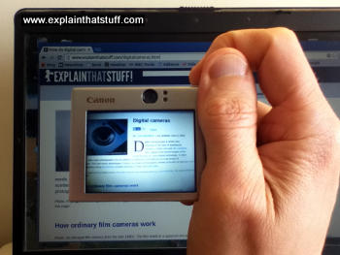
Photo: Digital cameras are much more convenient than film cameras. You can instantly see how the picture will look from the LCD screen on the back. If your picture doesn't turn out okay, you can simply delete it and try again. You can't do that with a film camera. Digital cameras mean photographers can be more creative and experimental.
If you open up a digital photograph in a paint (image editing) program, you can change it in all kinds of ways. A program like this works by adjusting the numbers that represent each pixel of the image. So, if you click on a control that makes the image 20 percent brighter, the program goes through all the numbers for each pixel in turn and increases them by 20 percent. If you mirror an image (flip it horizontally), the program reverses the sequence of the numbers it stores so they run in the opposite direction. What you see on the screen is the image changing as you edit or manipulate it. But what you don't see is the paint program changing all the numbers in the background.
Some of these image-editing techniques are built into more sophisticated digital cameras. You might have a camera that has an optical zoom and a digital zoom.
An optical zoom means that the lens moves in and out to make the incoming image bigger or smaller when it hits the CCD.
A digital zoom means that the microchip inside the camera blows up the incoming image without actually moving the lens.
So, just like moving closer to a TV set, the image degrades in quality. In short, optical zooms make images bigger and just as clear, but digital zooms make images bigger and more blurred.

Why digital cameras compress images
Imagine for a moment that you're a CCD or CMOS image sensing chip. Look out of a window and try to figure out how you would store details of the view you can see. First, you'd have to divide the image into a grid of squares. So you'd need to draw an imaginary grid on top of the window. Next, you'd have to measure the color and brightness of each pixel in the grid. Finally, you'd have to write all these measurements down as numbers. If you measured the color and brightness for six million pixels and wrote both down both things as numbers, you'd end up with a string of millions of numbers—just to store one photograph! This is why high-quality digital images often make enormous files on your computer. Each one can be several megabytes (millions of characters) in size.
To get around this, digital cameras, computers, and other digital gadgets use a technique called compression. Compression is a mathematical trick that involves squeezing digital photos so they can be stored with fewer numbers and less memory. One popular form of compression is called JPG (pronounced J-PEG, which stands for Joint Photographic Experts Group, after the scientists and mathematicians who thought up the idea). JPG is known as a "lossy" compression because, when photographs are squeezed this way, some information is lost and can never be restored. High-resolution JPGs use lots of memory space and look very clear; low resolution JPGs use much less space and look more blurred. You can find out more about compression in our article on MP3 players.
Most digital cameras have settings that let you take pictures at higher or lower resolutions. If you select high-resolution, the camera can store fewer images on its memory card—but they are much better quality. Opt for low-resolution and you will get more images, but the quality won't be as good. Low-resolution images are stored with greater compression.

Turning ordinary photos into digital photos
There is a way to turn photos from an ordinary film camera into digital photos—by scanning them. A scanner is a piece of computer equipment that looks like a small photocopier but works like a digital camera. When you put your photos in a scanner, a light scans across them, turning them into strings of pixels and thus into digital images you can see on your computer.

Inside a digital camera
Ever wondered what's inside a digital camera? What takes the photo? Where's it stored? What makes the flash work? And how do all these bits connect together? When you take electronic gadgets apart, they're much harder to understand than ordinary machines (things that work through a clear physical mechanism): you can't always see which part does which job or how. Even so, it can be quite illuminating to peer into your favorite gadgets to see what's hiding inside. I don't recommend you try this at home: opening things up is the quickest way to invalidate your warranty; it's also a good way to ensure they'll never work again!

The main parts of a digital camera
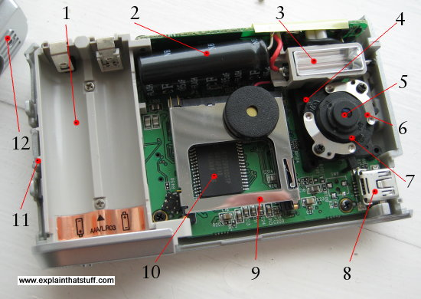
Photo: The parts in a basic digital camera. Were it not for the LCD screen and batteries (the two biggest components), you could probably make a camera like this as small as a postage stamp!
I've opened up the camera in our top photo—and these are the parts I've found inside:
- Battery compartment: This camera takes two 1.5-volt batteries, so it runs on a total voltage of 3 volts (3 V).
- Flash capacitor: The capacitor charges up for several seconds to store enough energy to fire the flash.
- Flash lamp: Operated by the capacitor. It takes a fair bit of energy to fire a xenon flash like this, which is why a lot of indoor flash photography quickly uses up your batteries.
- LED: A small red LED (light-emitting diode) indicates when the self-timer is operating, so you can take photos of yourself more easily.
- Lens: The lens catches light from the object you're photographing and focuses it on the CCD.
- Focusing mechanism: This camera has a simple switch-operated focus that toggles the lens between two positions for taking either close-ups or distant shots.
- Image sensor: This is the light-detecting microchip in a digital camera and it uses either CCD or CMOS technology. You can't actually see the chip in this photo, because it's directly underneath the lens. But you can see what it looks like in our article on webcams.
- USB connector: Attach a USB cable here and connect it to your computer to download the photos you've taken. To your computer, your camera looks like just another memory device (like a hard drive).
- SD (secure digital) card slot: You can slide a flash memory card in here for storing more photos. The camera has a very small internal memory that will store photos too.
- Processor chip: The camera's main digital "brain". This controls all the camera's functions. It's an example of an integrated circuit.
- Wrist connector: The strap that keeps the camera securely tied to your wrist attaches here.
- Top case: Simply screws on top of the bottom case shown here.
Another important part, not shown here, is the LCD display that shows you the photos you've taken. It's mounted on the back of the electronic circuit board so you can't see it in this photo.

How do digital cameras compare with smartphone cameras?
From what I've said so far, you can see that digital cameras are great things—if you're comparing them to old-style film cameras, that is. Thanks to their superb, cutting-edge image sensors, there's really no good reason (other than a nostalgic preference for analog technology) to use film. You might be forgiven for thinking sales of digital cameras would be rocketing as a result, but you'd be wrong. Over the last few years, digital cameras have seen double-digit falls in sales in parallel with the massive rise of smartphones and tablets (which now sell more than a 1.5 billion each year). Check out a photo-sharing site like Flickr and you'll find the most popular "cameras" are actually phones: in June 2018, at the time I'm writing this, Flickr's top five cameras are all iPhones. Is there a good reason to own a standalone digital camera anymore or can you now do everything with a camera phone?
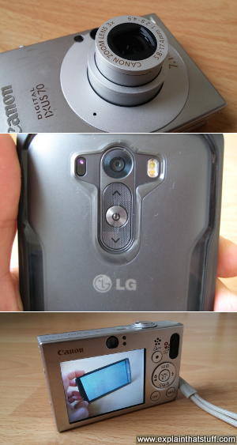
Photo: The pros and cons of digital cameras and smartphones summarized in three photos. Even point-and-shoot digital cameras like my old Canon Ixus have bigger, better, telescopic lenses (top) and sensors compared to the ones in the best smartphone cameras, like my new LG (middle). But smartphones undoubtedly score on connectivity and they have bigger, better, and clearer screens (bottom). Here you can see my smartphone's huge screen pictured in a preview photo on the Canon's tiny screen.

Sensors and screens
Step back a decade and there was no comparison at all between the rough and clunky snapshot cameras on cellphones and even the most mediocre compact digital cameras. While the digitals were boasting ever-increasing numbers of megapixels, cellphones took crude snaps little better than the ones you could get from a basic webcam (1 megapixel or less was common). Now all that's changed. The 10-year-old Canon Ixus/Powershot digital camera I use routinely is rated at 7.1 megapixels, which is perfectly fine for almost anything I ever want to do. My new LG smartphone comes in at 13 megapixels, which (theoretically, at least) sounds like it must be twice as good.
But wait! "Megapixels" are a misleading marketing ploy: what really matters is the size and quality of the image sensors themselves. Generally, the bigger the sensor, the better the pictures. Comparing the raw technical data, the Canon Ixus claims a 1/2.5" CCD while the LG has a 1/3.06" CMOS (a newer, somewhat different type of sensor chip). What do those numbers actually mean? Sensor measurements are based on needlessly confusing math that I'm not going to explain here, and you'll have take it on trust that both of these cameras have tiny sensors, about half the size of a pinkie nail (measuring less than 5mm in each direction), though the Canon sensor is significantly bigger. The Digital Ixus, though eight years older than the LG smartphone, and with apparently half as many "megapixels," has a significantly bigger sensor chip and one that's likely to outperform the LG, especially in lower light conditions.
The Canon also scores with a much better, telescopic lens (technically rated 5.8–17.4 mm, which is equivalent to 35–105mm)—better quality and telescopic to boot—that can take everything from infinity-distance landscapes to close-up macro shots of spiders and flies. But I have to upload my photos to a computer to get a sense of how good or bad they are because the Canon only has a tiny 6cm (2.5-inch) LCD screen. The LG is over twice as good on the diagonal screen dimension, with a 14cm (5.5 inch) "monitor." Where Canon estimates that the Ixus screen has 230,000 pixels, the LG boasts quad HD (2560×1440 pixels), or roughly sixteen times more. I might not be able to take better photos with the LG, but at least I can instantly assess and appreciate them on a screen as good as an HD TV (albeit still pocket-sized).
Bear in mind that my Canon is just a point-and-shoot compact, so this is not really a fair comparison between what you can achieve with a really good digital camera and a really good smartphone. My LG is right up at the better end of smartphone cameras, but the Ixus isn't anywhere near as good as the best digital cameras. A professional DSLR would have a much bigger sensor than a smartphone—up to 3.6cm × 2.4cm—so it would be able to capture really fine detail in even the lowest of light levels. It would also have a bigger and better screen and better (interchangeable) lenses.

Social media
Of course, where smartphone cameras really score is in the "smartphone" department: they're computers, in essence, that are pop-in-the-pocket portable and always online. So not only are you more likely to capture chance photos (because you're always carrying a camera), but you can instantly upload your snaps to the aptly-named Instagram, Facebook, or Twitter. And that's the real reason why smartphone cameras have surpassed old-school digitals: photography itself has changed from the digital-equivalent of the 19th-century Daguerreotype (itself a throwback to the portrait paintings of old) to something more off-the-cuff, immediate, and, of course, social. For the purposes of Facebook or Twitter, often viewed on small-screen mobile devices, you don't need more than a couple of megapixels, at most. (Prove it yourself by downloading a hi-res image from Instagram or Flickr, and you'll find it's seldom more than a couple of hundred kilobytes in size and 1000 megapixels or less in each dimension, making less than one megapixel in total.) Even on better photo-sharing websites like Instagram and Flickr, most people will never be browsing your photos in multi-megapixel dimensions: they simply wouldn't fit on the screen. So even if your smartphone doesn't have masses of megapixels, it doesn't really matter: most people flicking through your photos on their smartphones won't notice—or care. Social media means never having to say you're sorry you forgot your DSLR and only had your iPhone!

Smartphone add-ons
Now it's absolutely the case that photos taken with a top-notch Canon or Nikon DSLR will beat, hands down, snapshots from even the best smartphones—but that's often because it's not a like-for-like comparison. Often, we're comparing good amateur photos taken with smartphones to brilliant professional photos taken with DSLRs. How much of what we're seeing is the camera... and how much the eye of the photographer? Sometimes it's hard to separate the two things
Professionals can achieve amazing results with smartphones—but so can amateurs, with a bit of extra help. One of the drawbacks of smartphone cameras is the lack of manual control (generally even less than with a basic compact digital camera). You can get around that, to a certain extent, by using add-on apps that give you much more control over fiddly, old-school settings like ISO, aperture, shutter speed, and white balance. (Search your favorite app store for keywords like "professional photography" or "manual photography".) You can also add snap-on lenses to smartphones to get around the drawbacks of a fixed-focal-length lens (though there's nothing you can do about the tiny, poorer-quality image sensor). Once your photos are safely snapped, there are plenty of photo-editing apps for smartphones as well, including a slimmed-down, free version of PhotoShop, which can help you retouch your amateur "sow's ears" into professional "silk purses."

So why still buy digital?
Since many people now own a smartphone, the real question is whether you need a digital camera as well. It's very hard to see an argument for point-and-shoot compacts anymore: for social-media snaps, most of us can get by with our phones. For this website, I take a lot of macro photos—close-ups of circuits and mechanical parts—with my Ixus that I couldn't possibly capture with the LG, so I won't be jumping ship anytime soon.
If you want to take professional quality photos, there's really no comparison between smartphones and DSLRs. A top-notch DSLR has a better-quality image sensor (up to 50 times bigger in area than the one in a smartphone) and a much better lens: these two fundamentally important things make the "raw" image from a DSLR far better. Add in all those fiddly manual controls you have on a DSLR and you'll be able to capture a far greater range of photos across a far wider range of lighting conditions. If you really care about the quality of your photos, instant-uploading to sharing sites might be a less important consideration: you'll want to view your photos on a big monitor, retouch them, and only share them when you're happy. Having said that, you can now buy hybrid digital cameras with built-in Wi-Fi that offer similar instant-sharing convenience to smartphones. And, of course, there's nothing to stop you carrying a smartphone and a DSLR if you really want the best of both worlds!

What is MP3 technology?

MP3 files
An MP3 player gets it name from the MP3 files that you store on it. Just as DOC is a type of computer file used by the Microsoft Word word-processing program, and PDF is another type of file for storing printable documents, so MP3 is a particular file type used for storing music. Think of MP3s as computer files and an MP3 player as a special type of computer, dedicated to playing back sounds stored in coded format inside those files, and you're halfway to understanding how it all works.

Sampling
MP3 is an example of digital technology, which means sounds you hear are stored in numerical form. CDs are digital too, but older music formats (including LP recordsand cassette tapes) used analog technology. That means music was stored as a physical or magnetic representation of the original sound, without using any numbers at all. A sound twice as loud as normal might have been stored by a groove on a plastic record that was twice as deep as normal, so the stored information was a faithful "analog" of the original sound.
The key to storing music (or any other kind of sound) in digital format is a process called sampling—At the time of recording, a computer "listens" to the music track that's being recorded and "samples" the volumes and frequencies of the sounds: about 44,000 times each second, it analyzes all the sounds it can hear and converts them into a number. This process is carried out by an electronic circuit called an analog to digital converter, which turns sounds (analog) into streams of numbers (digital), which are then stored in sequence in an MP3 file or on a CD. When the file or CD is played back later, the reverse process happens: a digital to analog converter turns the numbers back into analog electrical signals that become sounds when they're fed into a loudspeaker. The faster the computer samples (the higher the sampling rate), the more information it captures each time (the higher the bit depth), and more detail it captures each second (the higher the bit rate), the more closely the digital file resembles the original analog sounds and the higher the quality of the recording.

Screenshot: Software for "ripping" (converting) CDs to make MP3s typically lets you choose from a variety of different "encoding" types, including MP3. You can usually change the bit rate as well for better or worse quality (and bigger or smaller files). This program, Asunder, lets you select a bit rate from 65kbps (low-quality) up to 245kbps (high quality). A five-minute CD track will convert into something like a 3MB MP3 file at 65kbps or a 10MB file at 245kbps.
A higher sampling rate, bit depth, and bit rate give a better quality MP3 file. Typically, CD-quality sound involves sampling at a rate of 44.1kHz (44,100 times per second) and a bit depth of 16 (16 binary zeros and ones, so something like 0110110101001011). A really high quality MP3 "ripped" (generated from) a CD might be produced using a bit rate of 320kbps (320,000 bits per second), while a lower quality one might use 64kbps (64,000 bits per second) or even lower. The downside of higher sampling/bit rates and bit depth is that they produce more digital information that has to be stored—a bigger file size, in other words—and takes longer to download. (You can read a bit more about sampling in our article on analog and digital.)

What is compression?
One big advantage of digital technology is that you can store more information in less space. If you've got some encyclopedias on CD-ROMs or DVDs, you'll know that computers are particularly good at cramming large amounts of information into pretty tiny spaces. The Encyclopedia Britannica, whose 20-odd volumes fill a whole shelf in your local public library, fits comfortably onto a couple of CDs or a single DVD. Tricks like this are possible because computers use a technique called compression—a way of squeezing information so it takes up much less room.
Compression is the secret behind all kinds of digital technologies, including digital photos, music downloading, and a whole lot more, so it's worth going into in a bit more detail before we get back to MP3 players.

Lossy compression
Old-style telegrams are a good example of compression in action. Before telephones were invented, people sent short messages to one another over telegraph wires. The telegraphs were busy and costly, so messages had to be kept short and people compressed their messages into as few words as possible. A message like: "I think I might pay you a visit later this week. I do hope that's alright. Maybe you could reply and let me know if it's convenient?" was compressed into a telegram like: "Visiting later in week. Hope OK. Let me know." Thus, the 27 words of the original message become 9 words in the telegram.
The message is still completely understandable, if a little more terse. We can compress the original message because a lot of the information is "redundant": some of the words are unnecessary and don't really add all that much, so we don't lose the sense of the message when we delete them. We could compress the message even further, but if we take out more words, it'll soon stop making sense. In other words, the more we compress a piece of information, the more we reduce its quality. Even with a small amount of compression, some information has been lost: the telegram is less polite than the original message. And there's no way the receiver can take the 9-word message and figure out what were the other 18 words we deleted, so telegrams are an example of what we call lossy compression: the information we delete during compression is gone for good.

Image compression
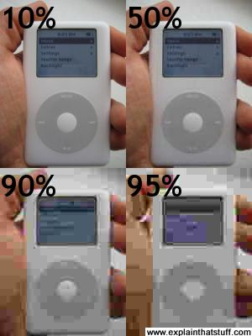
If you have a digital camera, you probably know about compression already. Your camera most likely stores photos in a format called JPG (pronounced and sometimes written J-PEG). On most cameras, you can set options so the photos are taken with higher or lower resolution (which just means more or less detail). The higher the resolution, the greater the detail, and the better the photos look—but the more space they take up. Since your camera has a limited memory, you can opt to store lots of low-quality, low-resolution (low-res) images or fewer higher-quality, high-resolution (hi-res) images. The low-res images are compressed more than the high-res ones and the JPG files are correspondingly smaller. However, if you compress photos too much, you start to lose the details very quickly. In the example shown here, I've compressed a photo of an iPod at different resolutions to show you how the details are rapidly lost (but note how many bytes of disk space is saved at the same time).
Photo: Lossy compression in action. With 10% compression, the original file takes up 10,000 bytes. Increasing the compression dramatically reduces the byte size (50% = 4000 bytes, 90% = 2500 bytes, and 95% = 1900 bytes), but with increasing loss of quality.
There's no way of taking one of the low-res photos and going back to the hi-res original: once the information is lost, it's gone for good. That means JPG is also a lossy compression. But note how much we can compress the original photo and still recognize what it is. Even with 95% compression, we can still make out that this is a photo of an iPod. With 50% compression, we hardly lose any detail at all.

How is music stored inside an MP3 file?
Normal sound files stored on a computer take up huge amounts of space. Consider: you can fit the Encyclopedia Britannica onto a couple of CDs, but one CD will normally hold only about an hour's worth (maybe a dozen or so tracks) of music. That means each track on a normal CD must be taking up a huge amount of space—equivalent to one or two volumes of an encyclopedia! MP3 is a mathematical trick for taking the same musical information and squeezing it into about one twelfth as much space. You can make MP3 files that are smaller or larger by compressing them by different amounts, but the more you compress them the worse they'll sound. Just like telegrams and JPGs, MP3 is a lossy compression.
Inside an MP3 file, music is stored as long strings of bits (binary numbers, zeros and ones) in a series of chunks called frames. Each frame starts with a short header (a kind of table of contents), followed by the music data itself. At the start of an MP3 file there is a kind of "index card" that stores details of the track name, artist, genre, and so on. This information is called metadata and each part of it (artist, track, and so on) is stored in what's called an ID3 tag. Many MP3 programs have an option that lets you "edit the ID3 tags." It sounds technical and complex, but it's simply a way to change the "index card" at the front of the MP3 file.
Artwork: A CD track takes up about 10–12 times as much room as the same track converted into MP3 format (depending on the bit rate).
The great thing about an MP3 file is that it takes up so little room. A typical music track takes up only about five megabytes or so when you turn it into MP3 form, compared to the 60 megabytes or so it would take up on a CD. That means you can send an MP3 file over the Internet twelve times more quickly and cheaply than the same information stored in CD format. You can also store an awful lot more MP3 files on your music player. The relatively small size of MP3 files and the speed with which they can be downloaded has revolutionized the music business since the mid-1990s.

Why CDs always sound better than MP3s
Why go to a store to buy a CD when you can download the track you want from the Net in a couple of minutes? I've made compression sound like a brilliant thing—and it is—but there's another side to the argument. There is a very good reason why you might want to pause before "ripping" your CDs (converting them digitally) to MP3s and tossing them into the nearest trash can.
Photo: Right: Takk by Sigur Ros.
Let's take a look at a typical CD and its MP3 equivalent. The superb album Takk, by the Icelandic band Sigur Ros, has 11 tracks and on the CD the audio files range in size from 19.7MB to 105.1MB, taking up approximately 660MB altogether. But look at those files in iTunes, Amarok, or another MP3 library and you'll find they're compressed by about 90 percent: they go from just 1.8MB to 9.9MB. Remember that MP3 is lossy compression: most of the audio information has been thrown away to create the MP3s and you can never get it back!
Now most of the time, that doesn't matter. MP3s sound just fine. If you're listening to music on the train or casually at home, an iPod sounds terrific. But listen to the same album with even a moderately good CD player and a good pair of audio headphones and it will sound stunningly better. Your ears really will notice the extra 90 percent!
Here's a test I did recently. I tried listening to Takk with a cheap CD player (rough cost $50) and a superb pair of headphones (roughly $100) and comparing it with my iPod (roughly $250). There's absolutely no comparison in the quality of the sound: the CD player sounds infinitely better because you hear so many more details—partly, I admit, because these headphones are so much better. Try it yourself! I'd still rather have the iPod most of the time, but there are times when I really want to hear a quality of sound, not just a quantity. Of course, listening to an iPod with superb headphones also greatly improves the sound quality—but, no matter how good your headphones, an MP3 player will never sound quite as good as a CD player because of lossy compression.

How does an MP3 player work?
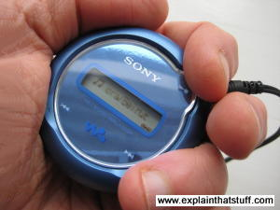
Photo: A Sony Network Walkman MP3 player uses flash memory to store songs instead of a hard drive, so it's much smaller and lighter than a traditional iPod. This is quite an old model with a 512MB memory, so it can store only about 8–10 CDs worth of music. That may not sound much compared to an iPod, but it's just right for keeping in your pocket or bag for those long, tedious journeys. The lack of hard drive and tiny screen also gives amazing battery life; a standard alkaline battery will power this little player for about a month of heavy use!
If MP3s are computer files, it follows that MP3 players must be computers. It's absolutely true! The iPod in your pocket is a far more powerful computer than the ones people had on their desks 20 years ago.
All computers, which are machines that process information (data), have four basic components. They have an input device (for getting the data in), a memory (for storing data), a processor (for working on the data), and an output device (for getting the data back out again). Think of an iPod or MP3 player and you'll see that it has all these things. It has an input (probably a USB docking lead that hooks it up to your computer), a memory (either a small hard drive or a flash memory that can store MP3 files), a processor (something that can read the MP3 files and turn them back into music), and an output (a socket where you plug in your headphones). Most MP3 players have another output also: a little LCDdisplay that tells you what's playing.
Switch on your iPod to play your favorite track and it works just like a computer. The processor chip loads an MP3 file, reads the ID3 index cards, and displays the artist and track name on the display. Next, it works its way through the MP3 file reading each frame in turn. It reads the header, followed by the data, and turns the digital information (the binary ones and zeros) back into sound frequencies that your ears and your brain decode as music. That's pretty much all there is to it. But remember this: the real secret of a digital music player is not the plastic gadget in your hand but the clever technology behind the MP3 files it's playing!

What's inside an iPod?
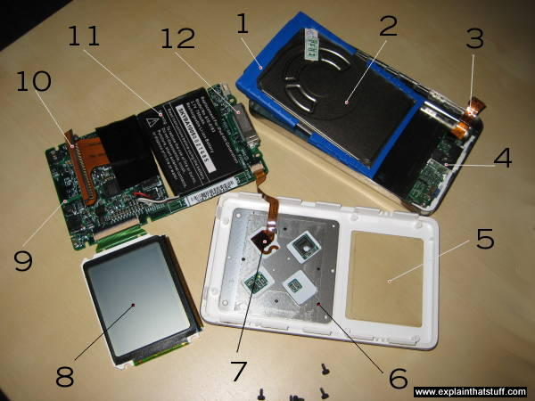
I don't recommend you take your iPod apart—you could easily damage it or invalidate the warranty. But if, like me, you have to replace a dying battery (a fairly simple job if you go slowly and carefully), you get a chance to see what's inside!
About half the space is taken up by a very thin hard drive (2), which is about the same size as your iPod but only half as thick. Underneath the hard-drive there's a lithium-ion rechargeable battery (11) and a motherboard (main circuit board) packed with chips that control all the components (9). Beneath the circuit board there's the scroll wheel (the iPod's equivalent of a mouse) and the LCD display. The circuit board is connected to the hard-drive by a flexible brown plastic "ribbon" connector. There's a smaller ribbon connector linking the circuit board to the docking connector (where you connect your iPod to your computer).
Here's a full list of all the bits:
- Hard drive shock absorbers (blue). These little bits of rubber clip on to the sides of the hard drive and cushion blows if you drop it.
- Hard drive. It's a standard, off-the-shelf PCMCIA drive. This one is a 20GB model made by Toshiba.
- Ribbon cable connector from the headphone socket and the "hold" button to the motherboard.
- Headphone socket.
- Clear perspex screen protector.
- Bottom of touch-wheel.
- Ribbon cable connector from touch-wheel to motherboard.
- LCD display screen (looking from the top). Like all the other components, this also connects to the motherboard with a ribbon cable.
- Motherboard: The iPod's main circuit board contains its sound-processor and memory chips.
- Ribbon cable connector from motherboard to hard-drive. I've unplugged the hard-drive to take the photo, but this is where it normally plugs in.
- Lithium-ion battery. This plugs into the bottom of the motherboard with a simple, standard, three-pin connector.
- Dock connector. This is where you plug your iPod in to charge it and synchronize it with your computer.
If your iPod is broken, and you're ready to consign it to the trash, it's worth knowing that all the main components are modular and all of them can be replaced if you're reasonably confident with electronics and you go slowly, carefully, and gently. If you know what you're doing, it takes about a minute to replace a battery or a hard drive, five minutes to replace a broken screen, and maybe ten minutes to completely replace the motherboard. You can easily find replacement iPod spares on auction sites such as eBay. The most difficult thing is removing the various ribbon connectors without breaking them (you can find out how do do that on many online sites, including thisGadget Hacks video.

