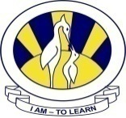
The City School
North Nazimabad Boys Campus

Date 16TH Oct,2015
Subject: Islamiyat
Class: 9
Teacher: Navaid Qureshi

Q. Write biographical accounts of Hazrat Imam-e-Hassan and Hazrat Imam-e-Hussain(RA)[10]
___________________________________________________________________________________________________

The City School
North Nazimabad Boys Campus

Date 22nd Oct,2015
Subject: Islamiyat
Class: 9
Teacher: M.Irfan

Q. Describe the part played by Hazrat Zaid bin Sabit (RA) in preserving the revelation after Prophet(SAW).[10]
___________________________________________________________________________________________________

