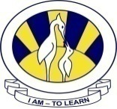
The City School
North Nazimabad Boys Campus

Date 16TH Oct,2015
Subject: Islamiyat
Class: 9
Teacher: M.Irfan

Q 1.write down the difficulties faced by the Holy Prophet (saw) during the years he lived in Makkah [10]
_____________________________________________________________________________________
_________________________________________
The City School
North Nazimabad Boys Campus

Date 22nd Oct,2015
Subject: Islamiyat
Class: 9
Teacher: M.Irfan

Q 1.Muhammad is the last Prophet of Allah or the Seal of the Prophets. Discuss [10]

______________________________________________________________________________________________________________________________

