The City School
North Nazimabad Boys Campus
Additional Mathematics
Class 9

Topic: Coordinate Geometry Revision Worksheet

Q1. Find the gradient of the line passing through each of the following pairs of points
(a) A(2, 3) and B(3, 6)
(b) C(2, 1) and D(-1, 4)
Q2. Given that A(1, 2), B(2, -3) and C(6, 1), show that AB = AC. Find the coordinates of the midpoint of AC.
Q3. Three points have coordinates A(-2, 1),B(10, 6) and C(a, -6). Given that AB = BC, find the possible values of a.
Q4. Find the equation of the line passing through (-3, 2) with gradient 2.
Q5. The line l has gradient 3 and cuts the x – axis at 4. Find its equation.
Q6. Find the coordinates of the midpoints of the line segments joining the following pairs of points
(a) (4, 5 ) and (6, 9)
(b) (2a, -a) and (4a, 5a)
Q7. If M(3, 5) is the midpoint of the line joining A(-3, 7) and B(p, q), find the value of p and of q
Q8. Four points have coordinates A(2, -3) , B(3, 0), C(0, 1) and D(-1, -2).
(a) Show that ABCD is a parallelogram
(b) Calculate the length of AC and BD
Q9. If A(2, 0) , B(p, -2), C(-1, 1) and D(3, r) are the vertices of a parallelogram ABCD, calculate the value of p and of r.
Q10. Given A(-1, 4) and B(5, 2),
find
(a) the point P on the x-axis such that AP =BP
(b) the point Q on the y-axis such that AQ = BQ.
Q11. A is the point (1,-2) and B is the point (7,6).
Find
a) The coordinates of the mid point AB
b) The length of the line segment AB c) The Gradient of AB
Q12. The points (6,0),(3,4) and (p,5) lie on a straight line.
a) Find the value of p
b) Find the Gradient of line Q. Show that the points A(4,5),B(3,2) and C(5,3) are the vertices of an isosceles triangle or not.
Q13.The graph shows the line m passing through the points A(-1,1) and B(5,5). Given that C is the point (4,1), find
a) The gradient of m
b) The coordinates of the mid point of AB
c) The area of Triangle ABC
d) The length of AB
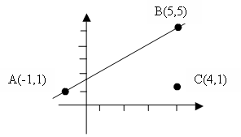
Q14. Show that the points A(4,5),B(3,2) and C(5,3) are the vertices of an isosceles triangle or not.
Q15. PQRS is a square. P is the point(0,7),Q(2,1) and R(8,3). Calculate a) The coordinates of S b) The area of square
Q16. The coordinates of the ends points of a line segment LM are L(7,3), M(1,-7).
a) Find the coordinates of point N on the y-axis such that LN=MN
Q17. Find the equation of the straight line joining the following points a) H(5,1) and K(5,6)
Q18. Find the equation of the straight line when its gradient and coordinates of a point on the straight line are as a) 1/4, (0,1/3)
Q19. A & B are the points of a straight line and their coordinates are (1,-2) and (7,6) respectively. Find a) The coordinate of mid point of AB b) The distance of point A from B
C(4,1)
Q20. The diagram shows three points A(-2,7), B(-2.2) and C(6,-4) of a triangle. Find
a) The area of triangle ABC.
b) The value of sin ABC (Hint, use formula, area = ½ ac sin ABC)
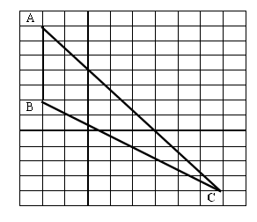
Q21. L is the point (1,5) and M is the point (5,1). If N is the third point (5,5)on the same plane,
a) Find the equation of line joining LM
b) Find the coordinates of the point where the line LM intersects the y-axis
c) Prove that Triangle LMN is an isosceles triangle or not
Q22. The equation of a straight line is 6x – 2y +1 = 0. Find
a) The gradient of the line
b) Equation of another line parallel to the given line and passes through the origin
c) Equation of line parallel to the given line and passes through the point(3,5)
Q23. The equation of line l is 3x –4y = 24. The line intersects the x-axis at A and the y-axis at B. Find
a) The coordinates of A and B points
b) The coordinates of the mid point M
c) Find the equation of line parallel to AB and passes through the point(4,9)
Q24. The points A, B and C have coordinates A(0,7),B(6,-1), and C(6,9). Calculate
a) The length of AB
b) Calculate the gradient of AC
c) Find the equation of line AC
d) ACPB is a quadrilateral with BC its axis of symmetry. Find the coordinates of P (Hint:- Draw points A,B and C on graph paper, then take BC as its axis of symmetry along y-axis and draw point P. write the coordinates of P)
Q25. Prove that A(0,9), B(4,7) and C(6,6) are collinear
Q26. The coordinates of the end points of a line segment PQ are P(3,7 ) and Q(11,-6).
a) Find the coordinates of the point R on the y-axis such that PR=QR
Q27. Find the perimeter and area of triangle LMN, L is the point (1,5), M is the point (5,1), and N is the point (5,5).

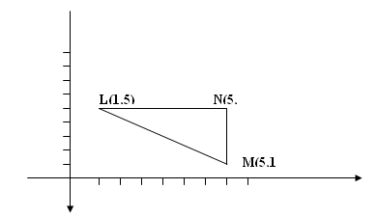

Q28. The equation of the line P is 2y – x = 10. Find
a) the coordinates of the point where p interests the y – axis
b) the coordinates of the point where p interests the x – axis
c) the gradient of P
d) the equation of the line which is parallel to p and which passes through the point (0,-3) e) the coordinates of the point where P intersects the line y= x
Q29. A is the point(0,5) and B is the point (5,3)
a) Find the equation of the line AB
b) the coordinates of the midpoint of AB
c) the coordinates of the point where the line AB intersects the x-axis
d) the length of AB, giving your answer correct to 2 decimal places e) the line y = 5 is the axis of symmetry of the triangle ABC. Find the coordinates of C
Q30. (a) A line passes through the point (0,5) and has gradient -2. Find the equation of the line.
(b) Another line has equation y = 3x - 6 and passes through the point (a, 0), find the value of a.
(c) A line passes through the point (9, 3 ) and has gradient 2.Find the equation of the line.
Q31. Find the coordinates of the midpoints of the line segments joining the following pairs of points
(a) (4, 5 ) and (6, 9)
(b) (2a, -a) and (4a, 5a)
Q32. Two points of a straight line AB are given. A(-3,7) and B(p, q). Find
a) If M(3, 5) is the midpoint of the line joining A(-3, 7) and B(p, q), find the value of p and of q
b) Find the gradient of the line AB
c) If the coordinates of point C are (3, 1). Is it collinear or not
Q33. Four points have coordinates A(2, -3) , B(3, 0), C(0, 1) and D(-1, -2).
a) Show that ABCD is a parallelogram
b) Calculate the length of AC and BD
Q34. A(1,5),B(3,2) and C(1,2) are the vertices of triangle ABC. Calculate the area of triangle ABC.

