Math Retake Test Paper 1 Marks: 40
Name: ____________________________ Time: 50min.
- (a) Evaluate $\frac{3}{8}+1\frac{1}{3}$ [1]
(b) Evaluate $5-3(2-1.4)$ [1]

- (a) Express $3\frac{3}{4}\%$ as a fraction in its simplest form. [1]
(b) Arrange these fractions in order, beginning with the smallest. [1]
$\frac{4}{5}$ $\frac{3}{4}$ $\frac{31}{40}$

- Estimate, correct to the nearest whole number, the value of $\sqrt{{2.986}^{2}+{4.002}^{2}}$ [1]

- $p=4×{10}^{5}$ $q=7×{10}^{6}$
Expressing each answer in standard form, find

- $p^{2}$ [1]
- $p+q$ [1]

- The diagram shows a trapezium with lengths in centimetres.
The area of the trapezium is 120${cm}^{2}$.
Find the value of $b$. [2]

- (a) Write $0.000 00521$ in standard form. [1]
- Giving your answer in standard form, evaluate
$\left(4×{10}^{7}\right)×(5×{10}^{-3})$. [1]

- In the triangle $ABC$, $AB = 7cm$, $AC = 6cm.$
- Construct triangle$ABC$. [2]
Line $BC$ is drawn for you.

- Measure angle $BAC$ in your triangle. [1]
- Fatima travels from London to Astana.
The time in Astana is $5$ hours ahead of the time in London, so when it is $10 00$ in London the local time in Astana is $15 00$.
She flies from London to Moscow and then from Moscow to Astana.
The flight leaves London at $12 25$ and takes $4$ hours to reach Moscow.
Fatima waits $4\frac{1}{2}$ hours in Moscow for the flight to Astana.
She arrives in Astana at $05 25$ local time.
How long did the flight from Moscow to Astana take? [2]

- $c=\sqrt{8a-3b}$
- Find $c$ when $a=3$ and $b=-4.$ [1]
- Rearrange the formula to make $b$ the subject. [2]

- The scale of a map is $1 : 25 000$.
- The scale can be written as $1 cm : d km$.
Find $d$. [1]
- He distance between two villages is 8km.
Find the distance, in centimeters, between the two villages on the map. [1]

- Given that ${ 6}^{x}=9,$ write down the value of
- $6^{-x}$ [1]
- $6^{\frac{x}{2}}$ [2]
- $6^{0}+6^{x}$ [1]

- In the diagram$, A, B, C$ and $D$ lie on the circle, centre $O$.
$AD$ is a diameter. The tangent to the circle at $B$ meets the line $DA$ produced at $T$.
$Angle AOB=68°$ and $Angle CAO=43°$. Find $x, y, z$, and $t$. [4]
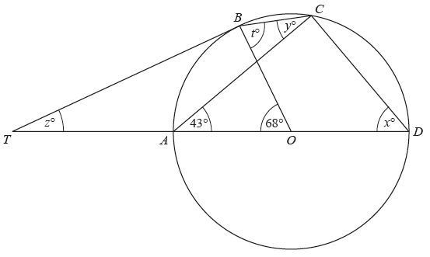

- The diagram shows triangles $A$ and $B$.
- Triangle $A$ is mapped onto triangle $B$ by an enlargement.
Find the scale factor, and the centre, for this enlargement. [2]

- Triangle $A$ is mapped onto triangle $C$ by a stretch, with invariant line the $x$-axis and stretch factor 2.
Draw triangle $C$. [2]
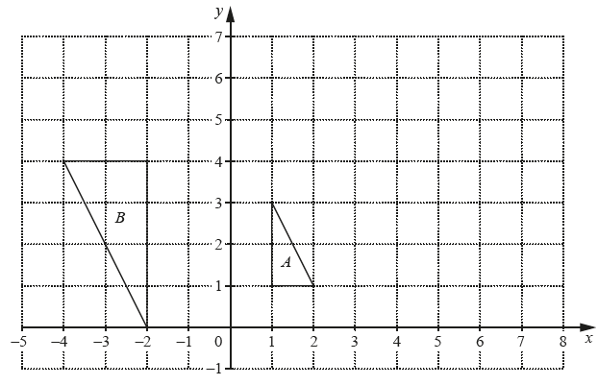
- Solve the simultaneous equations. [3]
$$3x+4y=3$$
$$2x-y=13$$

- The first four terms of a sequence, $S$, are $89, 83, 77, 71$.
Find an expression for $S_{n}$, the $n$th term of this sequence [2]

- $y$ is inversely proportional to the square of $x$.
Given that $y = 3$ when$x=2$ , find $y$ when $x=5.$ [2]

