Math Retake Test Paper 2 Marks: 60
Name: ____________________________ Time: 1hr. 15min.
- (a) Simplify
(i) $\frac{4x-1}{3}+\frac{x+5}{2}$ [2]

(ii) $\frac{1}{x}+2-\frac{3}{x+1}$ [2]
(b) Solve
(i) $\frac{7}{3-2m}=4$ [2]

(ii) $\frac{3x}{x+2}-\frac{4}{x-2}=3$ [3]

- (a) Aamir and Misbah travel to England.
Aamir exchanges $20 500$rupees and receives $£250.$
Misbah exchanges $26 650$ rupees into pounds $(£)$ at the same exchange rate.
How many pounds does Misbah receive? [2]
(b) Shahid goes to a bank to exchange some pounds $(£)$ for euros $(€).$
He has$£400$ which he wants to exchange.
The bank only gives euros in multiples of $5$ euros.
The exchange rate is $£1= €1.17.$ Find
- the number of euros he receives [2]
- his change from $£400$. [1]
(c) Kamran buys a fridge and a freezer in a sale.
The sale offers $15\%$ off everything and he pays a total of $\$357.$
Before the sale, the freezer cost $\$250.$
What was the cost of the fridge before the sale? [3]
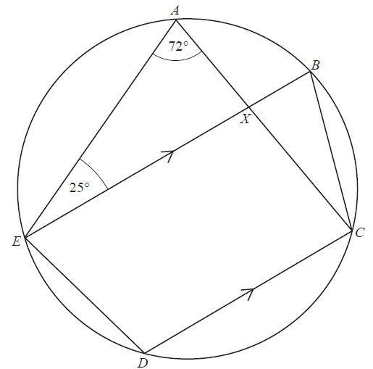

- $A, B, C, D$ and $E$ are five points on the
circumference of a circle. $EB$ is parallel to $DC$.
Angle $EAC$ is $72°$ and angle$AEB$ is $25°$.
$X$ is the intersection of $AC$ and $EB$.
Find the angles
- $EBC$ [1]
- $CXB$ [1]
- $EDC$ [1]
- $ACD$ [1]
- (a) Find the gradient of the line $J$. [1]
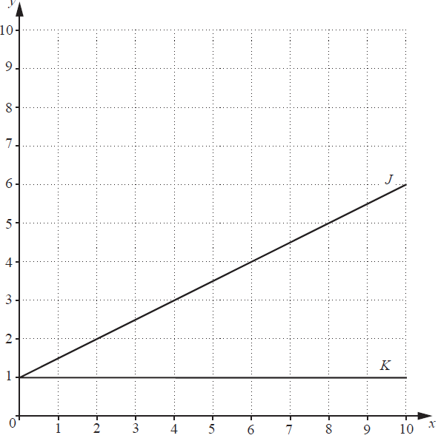
(b) Write down the equation of line $K$. [1]
(c) Draw a line $L$, through $(6,1)$ such
that the area enclosed between
lines $J, K$and $L$ is $6 {cm}^{2}$. [1]
(d) Find the equation of line $L$. [2]
(e) The line $N$ is perpendicular to line $J$ at $(2,2).$
Find the coordinates of the point
where line $N$ crosses the $y$-axis. [2]

- A pattern of numbers is given below.
Row 1 | $$\frac{1}{1×2}=\frac{1}{1}-\frac{1}{2}$$
Row 2 | $$\frac{1}{2×3}=\frac{1}{2}-\frac{1}{3}$$
Row 3 | $$\frac{1}{3×4}=\frac{1}{3}-\frac{1}{4}$$
Row 4 | $$\frac{1}{4×5}=\frac{1}{4}-\frac{1}{5}$$

- Write down Row 10. [1]
- Adding the first two rows gives the result $\frac{1}{1×2}+\frac{1}{2×3}=\frac{1}{1}-\frac{1}{3}=\frac{2}{3}$

Adding the first three rows gives the result $\frac{1}{1×2}+\frac{1}{2×3}+\frac{1}{3×4}=\frac{1}{1}-\frac{1}{4}=\frac{3}{4}$

- Write down the result of adding the first four rows. [1]
- Use the pattern to write down
- The value of $\frac{1}{1×2}+\frac{1}{2×3}+\frac{1}{3×4}+…+\frac{1}{19×20}$. [1]

- The number of rows that add up to $\frac{109}{110}$. [1]

- (a) $f\left(x\right)=\frac{2x+7}{3}$
- Find $f^{-1}(x)$ [2]
- Given that $f\left(m\right)=\frac{m}{2} ,$ find $m.$ [2]
(b) (i) Complete the table of values for $y=6+x-x^{2},$ and hence draw the
graph of $y=6+x-x^{2}$ on the grid below. [3]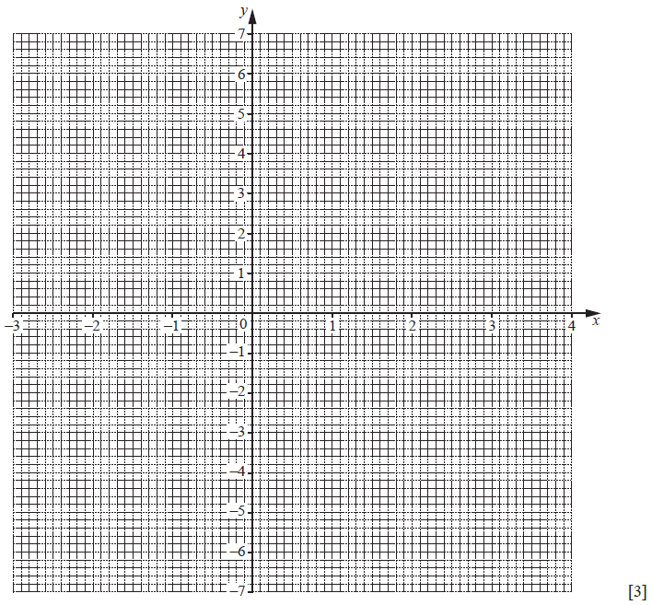
(ii) Use your graph to estimate the maximum value of $6+x-x^{2}.$ [1]
- By drawing the line $x+y=4$, find the approximate solutions to the equation $2+2x-x^{2}=0$ [2]
- The equation $x-x^{2}=k$ has a solution $x=3.5$.
By drawing a suitable line on the grid, find the other solution.
Label your line with the letter L. [2]
- Two ports, $A$ and $B$, are $15 km$ apart and $B$ is due south of $A$.

The scale drawing, drawn to a scale of 1 $cm$ to 2 $km$, shows $A, B$ and a third port $C$.

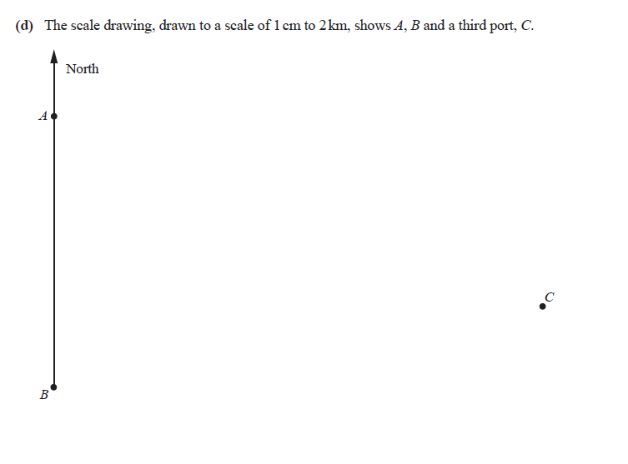

- A boat sails from $A$ on a bearing of $141°$.
When the boat has travelled 24 $km$, it stops at the point $X$.
Mark and label $X$ on the diagram. [2]
- A second boat is located
I less than 12 $km$ from $A$
II nearer to $BC$ than to $BA$.
Shade the region in which this second boat must lie. [3]
- The point $Y$ is the position of the second boat when it is as far as possible from $X$.
Mark and label $Y$ on the diagram and hence find the maximum possible distance between the two boats. [2]
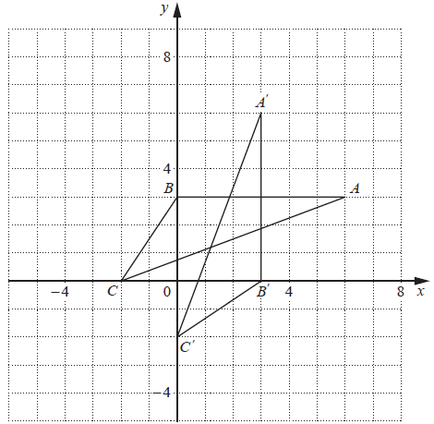

- The transformation T maps triangle $ABC$ onto triangle $A^{'}B^{'}C^{'}.$

- Describe fully the transformation $T$. [2]
- The matrix $M$ represents the transformation $T$.
Find the matrix $M$. [2]

- Triangle $A^{'}B^{'}C^{'}$ is mapped onto triangle $A^{''}B^{''}C^{''}$ by a reflection in the $y$-axis.
Draw and label triangle $A^{''}B^{''}C^{''}$ . [2]

- Triangle $ABC$ is mapped onto triangle $A^{''}B^{''}C^{''}$ by an anticlockwise rotation about the origin.

- State the angle of rotation. [1]
- Write the matrix for this rotation. [2]

