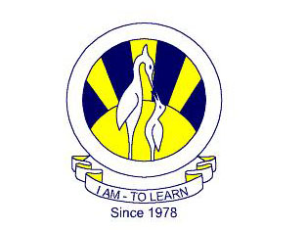
The City School
North Nazimabad Boys Branch
MohsinZaki
Topic: Coordinate Geometry
Date: 11-02-2017
Class: 9
Subject: Math

