The City School
North Nazimabad Boys Branch
Grade 9 Mathematics
Topic: Perimeter and Area of Shaded Region
Mr. MohsinZaki
Q:Find out the perimeter and area of shaded region.
(a)
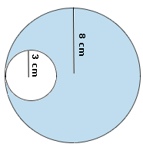
(b)
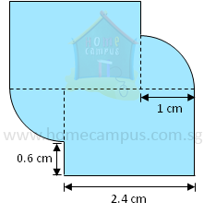

(c)
