The City School
North Nazimabad Boys Campus
Topic: Mixed Concept (Paper II)
Mr. Mohsin Zaki
Subject: Mathematics
Grade: 09 S- N
Q1: Solve the following equations, where possible giving your answers correct to 2 decimal places where necessary.
- $\frac{5}{x+1}+ \frac{8}{x+3}=5$ b. (3x-1)(2x+5) = (4 - x²)
- $\frac{8}{x-1}+ \frac{3}{x-2}=3$ d. 5x²+4x+5 = 3(1-3x)
Q2: A ladder 5.8 m long stands on level ground and its top just reaches the top of a wall 4.1 m high. How far is the foot of the ladder from the wall?
Q3: The length of the diagonal of a rectangular board is 61 m and the length of one side is 60 m. Find:
a. the width of the board
b. area of the board
Q4: 200 students took a test. The cumulative frequency graph information about their marks is shown below:

Use your graph to estimate
- Median, Lower Quartile, Upper Quartile
- Inter Quartile Range
20th and 80th Percentile
Q5: The table shows the marks obtained in tests of English and Mathematics by 140 students.
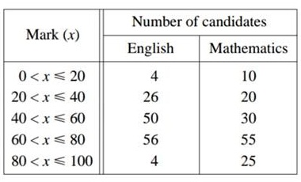
- Copy and complete the cumulative frequency table below
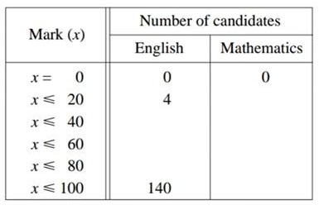
- Using a scale of 2 cm to represent 20 marks, draw a horizontal x-axis for 0 ≤ x ≤ 100.
Using a scale of 2 cm to represent 20 pupils, draw a vertical axis for values from 0 to 140.
On your axes, draw a label both smooth cumulative frequency curve to illustrate this information.
- Use your curves to find
- the upper and lower quartile mark for English and Mathematics.
- the inter quartile range for English and Mathematics.
- State, with a reason, which you think is the easier test.
Q6: Find the unknown values in the given figure. Give your answer correct to two significant figures or nearest degree
- 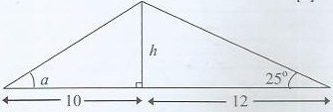
Q7: Given circle has a radius of 11cm. Take π=3.142 to calculate
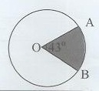
i) the length of the minor arc AB
ii) the area of the minor sector AOB
Q8: Ali walked a distance of 25km from A to B, at an average speed of x km/hr. Write down an expression for the time in hours, he took for the journey from A to B.
He returned by the same route but his average speed was 2km/hr less. Write down an expression for the time, in hours, he took the journey from A to B.
Given that the difference between the two times was 35minutes, form an equation in v and show that it reduced to 7x²-14x-600=0
Solve the above equation correct to 2 decimal places. Hence find the total time taken for the men to walk , giving your answer correct to the nearest minute

