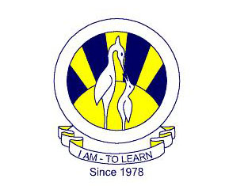
The City School
North Nazimabad Boys Branch
Subject: Mathematics
Teacher: Sir Mohsin Zaki
Grade 9(N,T,C)

Q1: The vertices of ABC are A (2, 4), B (9, 4) and C (7, 11)
- Find the area of ABC.
- Calculate the length of BC.
- Calculate the length of the perpendicular drawn from A to BC.
Q2: The straight line mx = 5y + 4 has the same gradient as the line 7x + 6y + 5 = 0.
Find the value of m.
Q3: The straight line with equation 5x + 7y = 35 cuts the x axis and y axis at points H and K respectively. Find the coordinates of H and K.
Q4: The coordinates of ABC are A( 2,6) B(4,2) and C(12,6). Show that the triangle is right angled at B.
Q5:For each of the question below, determine whether the triangles are congruent or not. If the triangles are congruent (a) state the case of congruency (b) name the three pairs of equal measurements.

