The City School
North Nazimabad Boys Campus
Chemistry:Metals
Remedial Class
Class:11
Teacher MS. Zubaida

Name: _________________________ Sec: _____ Date: _________ Max Marks [30]

Q1:Below is a section of the reactivity series of metals.
The non-metal, carbon is also included.

magnesium
aluminium
carbon
zinc increasing reactivity
iron
lead

aluminium and iron are found in nature as their oxides.
The methods of extracting the pure metals depend on their reactiv
(a) Aluminium is extracted by electrolysis from its oxide.
(i) What is the name of an aluminium ore consisting of aluminium oxide?
............................................................................................................................................................. [1]
(ii) During electrolysis, cryolite is added to molten aluminium oxide.
Explain why.
....................................................................................................................................................................
.............................................................................................................................................................. [2]
(iii) Write balanced ionic equations for the reactions occurring at the electrodes during the electrolysis.
anode
.............................................................................................................................................................. [1]
cathode
...............................................................................................................................................................[1].
(b) Iron is extracted from its oxide by reduction in a blast furnace.
(i) What is the name of the iron ore consisting of iron(III) oxide?
.............................................................................................................................................................. [1]
(ii) Explain what is meant by ‘reduction’.
...............................................................................................................................................................[1]
(iii) The main reducing agent in the blast furnace is carbon monoxide, which reacts with iron(III)
oxide to produce pure iron.
Balance the equation for this reaction.
___CO + Fe2O3 ___CO2 + ___Fe [2]
(iv) A waste product of the blast furnace is called slag.
Give one use for slag.
………………………………………………………………………………………………………...[1]
(c) Explain why aluminium is extracted by electrolysis, rather than in a blast furnace.
....................................................................................................................................................................
.............................................................................................................................................................. [2]

Q2:(a) State three physical properties which are characteristic of all metals.
…………………………………………………………………………………………………………………………………………………………………………………………………………………………………………………………………………………………………………………………………...[3]
(b) Metals are sometimes mixed with other elements in order to change their properties.
(i) What is the name given to a mixture of metals with other elements?
………………………………………………………………………………………………………..[1]

(ii) Match up the metals in the boxes on the left with their uses on the right. The first
one has been done for you.
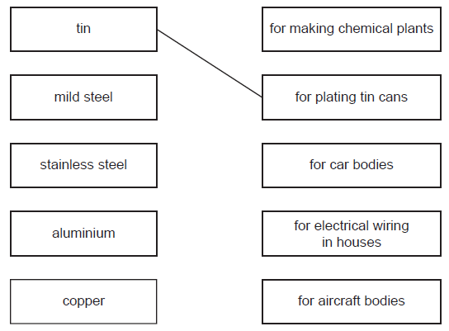
(c) Iron is extracted in a blast furnace. The list below gives some of the substances used
or formed in the extraction.
carbon monoxide coke iron ore limestone slag
(i) Which substance is a mineral containing largely calcium carbonate?
………………………………………………………………………………………………………...[1]
(ii) Which substance is formed when impurities in the ore react with calcium oxide?
………………………………………………………………………………………………………...[1]
(iii) Which substance is also called hematite?
………………………………………………………………………………………………………...[1]
(d) State two functions of the coke used in the blast furnace
(e) Most of the iron is converted into mild steel or stainless steel. Give one use for each.
mild steel……………………………………………………………………………………………
stainless steel………………………………………………………………………………………..[2]

Q3: Some reactions of metals W, X, Y and Z are given below.
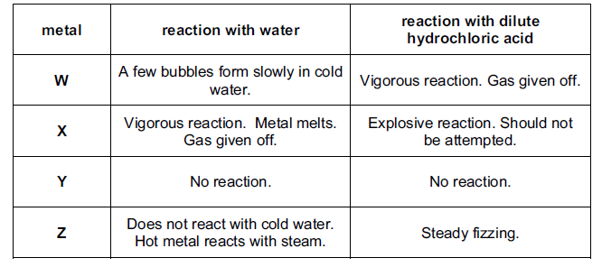

(a) Arrange these metals in order of reactivity.
most reactive………………………………………………………………………………………..
least reactive……………………………………………………………………………………….. [2]
(b) Which of these metals could be
(i) magnesium……………………………………………………………………………………… [1]
(ii) coppe…………………………………………………………………………………………… [1]
(c) The equation for the reaction of X with cold water is given below.
2X(s) + 2H2O(l) 2XOH(aq) + H2(g)
(i) Describe the test you would use to show that the gas evolved is hydrogen.
……………………………………………………………………………………………………………………………………………………………………………………………………………………………………………………………………………………………………[1]
(ii) How could you show that the water contained a compound of the type XOH?
……………………………………………………………………………………………………….[2]
(iii) In which group of the Periodic Table does metal X belong?
……………………………………………………………………………………………………… [1]
(iv) The ore of X is its chloride. Suggest how metal X could be extracted from its chloride.
……………………………………………………………………………………………………………………………………………………………………………………………………………………..[2]

