Must do the following questions with both pseudocode and flowchart.
Q1: Make a flowchart that reads two numbers and multiplies them together and print out their product.
Q2: Input radius and display the circumference and volume.
Q3: Make a flowchart that tells a user that the number they entered is not a 5 or a 6.
Q4: Make a flowchart that tells a user that according to the marks he entered out of 20, either he is pass or fail.
Q5: Draw the flowchart that performs the following: Ask a user to enter a number.
- If the number is between 0 and 10, write the word blue.
- If the number is between 10 and 20, write the word red.
- If the number is between 20 and 30, write the word green.
- If it is any other number, write that it is not a correct color option.
Q6: Draw a flowchart to write your name 10 times.
Q7: Draw a flowchart that take input the marks of 30 students of the class and display the percentage one by one. (Consider that the marks are given out of 125)
Q8
- Draw a flowchart to print 10 multiples of 5.
- Draw a flowchart to print 10 multiples of the number entered by the user
Q9: Draw a flowchart that take input the marks of 30 students of the class and display the whether each one of them is pass or fail. ( passing marks are 50)
Q10: Draw a flowchart that take input the marks of 30 students of the class and display how many students are pass. ( passing marks are 50)
Q11: Input 10 numbers and display their sum.
Q12: Draw a flowchart that can input 10 numbers and display the Maximum and Minimum number
Q13 (Q6, page 144): Daniel lives in Italy and travels to Mexico, India and New Zealand. The time difference are:
Country | Hours | Minutes
Mexico | -7 | 0
India | +4 | +30
New Zealand | +11 | 0
Thus, If it is 10:15 in Italy it will be 14:45 in India.
- Write an algorithm which:
- Inputs the name of the country
- Inputs the time in Italy in hours and in minutes
- Calculate the time in the country input using the data from the table
- Output the country and the time in hours and in minutes.
- Describe with examples two sets of test data you would use to test your algorithm.

Q14 (Q4, page 144) : A sweets shop sells five hundred different types of sweets. Each sort of sweet is identified by a different four digit code. All sweets that start with 1 are Chocolates, All sweets that start with 2 are toffees, All sweets that start with 3 are jellies and all other sweets are miscellaneous and can start with any other digit except zero.
- Write an algorithm, using a flowchart or Pseudocode which input the four digit code for all 500 items and output the number of chocolates, toffees and jellies.
- Explain how you would test your flow chart.
- Decide the test data to use and complete a trace table showing a dry run of your flow chart.
Q15:
Q16:
Q17:
Q18: Write pseudo code that will calculate a running sum. A user will enter numbers that will be added to the sum and when a negative number is encountered, stop adding numbers and write out the final result.

Q19: Write pseudo code that will perform the following.
a) Read in 5 separate numbers.
b) Calculate the average of the five numbers.
c) Find the smallest (minimum) and largest (maximum) of the five entered numbers.
Q20: Draw a flowchart to print multiple of 5 between 1 and 100 (including both 1 and 100).
Q 21: Write pseudo code that will count all the even numbers up to a user defined stopping point (for example : enter 0 to stop the input).
Q22: Write an algorithm, using pseudocode, to input three different numbers, multiply the two larger numbers together and output the result. Use the variables: Number1, Number2 and Number3 for your numbers and Answer for your result.
Q23: Write an algorithm to input three different numbers, and then output the largest number. Use either pseudocode or a flowchart.
OR
Write pseudo code that reads in three numbers and writes them all in sorted order.
Q24: Write an algorithm to input 1000 numbers.
- Count how many numbers are positive and how many numbers are zero. Then output the results. Use either pseudocode or a flowchart.
- Give one change you could make to your algorithm to ensure initial testing is more manageable.
Q25: Explain the difference between the programming concepts of counting and totalling.
Include an example of a programming statement for each concept in your explanation.
Q26:
- Draw a flowchart for an algorithm to input numbers. Reject any numbers that are negative and count how many numbers are positive. When the number zero is input, the process ends and the count of positive numbers is output.
- Explain the changes you will make to your algorithm to also count the negative numbers.
Q27: Write an algorithm using either pseudocode or a flowchart, to:

• input a positive integer
• use this value to set up how many other numbers are to be input
• input these numbers
• calculate and output the total and the average of these numbers.
Q28: Write an algorithm in pseudocode, using a single loop, to print 50 names that have been
stored in an array.
Q29 (Q7, page144): A school is doing a check on the heights and weights of the students. The school has 1000 students. Draw a flowchart, which:
- Input height and weight of all 1000 students
- Output the average height and weight
- Include any necessary error traps for the input
Q30: Q8: A small café sells five types of items:
Bun $0.50
Coffee $1.20
Cake $1.50
Sandwich $2.10
Dessert $4.00
Write a program, which
- Input every item sold during the day
- Uses an item called “end” to finish the day’s input
- Adds up the daily amount taken for each type of item
- Outputs the total takings ( for all items added together ) at the end of the day
- Output the item that had the highest takings at the end of the day
Questions from recent past papers
Q31: IF ... THEN ... ELSE ... ENDIF and CASE ... OF ... OTHERWISE ... ENDCASE are two different conditional statements that you can use when writing pseudocode. Explain, using examples, why you would choose to use each conditional statement.
Example 1 ........................................................................................................................................
Reason for choice ............................................................................................................................
Example 2 ........................................................................................................................................
Reason for choice ........................................................................................................................... [6]
Q: Show two ways of selecting different actions using Pseudocode.(same as Q7)
(Hint: If and Case with suitable examples)
Q32: “REPEAT ... UNTIL” and “WHILE ... DO ... ENDWHILE” are two different loop structures you can use when writing pseudocode. Explain, using examples, why you would choose to use each type of loop.
Example 1 .........................................................................................................................................
Reason for choice ............................................................................................................................
Example 2 ........................................................................................................................................
Reason for choice .......................................................................................................................[6]
Q33: Give an example of a pseudocode statement or statements to perform each of the following functions.
A condition controlled loop ______________________________________________________
A conditional statement. _________________________________________________________
Totalling ______________________________________________________________________
Q34:
(a) Describe the purpose of each statement in this algorithm.
FOR I = 1 TO 300
INPUT Name[I]
NEXT I ............................................................................................................................................... [2]

(b) Identify, using pseudocode, another loop structure that the algorithm in part (a) could have used.
............................................................................................................................................... [1]

(c) Write an algorithm, using pseudocode, to input a number between 0 and 100 inclusive. The algorithm should prompt for the input and output an error message if the number is outside this range. [3]
Questions from Book
Q35: The temperature in an apartment must be kept between 18⁰C and 20⁰C. If the temperature reaches 22⁰C then the fan is switched On; If the temperature reaches 16⁰C then the heater is switched On; otherwise the fan and the heater are switched Off. The following library routines are available:
- GetTemperature
- FanOn
- FanOff
- HeaterOn
- HeaterOff
Write an algorithm using Pseudocode or flow chart, to keep the temperature at the right level.
Questions from Computer Studies past papers
Q36: A customer wants to compare prices of 1000 items sold in two supermarkets (price1 and price2). Write an algorithm, using pseudocode or a flowchart, which:
• inputs the two prices for all 1000 items
• outputs how many items were more expensive in supermarket 1
• outputs how many items were more expensive in supermarket 2
• outputs the largest price difference
Q37: A school has 3000 students sitting final examinations.
Each student sits eight examinations.
Write an algorithm, using pseudocode or a flowchart, which:
• inputs the marks for all8 examinations for each student
• outputs for each student the average mark for their 8 examinations
• outputs the highest mark overall
Q38:
Q39:
Q40:
Q32:
Q41:
Q42:
Q43:
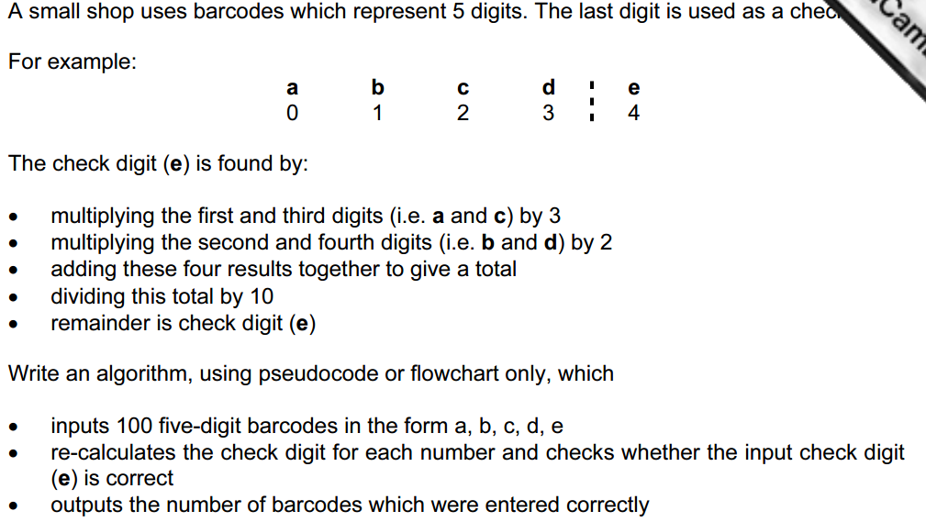
Q44:
Q45:
Q46:
Q47:
Q48:

