WORKSHEET ; AMMONIA AND NITROGEN CLASS 10 CHEM 5070

- Ammonia contains the elements nitrogen and hydrogen. It is manufactured from these elements in the Haber process

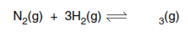

- The forward reaction is exothermic.

- Nitrogen is obtained from liquid air by fractional distillation. Why does this technique
separate liquid oxygen and nitrogen?

...................................................................................................................................

...................................................................................................................................

- Name two raw materials from which hydrogen is manufactured
...............................................................................................................................[3]

- The table shows how the percentage of ammonia in the equilibrium mixture varies with
pressure at 600 °C.

percentage ammonia | 8 | 12 | 15 | 20
pressure/atm | 200 | 300 | 400 | 500

- Explain why the percentage of ammonia increases as the pressure increases.

...................................................................................................................................

...............................................................................................................................[2]

- How would the percentage of ammonia change if the measurements had been made
at a lower temperature?

Explain your answer.

...................................................................................................................................

...................................................................................................................................

...............................................................................................................................[2]

- State two of the reaction conditions used in the Haber Process.

...................................................................................................................................

...............................................................................................................................[2]

- Ammonia is a base.

- Name a particle that an ammonia molecule can accept from an acid.

...................................................................................................................................

- Write an equation for ammonia acting as a base.

...............................................................................................................................[3]

- Given aqueous solutions, 0.1mol/dm3, of sodium hydroxide and ammonia, describe how
you could show that ammonia is the weaker base.

..........................................................................................................................................

......................................................................................................................................[2]

- Another compound that contains nitrogen and hydrogen is hydrazine, N2H4.

- Draw the structural formula of hydrazine. Hydrogen can form only one bond per
atom but nitrogen can form three.

- Draw a diagram that shows the arrangement of the valency electrons in one
molecule of hydrazine. Hydrazine is a covalent compound.
Use x to represent an electron from a nitrogen atom.
Use o to represent an electron from a hydrogen atom

- This question is about compounds of nitrogen.

- Describe the Haber process giving reaction conditions and a chemical equation.
Reference to rate and yield is not required.

.............................................................................................................................................

.............................................................................................................................................

.............................................................................................................................................

.............................................................................................................................................

....................................................................................................................................... [5]

- Give one use of ammonia
....................................................................................................................................... [1]

- The diagram shows the structure of a hydrazine molecule.

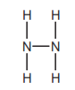

Draw the electron arrangement of a hydrazine molecule. Show the outer shell electrons only.

[2]

- Hydrazine is a base

Explain why it act as base.

....................................................................................................................................... [1]

Complete the chemical equation to show that hydrazine acts as a base when added to
water.

- Nitrogen dioxide is an atmospheric pollutant.

- State one environmental problem caused by nitrogen dioxide.

....................................................................................................................................... [1]

- Explain how oxides of nitrogen, such as nitrogen dioxide, are formed in car engines.

.............................................................................................................................................

....................................................................................................................................... [2]

[Total: 13]

- Ammonia is manufactured by the Haber process.

[2]
- Name the raw materials from which nitrogen and hydrogen are obtained.

- nitrogen from ……………………………………………………………………………………………………1]

- hydrogen from………………………………………………………………………………………………[1]

- Name the catalyst used in this process.

……………………………………………………………………………………………………………[2]

- What is the most important use of ammonia?

……………………………………………………………………………………………………………[1]

- The following graph shows how the percentage of ammonia in the equilibrium mixture
changes with temperature.

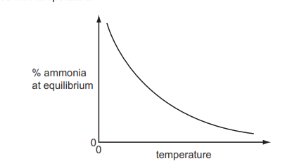

- Explain the term equilibrium.

…………………………………………………………………………………………………………………………………………………………………………………………………………………………………………………………………………………………………………………………………………………………………………………………………………………………………………………………………………………………………………………………………………………………………………………………………………………………………………………………….[4]

- How does the percentage of ammonia vary with temperature?
………………………………………………………………………………………………………………………………………………………………………………………………………………………………………………………………………………………………………………………………….[2]
- Sketch a graph which shows how the percentage of ammonia in the equilibrium
mixture varies with pressure
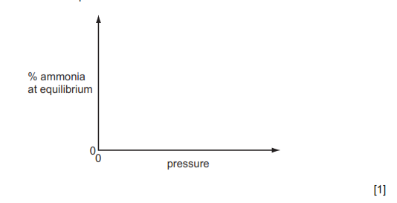
[2]
- Explain why the graph has the shape shown.

……………………………………………………………………………………………………………………………………………………………………………………………………………………………………………………………………………………………………………………………………………………………………………………………………………………………………………………………[2]

