The City School
NORTH NAZIMABAD BOYS CAMPUS
REVISION WORKSHEETS
CLASS 9 CHEMISTRY
Date: 26-11-2015
Class: 9
Teacher: Uzma Amir

Oral Care

Image Collection:

Human Anatomy
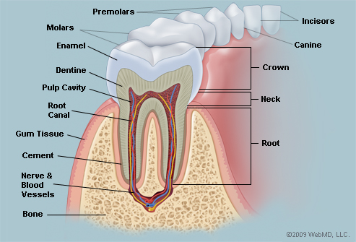

Picture of the Teeth
© 2015 WebMD, LLC. All rights reserved.
The teeth are the hardest substances in the human body. Besides being essential for chewing, the teeth play an important role in speech. Parts of the teeth include:
• Enamel: The hardest, white outer part of the tooth. Enamel is mostly made of calcium phosphate, a rock-hard mineral.
• Dentin: A layer underlying the enamel. Dentin is made of living cells, which secrete a hard mineral substance.
• Pulp: The softer, living inner structure of teeth. Blood vessels and nerves run through the pulp of the teeth.
• Cementum: A layer of connective tissue that binds the roots of the teeth firmly to the gums and jawbone.
• Periodontal ligament: Tissue that helps hold the teeth tightly against the jaw.
A normal adult mouth has 32 teeth, which (except for wisdom teeth) have erupted by about age 13:
• Incisors (8 total): The middlemost four teeth on the upper and lower jaws.
• Canines (4 total): The pointed teeth just outside the incisors.
• Premolars (8 total): Teeth between the canines and molars.
• Molars (8 total): Flat teeth in the rear of the mouth, best at grinding food.
• Wisdom teeth or third molars (4 total): These teeth erupt at around age 18, but are often surgically removed to prevent displacement of other teeth.
The crown of each tooth projects into the mouth. The root of each tooth descends below the gum line, into the jaw.

Teeth Conditions
- Cavities (caries): Bacteria evade removal by brushing and saliva and damage the enamel and deeper structures of teeth. Most cavities occur on molars and premolars.
- Tooth decay: A general name for disease of the teeth, including cavities and caries.
- Periodontitis: Inflammation of the deeper structures of the teeth (periodontal ligament, jawbone, and cementum). Poor oral hygiene is usually to blame.
- Gingivitis: Inflammation of the surface portion of the gums, around and between the crowns of the teeth. Plaque and tartar buildup can lead to gingivitis.
- Plaque: A sticky, colorless film made of bacteria and the substances they secrete. Plaque develops quickly on teeth after eating sugary food, but can be easily brushed off.
- Tartar: If plaque is not removed, it mixes with minerals to become tartar, a harder substance. Tartar requires professional cleaning for removal.
- Overbite: The upper teeth protrude significantly over the lower teeth.
- Underbite: The lower teeth protrude significantly past the upper teeth.
- Teeth grinding (bruxism): Stress, anxiety, or sleep disorders can cause teeth grinding, usually during sleep. A dull headache or sore jaw are symptoms.
- Tooth sensitivity: When one or more teeth become sensitive to hot or cold, it may mean the dentin is exposed.
Oral Health Trends:
- Dental Implants
- Bad Breath
- Teeth Whitening
- Porcelain Veneers
- Teeth Grinding
- TMJ

Oral Care

Teeth Tests
- Teeth X-ray films: X-ray pictures of the teeth may detect cavities below the gum line, or that are too small to identify otherwise.
- Teeth examination: By viewing and gently manipulating the teeth, a dentist can detect potential teeth problems.

Teeth Treatments
- Brushing teeth: Daily brushing of the teeth removes plaque and prevents cavities.
- Flossing teeth: Using floss or an approved dental gum cleaner cleans teeth below the gum line, where brushing cannot reach.
- Teeth cleaning: Professional teeth cleaning every six months may help prevent teeth and gum disease.
- Tooth filling: Drilling out the diseased part of a tooth and packing the space with a mineral filling can prevent a cavity from destroying the tooth.
- Root canal: The deep pulp of a tooth is drilled out, cleaned, and filled. A root canal is done when damage to the teeth has affected the deep pulp.
- Tooth extraction: If a tooth is too damaged to repair with a filling or root canal, it may be removed. Wisdom teeth are often extracted to prevent displacement of the other teeth.
- Braces: An artificial device or system that places teeth under tension for a long period of time. Eventually, braces can help crooked teeth become realigned.
- Mouth guard: A plastic mouthpiece can provide protection from teeth grinding and injury during sports.
- Dental sealants: A plastic sealant applied to the teeth can help block bacteria from hiding in crevices on teeth surfaces. Sealants can help prevent cavities.
- Teeth whitening: Over-the-counter and professional chemical treatments can bleach teeth to a brighter white. Tooth sensitivity is the most common side effect.

