O LEVEL CHEMISTRY 5070 ORGANIC CHEMISTRY

Worksheet 1
- The structures of six organic compounds are shown.

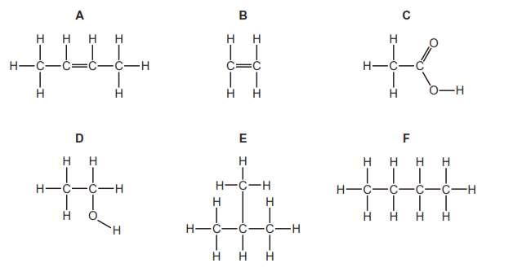

- Give the name of F.

………………………………………………………………………………………………………………………………[1]

- Identify two of the compounds that are members of the same homologous series.
Give the general formula of this homologous series.

Compounds:……………………………………………………………………………
General formula:……………………………………………………………………….[2]

- Which two compounds are isomers of each other?
Explain why they are isomers

Compounds;………………………………………………………………………………………………
Explanation;…………………………………………………………………………………………[2]

- Explain why B is an unsaturated hydrocarbon
………………………………………………………………………………………………..[1]

- Describe how D is manufactured from B. Give a chemical equation for the reaction.

………………………………………………………………………………………………………………………………………………………………………………………………………………………………………………………………………………………………………………[4]

- Compound A forms an addition polymer.

Draw two repeat units of the addition polymer formed from A.

[4]

Worksheet # 2

- A hydrocarbon has the following structural formula.

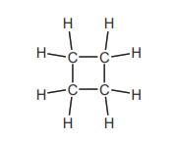

- State the molecular formula and the empirical formula of this hydrocarbon

…………………………………………………………………………………[2]

- Draw the structural formula of an isomer of the above hydrocarbon.

………………………………………………………………………………..[2]

- Explain why these two hydrocarbons are isomers.

………………………………………………………………………………..[1]

- Are these two hydrocarbons members of the same homologous series?
Give a reason for your choice.

………………………………………………………………………………………………………………………………………………………………………………………………………………………………………………………………………………………[2]

- Alkenes can be made from alkanes by cracking
Explain the term cracking.

………………………………………………………………………………………………………………………………………………………………………………………………………[2]
- One mole of an alkane, when cracked, produced one mole of hexane, C6H14, and two moles of ethene. What is the molecular formula of the original alkane?

…………………………………………………………………………………………………………………………………………………………………………………………………………………………………………………………………………………………………………………………………………………………………………………….[3]

- Alkenes are used in polymerisation reactions and addition reactions.

Draw the structural formula of the product formed by the addition polymerisation of but-2-ene. Its formula is given below.

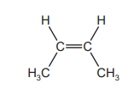

- Give the name and structural formula of the addition product formed from ethene and bromine.

name ...................................................................................................................................

structural formula…………………………………………………………………………………

Worksheet # 3

- Propanoic acid is a carboxylic acid. Its formula is CH3–CH2–COOH.

Propanoic acid is the third member of the homologous series of carboxylic acids

- Give the name and structural formula of the fourth member of this series.

name ...................................................................................................................................

formula .......................................................................................................................... [2]

- Members of a homologous series have very similar chemical properties.
State three other characteristics of a homologous series.

.............................................................................................................................................

.............................................................................................................................................

.............................................................................................................................................

....................................................................................................................................... [3]

- Carboxylic acids can be made by the oxidation of alcohols.

- Draw the structural formula of the alcohol which can be oxidised to propanoic acid.
Show all atoms and bonds

[2]

- Name a reagent, other than oxygen, which can oxidise alcohols to carboxylic acids.

……………………………………………………………………………………………………………………………………………………………………………………………………………………………………………………………………………………………………………………[3]

- Complete the following equations for some of the reactions of propanoic acid.
The salts of this acid are called propanoates.

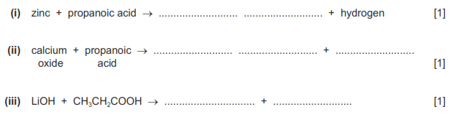

Worksheet # 4

The alkanes are a family of saturated hydrocarbons. Their reactions include combustion, cracking and substitution.

- What is meant by the term hydrocarbon?

…………………………………………………………………………………………………………………………………………………………………………………………………….[1]

- What is meant by the term saturated ?

………………………………………………………………………………………………………………………………………………………………………………….. [2]

- What is the general formula for the homologous series of alkanes?
....................................................................................................................................... [1]

- Calculate the mass of one mole of an alkane with 14 carbon atoms.

………………………………………………………………………………………………………………………………………………………………………………………..[2]

- The complete combustion of hydrocarbons produces carbon dioxide and water only

Write the equation for the complete combustion of nonane, C9H20.
....................................................................................................................................... [2]

- 20 cm3 of a gaseous hydrocarbon was mixed with an excess of oxygen, 200 cm3. The
mixture was ignited. After cooling, 40 cm3 of oxygen and 100 cm3 of carbon dioxide
remained. Deduce the formula of the hydrocarbon and the equation for its combustion. All
volumes were measured at r.t.p..

.............................................................................................................................................

.............................................................................................................................................

.............................................................................................................................................

.............................................................................................................................................

....................................................................................................................................... [3]

Worksheet # 5
The alcohols form a homologous series. The first five members are given in the table
below
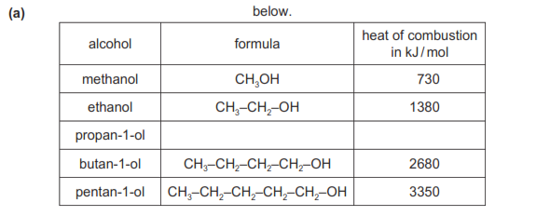

- Complete the table. [2]

- Complete the equation for the combustion of pentan-1-ol in excess oxygen

- State three characteristics of a homologous series

…………………………………………………………………………………………………………………………………………………………………………………………………………………………………………………………………………………………..[3]

- The following alcohols are isomers

CH3–CH2–CH2–CH2–OH and (CH3)2CH–CH2–OH

Explain why they are isomers.

....................................................................................................................................

....................................................................................................................................

.............................................................................................................................. [2]

- Draw the structural formula of another isomer of the above alcohols

[1]

- Chlorine reacts with propane in a substitution reaction to form 1-chloropropane
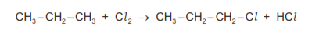

What is the essential condition for the above reaction?

....................................................................................................................................... [1]

There is more than one possible substitution reaction between chlorine and propane.
Suggest the structural formula of a different product.

....................................................................................................................................... [1]

- Ethanol is made from sugars by fermentation.

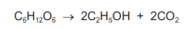

The mass of one mole of glucose, C6H12O6, is 180 g.
Calculate the maximum mass of ethanol which could be obtained from 72 g of
glucose
....................................................................................................................................

....................................................................................................................................

....................................................................................................................................

.............................................................................................................................. [3]

- Describe how ethanol is made from petroleum.
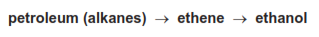

....................................................................................................................................

....................................................................................................................................

....................................................................................................................................

.............................................................................................................................. [3]

