The City School
North Nazimabad Boys Campus
Blog worksheet 2
Pakistan Studies – History (2095/01)
Class: 10

Name: ____________________ Sec: _____Date: ________Timing: 30 min Max Marks: 25
Section A
This question is about the creation of Pakistan during 1940 - 47.
Source A
‘The move towards autonomy and democratic self-government served to emphasize the serious differences between the League and Congress. Increasingly, Congress’s antagonism towards the League dismayed Quaid-i-Azam. Because of the hostile attitude he was now firmly realistic that the two could not cooperate. After a brief time in London, he had returned to India to work fulltime for the Muslim cause. The appeal of a separate state altogether was to grow stronger. Pakistan was now on the horizon.’ -An extract from ‘Pakistan: History, Culture and Government’ by Nigel Smith

Source B

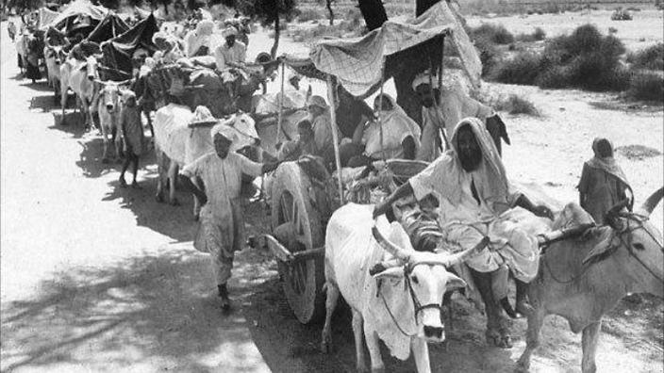
The Partition -1947
Q1. Study source A and source B carefully and then answer the questions.
- According to source A, why was Pakistan on horizon? [3]
- According to source B, what was the problem faced by Pakistan? [5]
- Why did Radcliff award was unjust for Pakistan? [7]
- Gandhi Jinnah Talks of 1942 contributed more than the Cabinet Mission Plan of 1946, to the partition of the sub-continent of Indian in 1947? Explain your argument. [14]

