Pakistan Studies
2059/2
Class 9
Few Sample questions
Q: Look at the given insert and answer the given questions.
- Identify the type of farming.
- Describe the method of farming shown in the given insert.
Q: Why does Pakistan need to increase the area of irrigated plantation?
Q: Why is afforestation can be termed as long term investment?
Q: Study the list below:
Pesticides, Knowledge, Sunshine, Fertilizer, Drainage, Soil, Irrigation, Rain, Seed

- From the above list, select any two human inputs. Elucidate how these may support in the enhancement of rice production.
- From the above list, select any two physical inputs. Discuss their impact on the output in terms of rice production.
Q: Explain why there is a shortage of water for irrigation in the Indus Plains.
Q: Discuss the effects of desert climate on the agricultural and industrial developments of
that area.
Q: To what extent do you agree that Pakistan being a developing country is in the process
of industrialization so Nuclear energy can speed up the process.
Q: Discuss the impact of Fish farming on environment.

Pakistan Studies
2059/1
Class 9
Section A
1.
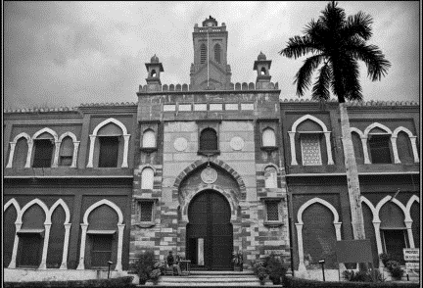
- How had MAO collage supported freedom movement?

2.
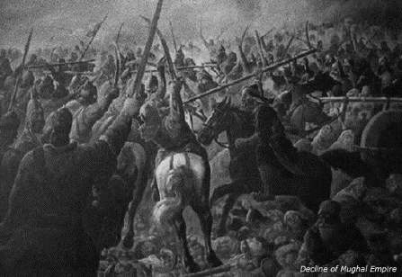
- Describe the consequences of war of succession on Mughal Empire.

3.
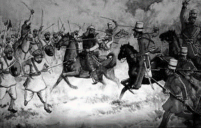
- What was the issue of greased cartridge in 1857?

4.
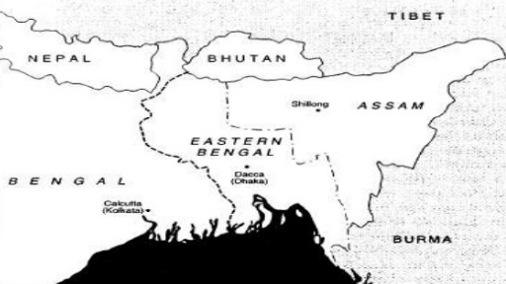
- Describe the reaction of Hindus towards Bengal partition in 1905.
Source B
- “The first half of the 19th century witnessed a movement known as Faraizi Movement in East Bengal. The founder of this movement was Haji Shariatullah. At this time the condition of the Bengali Muslims in the Sub-continent was very miserable. The British policy of distrust and oppression towards the Muslims rendered them economically and educationally crippled; and the oppression of the Zamindars made their lives unbearable.”
- What problems were faced by the Muslims in the 19th century?
- Why do you think that the Muslims were facing the problems?

- “Tipu Sultan was a fierce warrior king and was so quick in his movement that it seemed to the enemy that he was fighting on many fronts at the same time.Tipu managed to subdue all the petty kingdoms in the south. He defeated the Nizams and was also one of the few Indian rulers to have defeated British armies. He is said to have started a new coinage, calendar, and a new system of weights and measures mainly based on the methods introduced by French technicians.” By: Dr. Dulari Qureshi

- According to the given source, what do you understand about the rule of Tipu Sultan?

- The passing of the Resolution on 23rd March by the All India Muslim League at its Lahore session created a serious situation for the Congress leadership. Mohan Das Karam Chand Gandhi wrote in Harijan on 6th April 1940, “I admit that the step taken by the Muslim League at Lahore creates a baffling situation…the Two Nations theory is an untruth. The vast majority of Muslims of India are converts to Islam or are the descendants of converts. They did not become a separate nation, as soon as they converted.”

- According to the given source, what reason was quoted by Gandhi for not accepting Two Nation Theory?
Questions:
Qa. What was the importance of Simla Conference? /4
- Why is the year 1940, important for the Indian Muslims? /7
- “The resignation of Congress ministries in the year 1939 was the sign of relief for the Indian Muslims.” Justify the given statement with references. /14
Q a. How Quaid-e-Azam did organized the Government in the year 1947? /4
- Discuss the role of Allama Iqbal in the freedom struggle. /7
- “Khilafat movement died its natural death.” Do you agree? Give resons. /14

