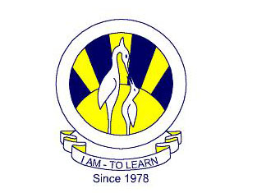
The City School
North Nazimabad Boys Campus
Class: 9 Subject: Paktistan Studies – History Teacher: Ms. Maira Arif
Worksheet # 2

Q1. Give short answers to the following:
- What did Octavian Hume establish in 1885?
- Who was responsible for the partition of Bengal in 1905?
- What led to Jallian Walla Bagh Incident?
- Who was the British Prime Minister who met the Khilafat delegation in 1920?
- Name the Constitutional Report published in 1928?
Q2. Give three reasons for the following:
- Why was the Lucknow Pact of 1916 made?
- Why was the Partition of Bengal reversed in 1911?
- Why was the Khilafat Movement established?
- Why did the Cripps Mission fail?
- Why was the Day of Deliverance in 1939 celebrated?

