The City School
North Nazimabad Boys Campus
Class: 9 Subject: Paktistan Studies – History Teacher: Ms. Maira Arif
Worksheet # 3

Souce A
All the Creatures of God have equal rights. No man is entitled to allow one particular race of man to obtain the good things of this world; and to bar the rest from participating in them, and it is the duty of the government to observe this divine law in all in its integrity.
From the writings of Sir Syed Ahmed Khan
Q1. According to the source A how India should be governed?
Source B
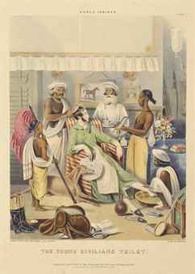
Q2. According to the source B how was the attitude of the British towards Indians?
Q3. Sate 7 factors/points for each of the following:
- Decline of the Mughal Empire
- Causes of Indian Revolt in 1857
- Work of Sir Syed Ahmed Khan
- Work of Shah Walliullah
- Development of Urdu language

