The City School
North Nazimabad Boys Campus
Class: 9 Subject: Paktistan Studies – History Teacher: Ms. Maira Arif
Worksheet # 4

Souce A
If you will work in cooperation, forgetting the past, burying the hatchet, you are bound to succeed. If you change your past and work together in a spirit that everyone of you – no matter to what community he belongs; no matter what relations you have had in the past, no matter is his colour, cast or creed…there will be no end to the progress you will make.
Part of Jinnah’s address to the Constituent Assembly in August 1947.
Q1. According to the source A what was Jinnah advising the Constituent Assembly to do?
Source B
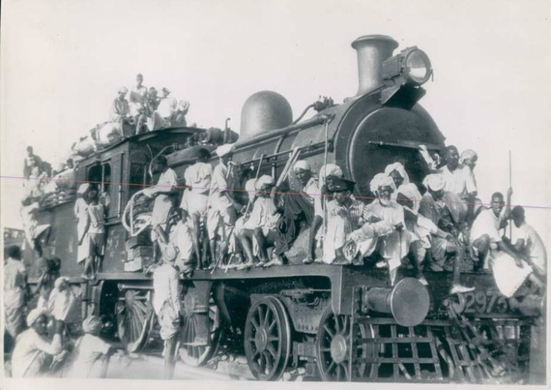
Q2. According to the source B how dreadful was the Partition in 1947?
Q3. Sate 7 factors/points for each of the following:
- Failure of the Khilafat Movement in 1922
- RTC’s 1930-32
- British Reforms of 1909 &1919
- Congress Rule 1937-39
- Pakistan Movement 1940-47

