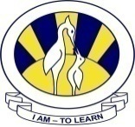
The City School
North Nazimabad Boys Campus
Home assignment

Date: 13-11-2015
Subject: Physcis
Class: 11TH
Teacher: Saba Junaid

Topic: Electromagnetic induction
J06/p2/Q3
D03/p2/Q8
J07/p2/Q10

Date of submission:20-11-15

3rd Monthly test syllabus

- Magnetism
- Electromagnetism

