The City School
North Nazimabad Boys Campus
Class 9 blog worksheet
Subject Physics
Date of submission 28 may 2017
Teacher Saba Junaid

1 (a) Fig. 1.1 shows a ray of light passing through the edge of a converging lens.

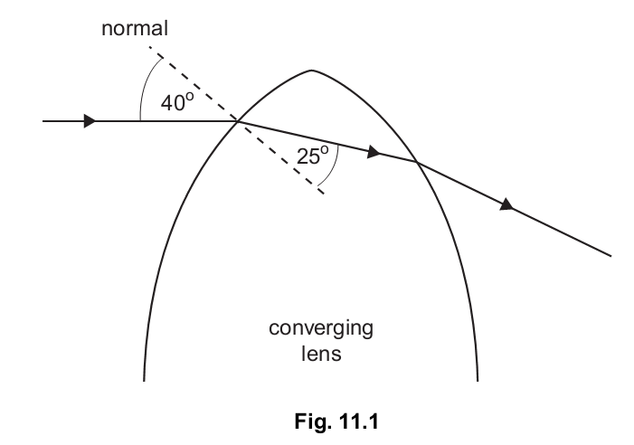
(i) Describe what happens to the direction of the ray of light as it enters and leaves the
lens. [2]
(ii) State what happens to the speed, frequency and wavelength of the light as it enters
the lens. [3]
(iii) Calculate the refractive index of the glass used in the lens. [3]
(b) The focal length of the lens is 20 cm. An object is placed 50 cm from the lens and an
image is formed on a screen.
(i) Explain what is meant by the focal length of a lens. You may draw a diagram if you
wish. [2]
(ii) Draw a ray diagram to scale to show the formation of the image. [3]
(iii) The image is real. State two other properties of the image. [2]

Q2 Fig. 2.1 shows a ray of light entering and passing along an optical fibre
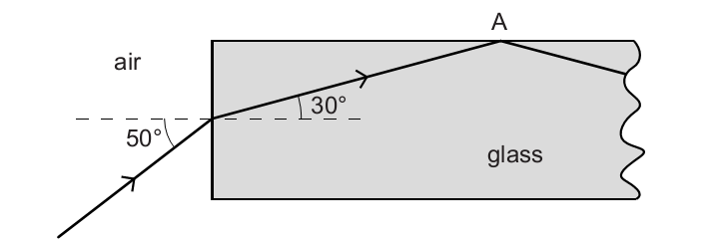
Fig. 2.1
(a) Calculate the refractive index of the glass in the optical fibre.
refractive index = ........................................................... [2]
(b) Explain why the ray of light is totally internally reflected at A.
...................................................................................................................................................
...................................................................................................................................................
............................................................................................................................................... [2]
(c) Both optical fibre and copper wire are used to transmit data.
Optical fibre is cheaper and can carry more data per second than copper wire.
State one other advantage of using optical fibre rather than copper wire to transmit data.
...................................................................................................................................................
...............................................................................................................................................[1]

