THE CITY SCHOOL

NNBC

PHYSICS-CLASS 9TH

BLOG WORKSHEET

TOPIC: PRESSURE

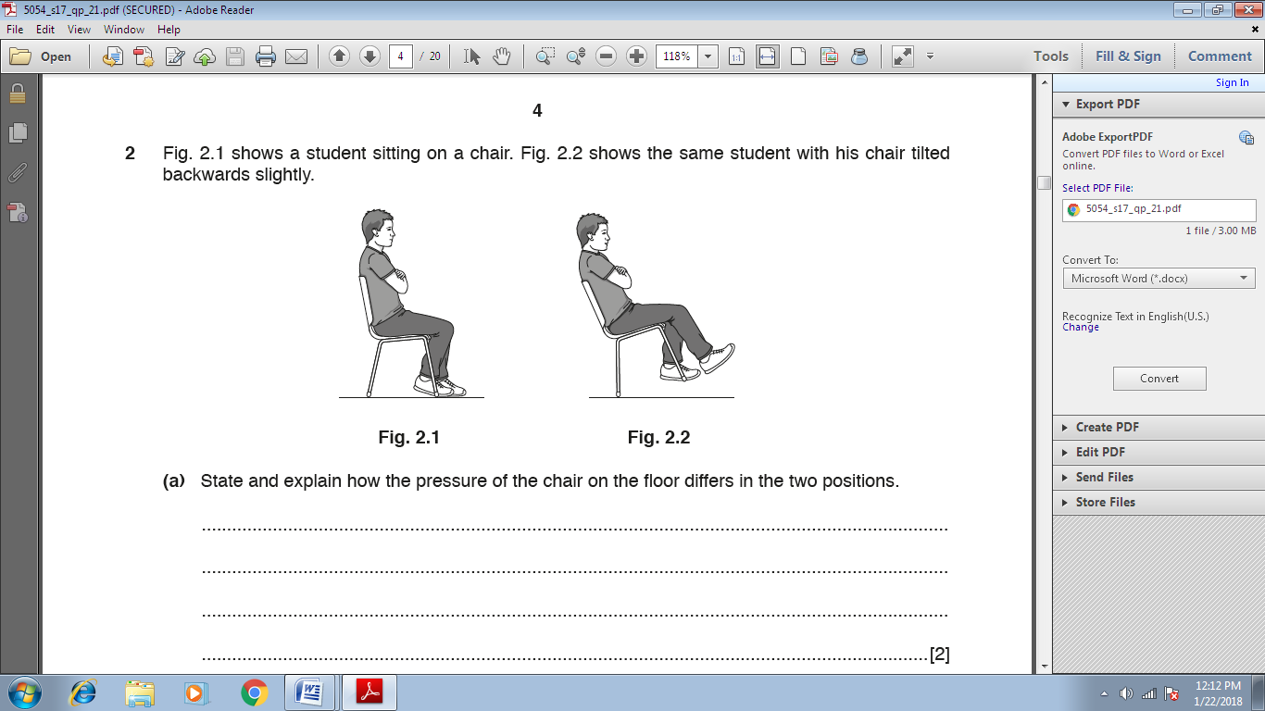

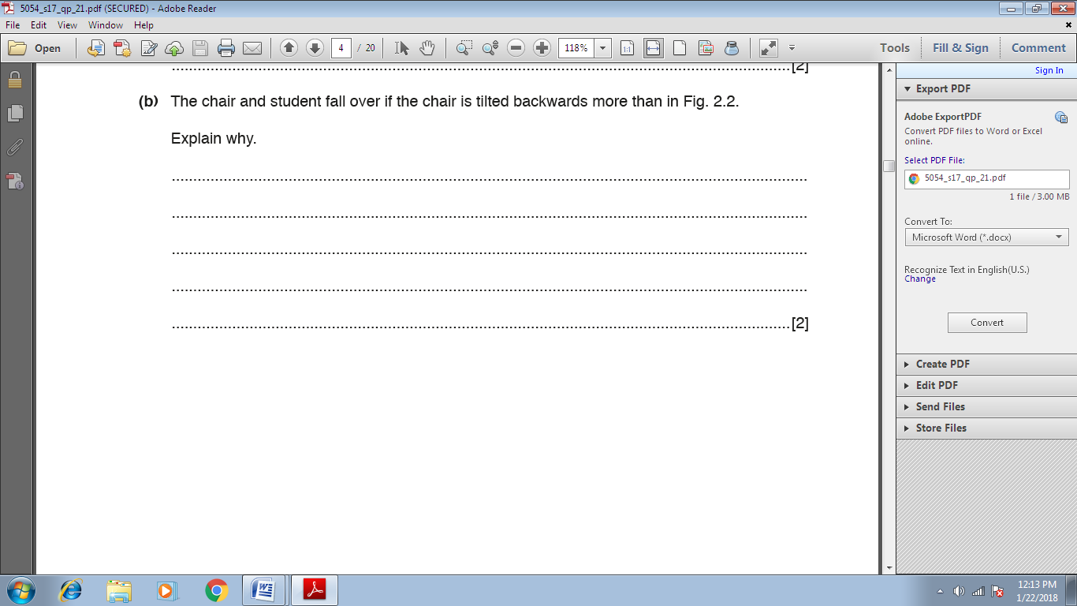

THE CITY SCHOOL

NNBC

CLASS 10TH

BLOG WORKSHEET

PHYSICS

TOPIC:HEAT



THE CITY SCHOOL

NNBC

PHYSICS BLOG WORKSHEET

CLASS 11TH

TOPIC:LIGHT

