BLOG WORKSHEET
Physics CLASS 9

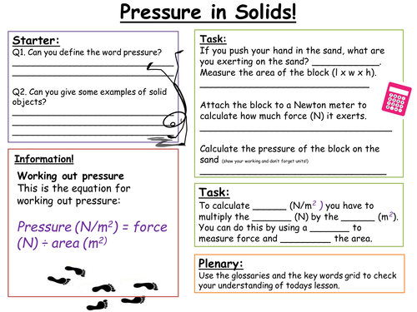
Teacher Name: Ahmed Kamal Class: 9 Subject: Physics Date: 26th jan’18

