**The City School**

**North Nazimabad Boys Campus**

**Physics worksheet**

**Grade: 10**

Name________________________

Class/sec **______**

**1 (a)** Fig. 1.1 shows a machine for making loud sounds. It is called a siren. This consists of arotating disc with 25 holes. As each hole passes the jet, a puff of air passes through thehole



**(i)** How many puffs of air will there be during one revolution of the disc?

number of puffs = ....................

**(ii)** The disc rotates 40 times per second. Show that the frequency of the note produced

by the siren is 1000 Hz. [3]

**(b)** The siren described in **(a)** is located some distance from a large building, as shown in given figure.



The siren is briefly sounded once. A short time later, the sound is heard again.

1. Why is this second sound heard?

..................................................................................................................................

1. What is the frequency of this second sound? Tick one box.

less than 1000 Hz 

1000Hz 

more than 1000 Hz 

**(iii)** What is the amplitude of this second sound? Tick one box.

less than the original sound 

more than the original sound 

same as the original sound  [3]

**2** Plane waves travel from medium A to medium B at an angle of incidence of 500.

The velocity of the waves in medium B is only three-quarters of that in medium A.

What is the angle of refraction? [3]

………………………………………………………………………………………………………

………………………………………………………………………………………………………

………………………………………………………………………………………………………

……………………………………………………………………………………………………

**7** A laboratory technician has ten pieces of plastic, all cut from the same thin sheet.

The technician wishes to find the thickness of a piece of plastic as accurately as possible.

**(a)** Name the instrument that should be used.

______________________________________________________________________________________________________________________________ [1]

**(b)** Describe how the instrument should be used to find the thickness.

_________________________________________________________________________________________________________________________________________________________________________________________________________________________________________________________________________________________________________________________________________________________________________ {3}

The City School

North Nazimabad Boys Campus

**PHYSICS Class 9**

**Revision Worksheet # 001**

Name:_______________________ Sec.: __________ Date: __________

Q1 Astudentdrops atable-tennisballinair.

Whathappenstothevelocityand totheaccelerationoftheballduringthefirstfewsecondsafter release?

|  |  |  |
| --- | --- | --- |
|  | velocity | acceleration |
| A B C  D | decreases decreasesincreases  increases | decreases increases decreases  increases |

Q2 Thediagramshowsamotorcyclist leaningoverinordertomovearound acorner.

Whichforcecauseshimtomovearound thecorner?

motorcyclist

**C**

**D B**

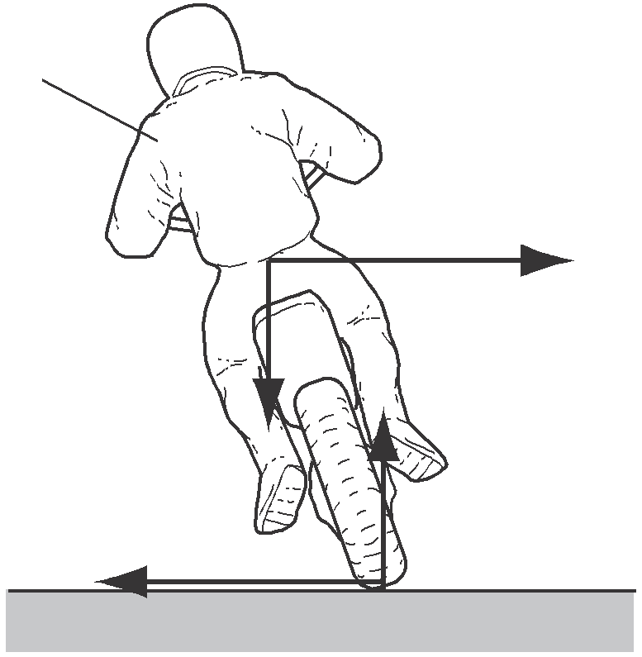

Q3 Thediagramshowsauniformbalancedbeam,pivotedabout itscentre.

P

|  |  |  |  |  |
| --- | --- | --- | --- | --- |
|  | | 2cm |  | |
|  | | | | |
|  | 6cm 2cm | | |  |

3N 4N

WhatisthevalueofforceP?

A 5N B 7N C 10 N D 13 N

Q4 Thediagramshowsfourshapes,cutfromthesamepiece ofcard.

Whichshapehas itscentreofmass nearesttothebaseline?

**A B C D**

base line

Q5 Ametalwire,ofinitiallength 1000mm,extendsby4mmwhenaloadof2Nisaddedtoit.

What isthe length ofthe wirewhen a further 3Nisadded,assumingthat the wiredoesnot extendbeyondthelimitofproportionality?

A 1006mm B 1008mm C 1010mm D 1012

Q6 Twomajorcomponents ofacoal-firedpower station areaturbine andagenerator.

Whataretheoutputformsofenergy fromtheturbine andfromthegenerator?

|  |  |  |
| --- | --- | --- |
|  | turbine | generator |
| A B C  D | electrical electricalheat  kinetic | electrical kinetic kinetic  electrical |

Q7 Whatisefficiency?

Atotalenergyinput

usefulenergyoutput

Btotalpowerinput

usefulenergyoutput

C usefulenergyoutputtotalenergyinput

D usefulpoweroutputtotalenergyinput

Q8 Afixedmassofgas isenclosedinacylinderbyamovablepiston.

gas

piston



Thepiston ismoved sothatthevolume occupiedbythegas increases.Thetemperatureremains constant.

Whathappenstothepressureofthegas andwhydoesthishappen?

|  |  |  |
| --- | --- | --- |
|  | pressure | reason |
| A B C  D | decreases decreasesincreases  increases | themoleculesmovemoreslowly  themoleculescollidewiththepistonless frequently themoleculesmovemorequickly  themoleculescollidewiththepistonmorefrequently |

Q9 Astudentdrops atable-tennisballinair.

Whathappenstothevelocityand totheaccelerationoftheballduringthefirstfewsecondsafter release?

|  |  |  |
| --- | --- | --- |
|  | velocity | acceleration |
| A B C  D | decreases decreasesincreases  increases | decreases increases decreases  increases |