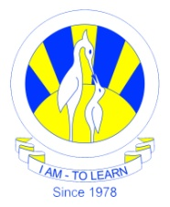
The City School
North Nazimabad Boys Campus

Class : 11
Subject : Physics
Topic : reflection and refraction
Teacher : saba Junaid
Date of submission : 12 sep 2017,Wednesday

ATP questions

June 2014 Q3
November 2013 Q2
June 2010 Q4
November 2007 Q3

