The City School
North Nazimabad Boys Campus

Class : 9
Subject : Physics
Teacher : Ahmed kamal
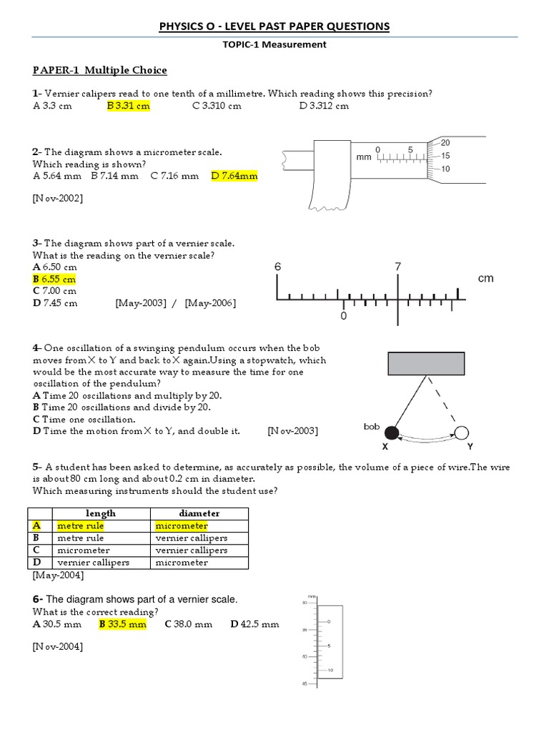
Date : 16-09-2017

