O LEVEL CHEMISTRY 5070 POLYMER CHEMISTRY

WORKSHEET 1

- There are two types of polymerisation, addition and condensation.

- Explain the difference between these two types of polymerisation.

…………………………………………………………………………………………………………………………………………………………………………………………………………………………………………………………………………………………………………………...[3]

- Some plastics, formed by polymerisation, are non-biodegradable.

Describe two pollution problems that are caused by non-biodegradable plastics.

………………………………………………………………………………………………………………………………………………………………………………………………………………………………………………………………………………………………………………………………………………………………………………………………………………………………………………………[2]

- The polymer known as PVA is used in paints and adhesives. Its structural formula is shown below.

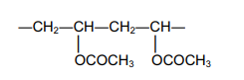

- Deduce the structural formula of its monomer.

[1]

- A condensation polymer can be made from the following monomers.

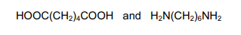

Draw the structural formula of this polymer.

[3]

- Synthetic polymers are disposed of in landfill sites and by burning

- Describe two problems caused by the disposal of synthetic polymers in landfill sites.
.............................................................................................................................................

....................................................................................................................................... [2]

- Describe one problem caused by burning synthetic polymers

…………………………………………………………………………………………………………………………………………………………………………………………………….[1]

- State two uses of synthetic polymers.
....................................................................................................................................................
.............................................................................................................................................. [1]

- The structural formulae of two synthetic polymers are given below.

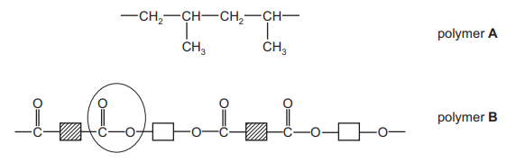

- Draw the structural formula of the monomer of polymer A.

- Identify the functional group circled in polymer B

……………………………………………………………………………………………………………………………………………………………………………………………………[2]

- Deduce the two types of organic compound which have reacted to form polymer B.
....................................................................................................................................... [2]

- Explain the difference between addition and condensation polymers. Classify A and B as either addition or condensation polymers.

....................................................................................................................................................

....................................................................................................................................................

....................................................................................................................................................

.............................................................................................................................................. [3]

- Polymers are made by the polymerisation of simple molecules called monomers.

The structural formula of a polymer is given below.

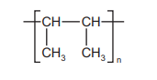

This polymer is made by addition polymerisation.

- Draw the structural formula of its monomer.

[2]

- The two monomers shown below form a nylon which is a condensation polymer.

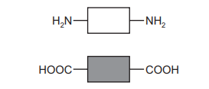

- Draw its structural formula showing one repeat unit of the polymer.

[3]

- Name the natural macromolecule which contains the same linkage as nylon.

....................................................................................................................................... [1]

- Explain the difference between addition polymerisation and condensation polymerisation.

.............................................................................................................................................

.............................................................................................................................................

....................................................................................................................................... [2]

- Many polymers are non-biodegradable.

- Explain the term non-biodegradable.

.............................................................................................................................................

....................................................................................................................................... [2]

- State three problems caused by the disposal of non-biodegradable polymers

.............................................................................................................................................

.............................................................................................................................................

...................................................................................................................................... [3]

- Storage tanks for cold water are now made from polymers because they are cheaper than metal tanks. Suggest two other advantages of making cold water tanks from polymers.

....................................................................................................................................................

.............................................................................................................................................. [2]

- Many monomer molecules react together to form one molecule of a polymer. This reaction is called polymerisation.

- The structural formula of the polymer, poly(chloroethene), is given below. This polymer
is also known as PVC

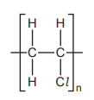

- A major use of PVC is insulation of electric cables. PVC is a poor conductor of
electricity. Suggest another property which makes it suitable for this use.

.............................................................................................................................. [1]

- One way of disposing of waste PVC is by burning it. This method has the disadvantage
that poisonous gases are formed.
Suggest two poisonous gases which could be formed by the combustion of PVC.

.............................................................................................................................. [2]
- Deduce the structural formula of the monomer from that of the polymer.

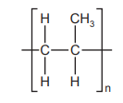

- structural formula of monomer

[1]

- Deduce the structural formula of the polymer, poly(phenylethene), from the formula
of its monomer, phenylethene.

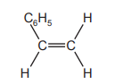

structural formula of polymer

[1]

- The carbohydrate, glucose, polymerises to form the more complex carbohydrate starch.

If glucose is represented by

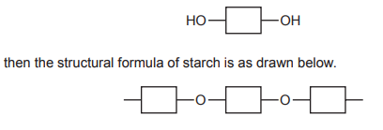

- How does the polymerisation of glucose differ from that of an alkene such as phenylethene?

..........................................................................................................................................

...........................................................................................................................................

..................................................................................................................................... [2]

- Plastics are polymers. They are formed from their monomers by polymerisation.

- Two methods for the disposal of waste plastics are

- burning
- recycling.

- Describe one advantage and one disadvantage of each method.

burning..............................................................................................................................

...........................................................................................................................................

...........................................................................................................................................

recycling ...........................................................................................................................

...........................................................................................................................................

..................................................................................................................................... [4]

- There are two types of polymerisation reaction. Give their names and explain the
differences between them.
....................................................................................................................................

....................................................................................................................................

....................................................................................................................................

.............................................................................................................................. [4]

- Give the structural formula of a polymer which is formed from two different monomers

[4]

