The City School

**North Nazimabad Boys Campus**

**Revision worksheet (electrolysis)**

**Chemistry**

**Teacher : Zubaida Aslam Class :11 Date:6-11-2015 Subject :Chemistry**

Name: _________________________________ Sec: _____ Date: _______________

1 During the electrolysis of a MOLTEN salt (compound) the product at the CATHODE

is:

A. Non – metal

B. Metal

C. Sodium

D. Chlorine

2 During the electrolysis of a MOLTEN lead iodide PbI2the product at the anode

and the cathode are:

Anode Cathode

A. hydrogen and iodine

B. iodine and lead

C. lead and iodide

D. lead and iodine

3 When aqueous 2 4(aq) H SO solution is electrolysed using inert carbon

electrodes, the substance formed at anode is

(a) hydrogen gas

(b) Oxygen gas

(c) Copper (II) ion

(d) Copper deposit

4 Which of the following does NOT contain free ions?

(a) Aqueous hydrogen chloride

(b) Aqueous ammonia

(c) Solid potassium nitrate

(d) Molten potassium chloride

5 Two elements X and Y form ionic compounds, XBr2 and Y2O3. The

compounds are separately **melted** and **electricity** is passed through the

liquids.

What are the products at the cathodes?

**A.** bromine and oxygen

**B.** bromine and Y

**C.** oxygen and X

**D.** X and Y

6 :





7



8



9



10



1111

2

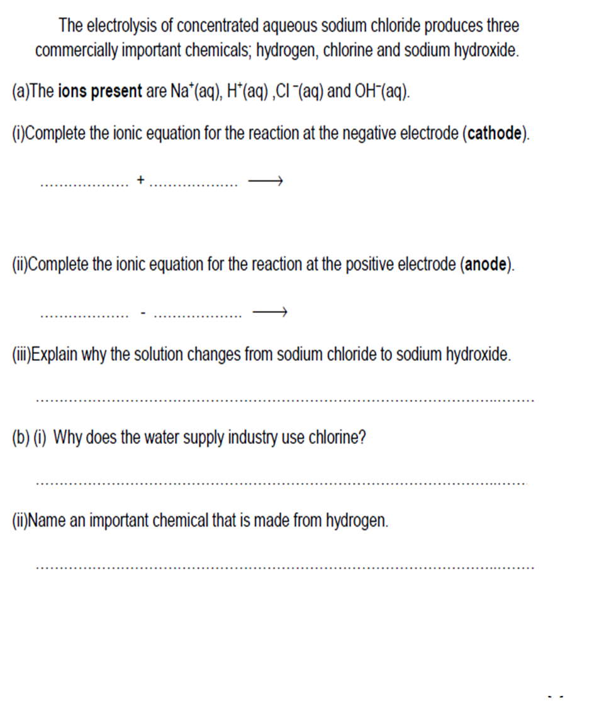

12