The CitySchool
North Nazimabad Boys Campus

Quadratic Equations Explanation

Date: 11-02-2017

Class: 9
Subject: Maths
Teacher: Sheema Aftab
An example of a Quadratic Equation:
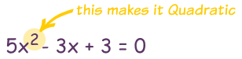
Quadratic Equations make nice curves, like this one:
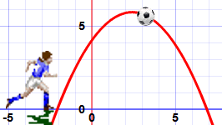

Name
The name Quadratic comes from "quad" meaning square, because the variable gets squared (like x²).
It is also called an "Equation of Degree 2" (because of the "2" on the x)

Standard Form
The Standard Form of a Quadratic Equation looks like this:
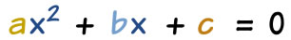
- a, b and c are known values. a can't be 0.
- "x" is the variable or unknown (we don't know it yet).
Here are some more examples:
2x² + 5x + 3 = 0 |  | In this one a=2, b=5 and c=3
x² − 3x = 0 |  | This one is a little more tricky:  - Where is a? Well a=1, and we don't usually write "1x²"  - b = -3  - And where is c? Well c=0, so is not shown.
5x − 3 = 0 |  | Oops! This one is not a quadratic equation: it is missing x²  (in other words a=0, which means it can't be quadratic)

Hidden Quadratic Equations!
So the "Standard Form" of a Quadratic Equation is
ax² + bx + c = 0
But sometimes a quadratic equation doesn't look like that! For example:
In disguise | → | In Standard Form | a, b and c
x² = 3x − 1 | Move all terms to left hand side | x² − 3x + 1 = 0 | a=1, b=−3, c=1
2(w² − 2w) = 5 | Expand (undo the brackets),  and move 5 to left | 2w² − 4w − 5 = 0 | a=2, b=−4, c=−5
z(z−1) = 3 | Expand, and move 3 to left | z² − z − 3 = 0 | a=1, b=−1, c=−3

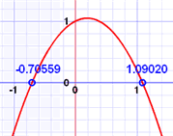 |  | Have a Play With It  Play with the "Quadratic Equation Explorer" so you can see:  - the graph it makes, and  - the solutions (called "roots").

How To Solve It?
The "solutions" to the Quadratic Equation are where it is equal to zero.
There are usually 2 solutions (as shown in the graph above).
They are also called "roots", or sometimes "zeros"
There are 3 ways to find the solutions:
1. We can Factor the Quadratic (find what to multiply to make the Quadratic Equation)
2. We can Complete the Square, or
3. We can use the special Quadratic Formula:
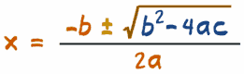
Just plug in the values of a, b and c, and do the calculations.
We will look at this method in more detail now.

About the Quadratic Formula

Plus/Minus
First of all what is that plus/minus thing that looks like ± ?
The ± means there are TWO answers:
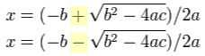
Here is why we can get two answers:
But sometimes we don't get two real answers, and the "Discriminant" shows why ...

Discriminant
Do you see b² − 4ac in the formula above? It is called the Discriminant, because it can "discriminate" between the possible types of answer:
- when b² - 4ac is positive, we get two Real solutions
- when it is zero we get just ONE real solution (both answers are the same)
- when it is negative we get two Complex solutions
Complex solutions? Let's talk about them after we see how to use the formula.

Using the Quadratic Formula
Just put the values of a, b and c into the Quadratic Formula, and do the calculations.

Example: Solve 5x² + 6x + 1 = 0
Coefficients are: |  | a = 5, b = 6, c = 1
Quadratic Formula: |  | x = −b ± √(b² − 4ac)2a
Put in a, b and c: |  | x = −6 ± √(6² − 4×5×1)2×5
Solve: |  | x = −6 ± √(36 − 20)10
 |  | x = −6 ± √(16)10
 |  | x = −6 ± 410
 |  | x = −0.2 or −1

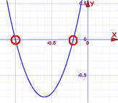 | Answer: x = −0.2 or x = −1  And we see them on this graph.

Check -0.2: | 5×(−0.2)² + 6×(−0.2) + 1  = 5×(0.04) + 6×(−0.2) + 1  = 0.2 − 1.2 + 1  = 0
Check -1: | 5×(−1)² + 6×(−1) + 1  = 5×(1) + 6×(−1) + 1  = 5 − 6 + 1  = 0

Remembering The Formula
I don't know of an easy way to remember the Quadratic Formula, but a kind reader suggested singing it to "Pop Goes the Weasel":
♫ | "x equals minus b |  | ♫ | "All around the mulberry bush
 | plus or minus the square root |  |  | The monkey chased the weasel
 | of b-squared minus four a c |  |  | The monkey thought 'twas all in fun
 | all over two a" |  |  | Pop! goes the weasel"
Try singing it a few times and it will get stuck in your head!
Or you can remember this story:
x = −b ± √(b² − 4ac)2a
"A negative boy was thinking yes or no about going to a party,
at the party he talked to a square boy but not to the 4 awesome chicks.
It was all over at 2 am."

Complex Solutions?
When the Discriminant (the value b² − 4ac) is negative we get Complex solutions ... what does that mean?
It means our answer will include Imaginary Numbers. Wow!

Example: Solve 5x² + 2x + 1 = 0
Coefficients are: |  | a = 5, b = 2, c = 1
Note that the Discriminant is negative: |  | b² − 4ac = 2² − 4×5×1 = -16
Use the Quadratic Formula: |  | x = −2 ± √(−16)10

Summary
- Quadratic Equation in Standard Form: ax² + bx + c = 0
- Quadratic Equations can be factored
- Quadratic Formula: x = −b ± √(b² − 4ac)2a
- When the Discriminant (b²−4ac) is:
  - positive, there are 2 real solutions
  - zero, there is one real solution
  - negative, there are 2 complex solutions

