Question and Solution of pre release material june 2016
Computer Science 2210

Note : Two solutions are given below, both of them are acceptable. Which ever solution you find easy, learn it for all three tasks.

(Images are not very clear so please open the site. Complete tasks and their solutions both are also available on the links)

http://ruknuddin.com/wp/wp-content/uploads/2016/01/Pre-release-mj16p22-task-1-pseudo-case-selection.jpg

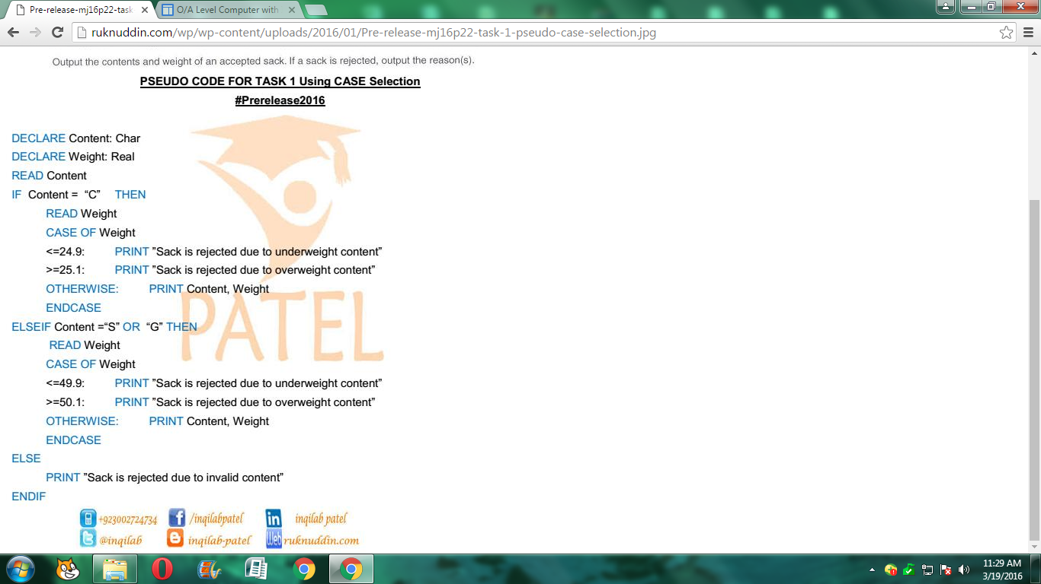

https://sites.google.com/a/ruknuddin.com/inqilab-patel-magazine/recent-announcement/task2solutionformayjune2016pre-release

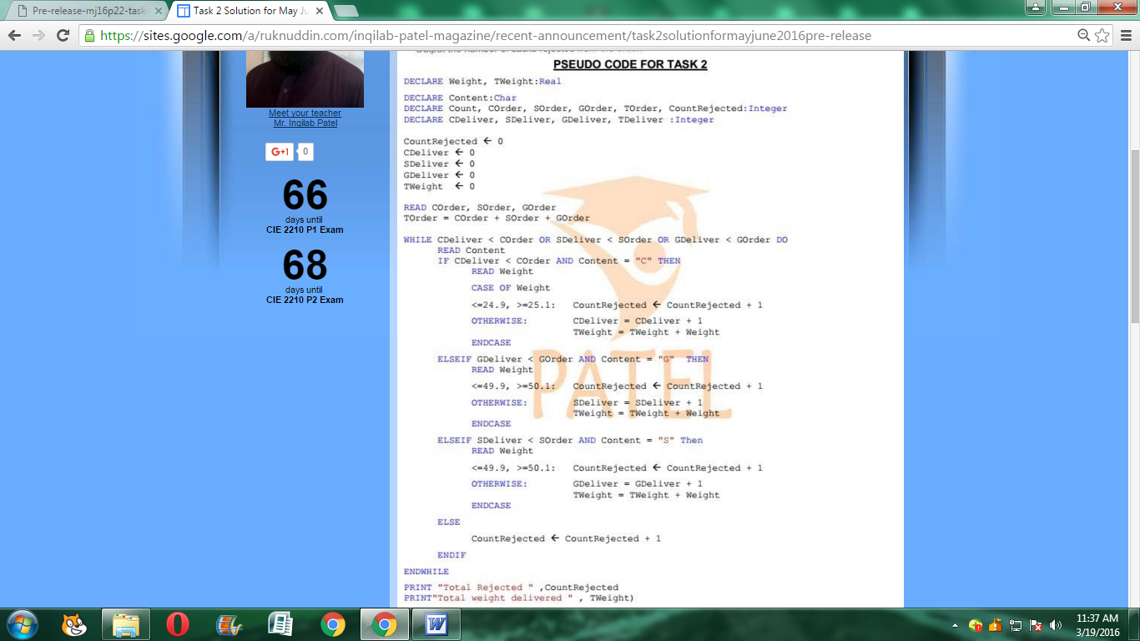
https://sites.google.com/a/ruknuddin.com/inqilab-patel-magazine/recent-announcement/prereleasematerialtask3pseudocode

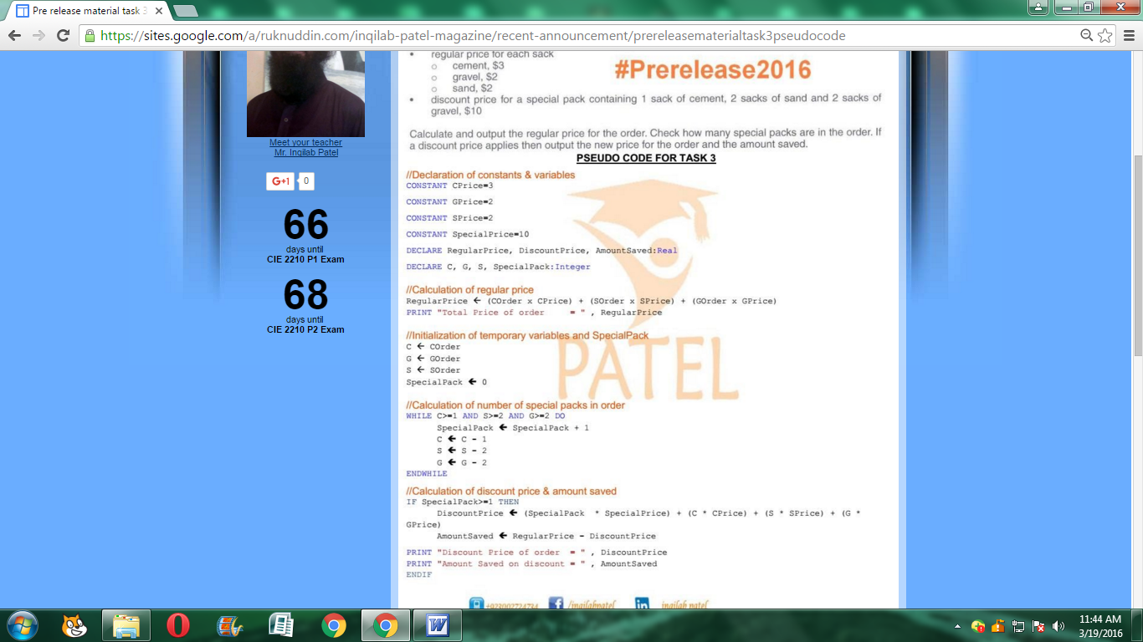

Solution on youtube.com

https://www.youtube.com/watch?v=OgqR7CVC1EI

https://www.youtube.com/watch?v=Oa2WWPjbSaM

https://www.youtube.com/watch?v=FFeROkGfdZY

