Name ……………………………………………… Class ……………………………
Biology
Q.1 In an experiment to investigate anaerobic respiration, two bottles are set up in a warm room, as shown in the diagram.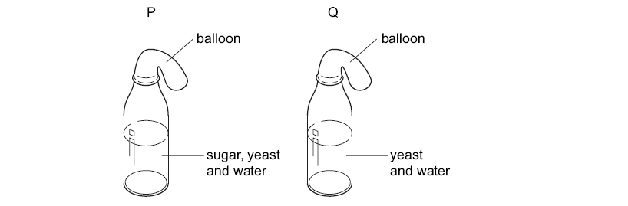
a- What would happen to each balloon after one day?

P……………………………………………………………………………………………..

Q …………………………………………………………………………………………… [2]

b- The diagrams below show some results from the students’ experiments.
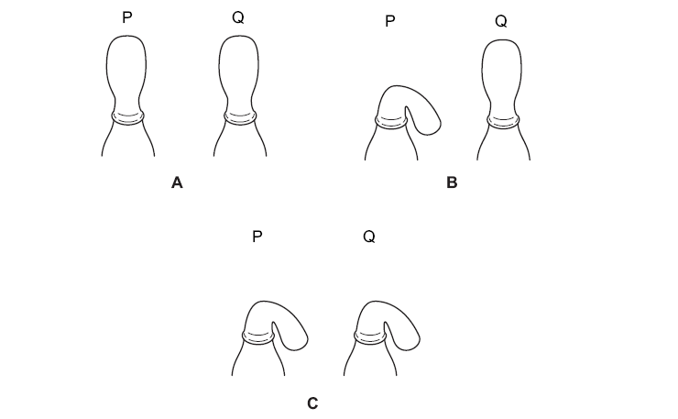
i- According to your answers in part (a) which diagram, if any, would support your answer?

…………………………………………………………………………………………………. [1]

ii- Explain your answer.

………………………………………………………………………………………………………

………………………………………………………………………………………………… [2]

2. . In an experiment, three glass bell jars were set up as shown in the diagram.
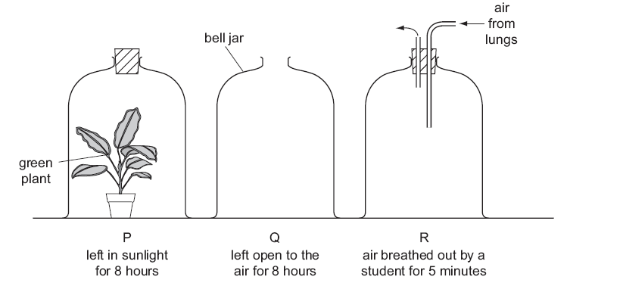
At the end of the experiment, which bell jar has the most oxygen and which has the least?
Most oxygen ……………………………………………………………………………..
Least oxygen……………………………………………………………………………… [2]
3. The apparatus shown in the diagram is used to investigate the effect of a green plant on carbon dioxide in the air.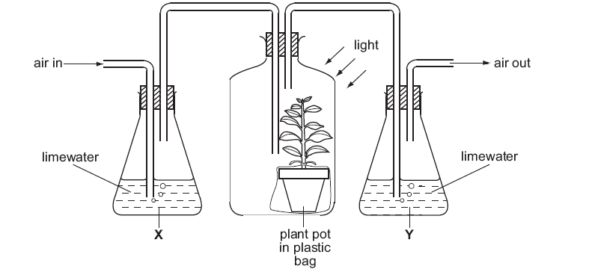
Limewater goes cloudy if carbon dioxide is bubbled through it.

What happens to the limewater in X and in Y?
(a) X:………………………………………………………………………………………………
Y:………………………………………………………………………………………… [2]
(b) Explain your answer fully.
………………………………………………………………………………………………………
………………………………………………………………………………………………………
………………………………………………………………………………………………………
………………………………………………………………………………………………….. [3]
4. An active yeast culture is placed in a test-tube. This test-tube is connected by a delivery tube to a second test-tube containing hydrogencarbonate indicator shown in Fig. 2.1.
Hydrogencarbonate indicator changes colour according to pH. In alkaline solutions the indicator becomes purple and in acidic solutions the indicator becomes yellow.
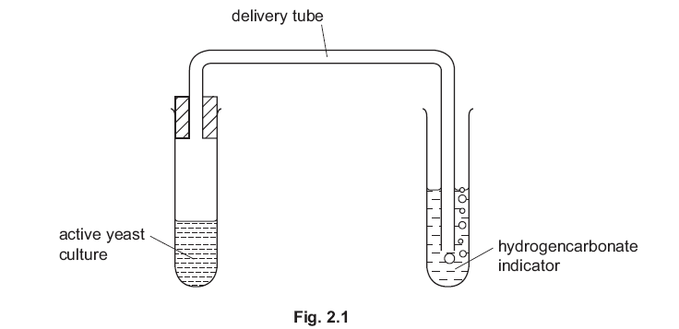At the start of the experiment the indicator is red in colour. After 15 minutes the indicator becomes yellow.
(a) Explain the reason for this colour change.
………………………………………………………………………………………………………
………………………………………………………………………………………………………
………………………………………………………………………………………………… [3]
(b) Describe how you would collect and measure the volume of gas given off per minute by20 cm³ of the active yeast culture.
………………………………………………………………………………………………………
………………………………………………………………………………………………………
………………………………………………………………………………………………………
………………………………………………………………………………………………………
………………………………………………………………………………………………………
………………………………………………………………………………………………………
………………………………………………………………………………………………………
………………………………………………………………………………………………………
………………………………………………………………………………………………… [6]

