The City School
NORTH NAZIMABAD BOYS CAMPUS
REVISION WORKSHEETS
CLASS 9 CHEMISTRY
Date: 26-11-2015
Class: 9
Teacher: Uzma Amir

- Which of the following has a nucleon (mass) of 3?
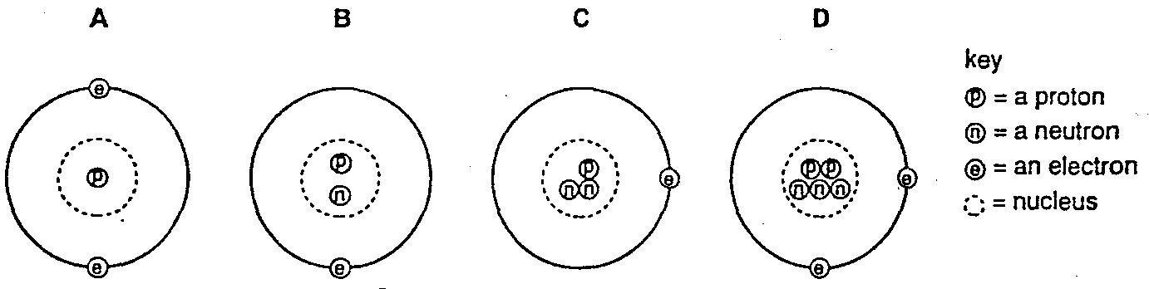

- An atom of any element must contain equal numbers of
A electrons and neutrons.
B electrons and protons.
C neutrons and protons.
D electrons, neutrons and protons.

- How many protons, neutrons and electrons are present in an atom of the element with proton (atomic) number 6 and nucleon (mass) number 14?
 | Protons | neutrons | electrons
A | 6 | 8 | 6
B | 6 | 8 | 8
C | 8 | 6 | 6
D | 8 | 6 | 8

- The Table shows the particles in an atom.
Particle | charge | approximate relative mass
Proton | +1 | 1
Electron |  | 1/2000
Neutron | 0 | 1
Which number completes the table?
A -1 B 0 C +1 D +2

- The diagram shows the electronic structure of an atom. What is the number of protons in the nucleus?
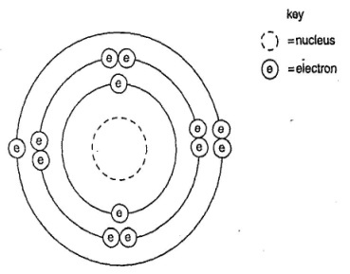
A.7 B.13 C.6 D.8

- Deuterium and tritium are isotopes of hydrogen. What are the correct numbers for X and Y?
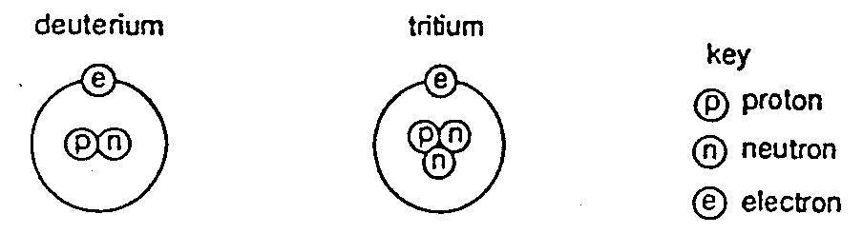

Isotope | number of protons | number of neutrons | number of electrons | nucleon (mass) number
Deuterium | 1 | 1 | 1 | X
tritium | 1 | 2 | 1 | Y

 | X | Y
A  B  C | 1  1  2 | 1  2  3
D | 3 | 4

- Which two diagrams show two different types of atom of the same element?

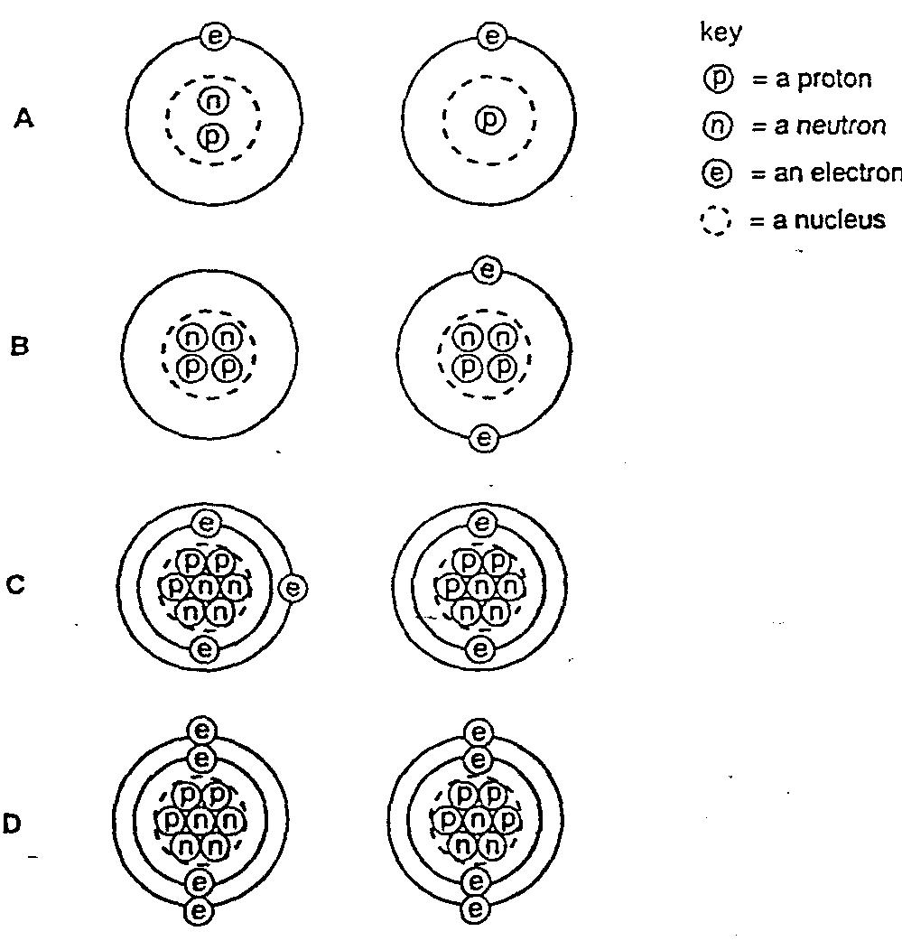

- Look at given atomic structures
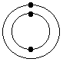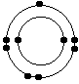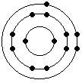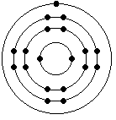
Which electron arrangement corresponds to the first element on period 2 of the Periodic Table?
- electron arrangement X
- electron arrangement Y
- electron arrangement W
- electron arrangement Z

- look at the periodic table;
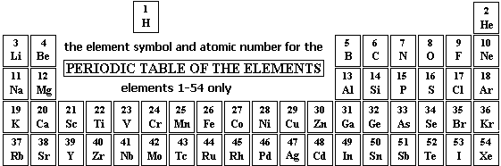
Where in the Periodic Table are you MOST LIKELY to find an element that is a low melting solid and a good conductor of heat?
- Group 7
- Group 1
- Transition series
- Group 4

- Which of the following is TRUE about the trend DOWN the Group 7 Halogens with increase in atomic number?
- the colour of the element gets darker
- the melting points decrease
- the reactivity increases
- the atoms get smaller

- The equation for the reaction between aqueous lead(II) nitrate and aqueous potassium iodide is shown.
Pb(NO3) 2(aq) + 2KI(aq) → PbI2(s) + 2KNO3(aq)
Colourless colourless yellow colourless
- Which method could be used to separate the products?
A chromatography
B crystallization
C distillation
D filtration

- Which of the following is NOT a trend that varies systematically in the periodic table?
- Electronegativity
- symbols of elements
- ionization energy
- atomic radius
- following picture are showing some methods of Purification

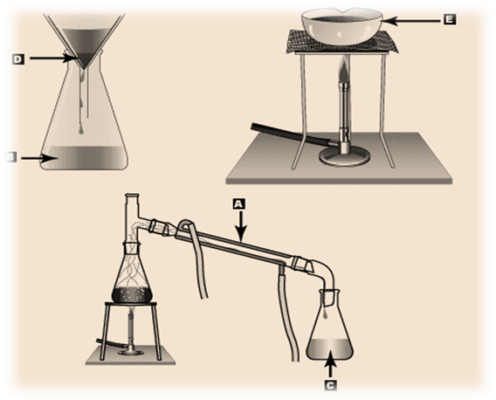
What are C,D and E showing?
 | Distillate | Residue | Evaporation
A  B  C  D | C  D  E  D | D  E  D  C | E  C  C  E

- The atomic radius of F, Br, and I are 64, 114, and 138 pm respectively. From this information (and not your book) estimate a reasonable atomic radius of Cl.
- 53 pm
- 89 pm n
- 126 pm
- 162 pm

- Use the periodic table (not any tables or charts in your book) to predict which element has the largest atomic radius.
- Na
- He
- Li
- Ca
- Look at the pictures and find out the correct sequence in the given table.
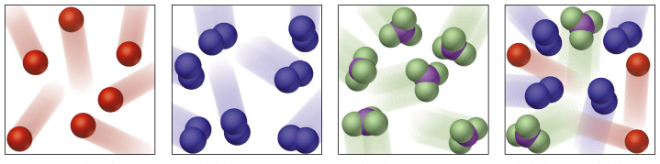
W X Y Z

 | Mixture | Molecule of Elements | Molecule of compounds
A  B  C  D | X  Z  W  Z | Y  X  X  W | Z  Y  Y  X

- Which is TRUE about the compounds formed by reacting a Halogen (X) with hydrogen gas?
- the liquid will be a good electrical conductor
- the reaction is given by the equation: H + X ==> HX
- they will have a low melting and boiling point
- in water form an alkaline solution of pH 14
- Which statement is correct, about the diffusion of one gas into another?
- Once the gases are fully mixed, the particles stop moving.
- The particles of both gases continue moving in a random way.
- The heavier gas sinks to the bottom of the mixture.
- The gases combine to form a new product.
- You are asked to prepare copper II sulphate by using copper oxide and sulphuric acid Which set of apparatus will you need?
- Pipette , test tube, china dish
- Burette , balance, stop watch
- Test tube, meter scale, balance
- Pipette, balance, thermometer

.
A1 Choose from the following elements to answer the questions below.
Argon bromine carbon hydrogen iodine
iron neon sulphur sodium
Each element can be use used once, more than once, or not at all.
Name an element which
(a) Forms an alkali when reacts with water.
____________________________________________________________________[1]
(b) a liquid at room temperature and pressure.
_____________________________________________________________________[1]
(c) Reacts with aqueous copper sulphate and displaces copper
____________________________________________________________________[1]
(d) Forms during the reaction of acids and metals.
____________________________________________________________________[1]
(e) Has a giant molecular structure.
____________________________________________________________________[1]
(f) A non-metal which conducts electricity.
____________________________________________________________________[1]
(g) Forms an ion that carries a negative charge.
_______________________________________________________________________[1]

___________

- Sodium chloride has a melting point of about 801 °C. Explain why sodium chloride has a high melting point [2]
___________________________________________________________________________________________________________________________________________________________________________________________________________________________________________________
- Magnesium oxide, MgO, has a similar structure to sodium chloride. Suggest why the melting point of magnesium oxide is higher than that of sodium chloride.

B 6. Part of the reactivity series of metals is shown below.
Most reactive
1 | Potassium
2 | Sodium
3 | Calcium
4 | Aluminum
5 | Zinc
6 | Lead
Least reactive
Use the information above.
- Which two metals would react with calcium chloride in a displacement reaction?

a._________________
b._________________

- Write down symbol equations for the above displacement reactions:
a._________________________________________________________________________
b._________________________________________________________________________
- What does Displacement reaction mean?
____________________________________________________________________________________________________________________________________________________
IV Complete the sentences using the words below:
reactive series equation ores

- Metal __________ are natural compounds.
- A reactivity _____________shows how the properties of metals compare.
- A _______________shows what happens in a chemical reaction.
- Some metals are more _____________than others.
B 7. Read the information mentioned in the table and write down the answers of the questions given below:
Substances | Shape | Size | Compressibility | Flow
A | Definite | Definite | No | No
B | Indefinite | Indefinite | Yes | Yes
C | Indefinite | Definite | No | Yes
- Identify substance B and tell about the energy possessed by the particles of substance B?
______________________________________________________________________________
- Keeping in mind the shape and size, describe the arrangement of particles in substance A?
____________________________________________________________________________________________________________________________________________________________
- Draw particle model of substance C

- Which substance has the highest rate of diffusion?
___________________________________________________ ______________________
- Explain your answer of part IV in term of Kinetic Particle Theory
_____________________________________________________________________________________________________________________________________________________
___________________________________________________________________________

