Sensors and their applications
A sensor is a device that detects and responds to some type of input from the physical environment. The specific input could be light, heat, motion, moisture, pressure, or any one of a great number of other environmental phenomena. The output is generally a signal that is converted to human-readable display at the sensor location or transmitted electronically over a network for reading or further processing.
Or
A Sensor is an input device which provides an output (signal) with respect to a specific physical quantity (input).
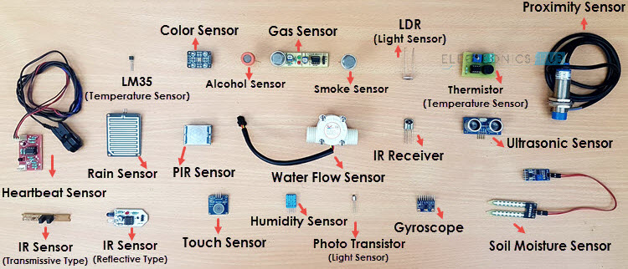

Different Types of Sensors

The following is a list of different types of sensors that are commonly used in various applications. All these sensors are used for measuring one of the physical properties like Temperature, Resistance, Capacitance, Conduction, Heat Transfer etc.
- Temperature Sensor
- Proximity Sensor
- Accelerometer
- IR Sensor (Infrared Sensor)
- Pressure Sensor
- Light Sensor
- Ultrasonic Sensor
- Smoke, Gas and Alcohol Sensor
- Touch Sensor
- Color Sensor
- Humidity Sensor
- Tilt Sensor
- Flow and Level Sensor

Temperature Sensor
One of the most common and most popular sensor is the Temperature Sensor. A Temperature Sensor, as the name suggests, senses the temperature i.e. it measures the changes in the temperature.
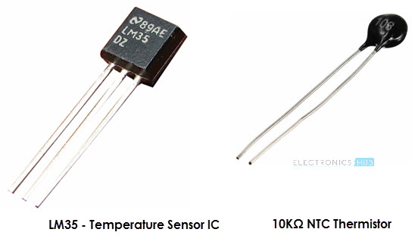
In a Temperature Sensor, the changes in the Temperature correspond to change in its physical property like resistance or voltage.
There are different types of Temperature Sensors like Temperature Sensor ICs (like LM35), Thermistors, Thermocouples, RTD (Resistive Temperature Devices), etc.
Temperature Sensors are used everywhere like computers, mobile phones, automobiles, air conditioning systems, industries etc.
A simple project using LM35 (Celsius Scale Temperature Sensor) is implemented in this project: TEMPERATURE CONTROLLED SYSTEM.

Proximity Sensors
A Proximity Sensor is a non-contact type sensor that detects the presence of an object. Proximity Sensors can be implemented using different techniques like Optical (like Infrared or Laser), Ultrasonic, Hall Effect, Capacitive, etc.
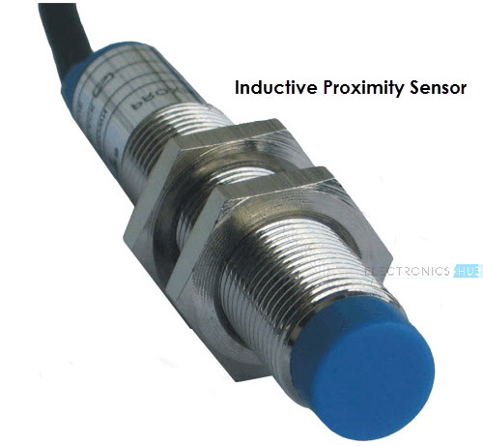
Some of the applications of Proximity Sensors are Mobile Phones, Cars (Parking Sensors), industries (object alignment), Ground Proximity in Aircrafts, etc.
Proximity Sensor in Reverse Parking is implemented in this Project: REVERSE PARKING SENSOR CIRCUIT.

Infrared Sensor (IR Sensor)
IR Sensors or Infrared Sensor are light based sensor that are used in various applications like Proximity and Object Detection. IR Sensors are used as proximity sensors in almost all mobile phones.
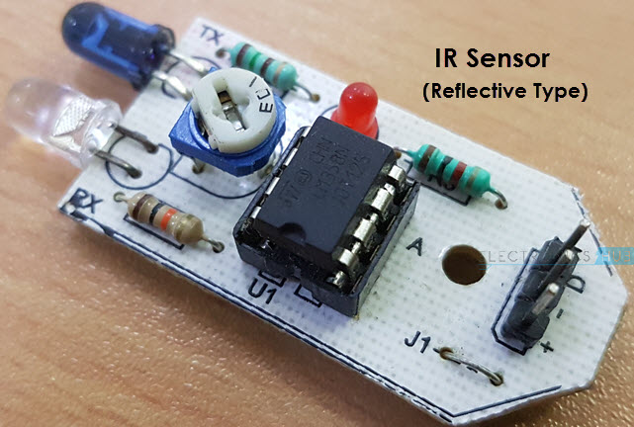
There are two types of Infrared or IR Sensors: Transmissive Type and Reflective Type. In Transmissive Type IR Sensor, the IR Transmitter (usually an IR LED) and the IR Detector (usually a Photo Diode) are positioned facing each other so that when an object passes between them, the sensor detects the object.
The other type of IR Sensor is a Reflective Type IR Sensor. In this, the transmitter and the detector are positioned adjacent to each other facing the object. When an object comes in front of the sensor, the sensor detects the object.
Different applications where IR Sensor is implemented are Mobile Phones, Robots, Industrial assembly, automobiles etc.
A small project, where IR Sensors are used to turn on street lights: STREET LIGHTS USING IR SENSORS.

Ultrasonic Sensor
An Ultrasonic Sensor is a non-contact type device that can be used to measure distance as well as velocity of an object. An Ultrasonic Sensor works based on the properties of the sound waves with frequency greater than that of the human audible range.
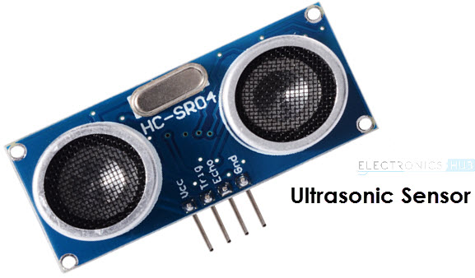
Using the time of flight of the sound wave, an Ultrasonic Sensor can measure the distance of the object (similar to SONAR). The Doppler Shift property of the sound wave is used to measure the velocity of an object.
Arduino based Range Finder is a simple project using Ultrasonic Sensor: PORTABLE ULTRASONIC RANGE METER.
Light Sensor
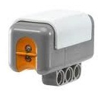
A Light Sensor generates an output signal indicating the intensity of light by measuring the radiant energy that exists in a very narrow range of frequencies basically called “light”, and which ranges in frequency from “Infra-red” to “Visible” up to “Ultraviolet” light spectrum.
The light sensor is a passive devices that convert this “light energy” whether visible or in the infra-red parts of the spectrum into an electrical signal output. Light sensors are more commonly known as “Photoelectric Devices” or “Photo Sensors” because the convert light energy (photons) into electricity (electrons).

