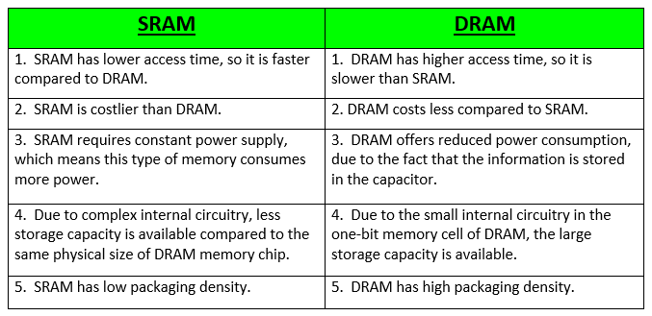

Your computer probably uses both static RAM and dynamic RAM at the same time, but it uses them for different reasons because of the cost difference between the two types. If you understand how dynamic RAM and static RAM chips work inside, it is easy to see why the cost difference is there, and you can also understand the names.
Dynamic RAM is the most common type of memory in use today. Inside a dynamic RAM chip, each memory cell holds one bit of information and is made up of two parts: a transistorand a capacitor. These are, of course, extremely small transistors and capacitors so that millions of them can fit on a single memory chip. The capacitor holds the bit of information -- a 0 or a 1 (see How Bits and Bytes Work for information on bits). The transistor acts as a switch that lets the control circuitry on the memory chip read the capacitor or change its state.
A capacitor is like a small bucket that is able to store electrons. To store a 1 in the memory cell, the bucket is filled with electrons. To store a 0, it is emptied. The problem with the capacitor's bucket is that it has a leak. In a matter of a few milliseconds a full bucket becomes empty. Therefore, for dynamic memory to work, either the CPU or the memory controller has to come along and recharge all of the capacitors holding a 1 before they discharge. To do this, the memory controller reads the memory and then writes it right back. This refresh operation happens automatically thousands of times per second.
This refresh operation is where dynamic RAM gets its name. Dynamic RAM has to be dynamically refreshed all of the time or it forgets what it is holding. The downside of all of this refreshing is that it takes time and slows down the memory.
Static RAM uses a completely different technology. In static RAM, a form of flip-flop holds each bit of memory (see How Boolean Gates Work for detail on flip-flops). A flip-flop for a memory cell takes 4 or 6 transistors along with some wiring, but never has to be refreshed. This makes static RAM significantly faster than dynamic RAM. However, because it has more parts, a static memory cell takes a lot more space on a chip than a dynamic memory cell. Therefore you get less memory per chip, and that makes static RAM a lot more expensive.

