The City School
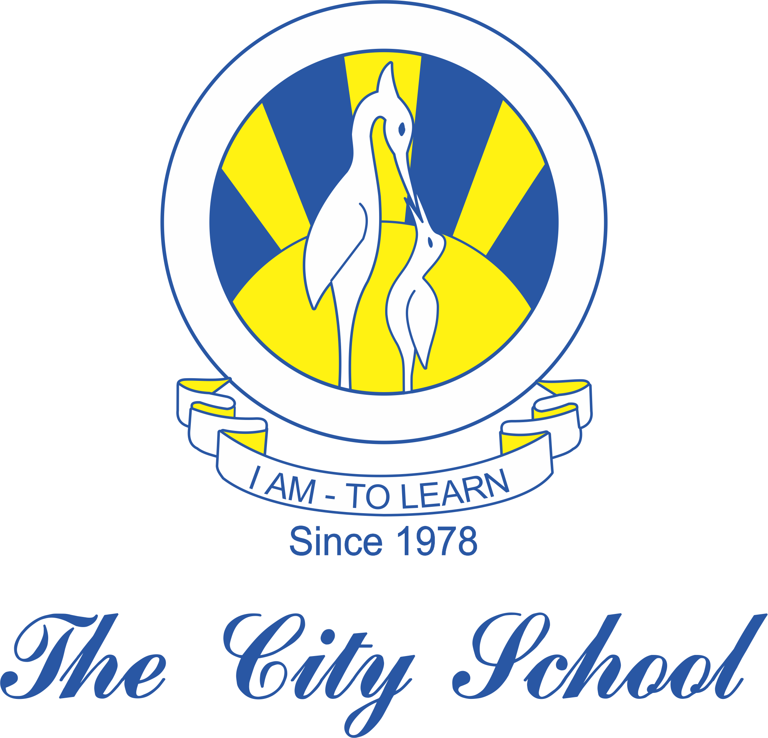
Syllabus for First Term
English 1123
Grade 9
Paper 1: writing
Directed writing:
Letters ( formal and informal)
Report writing
Creative writing:
Narrative essay
Descriptive essay
Argumentative essay
Paper 2: Reading
Reading for ideas
Reading for meanings

