The City School
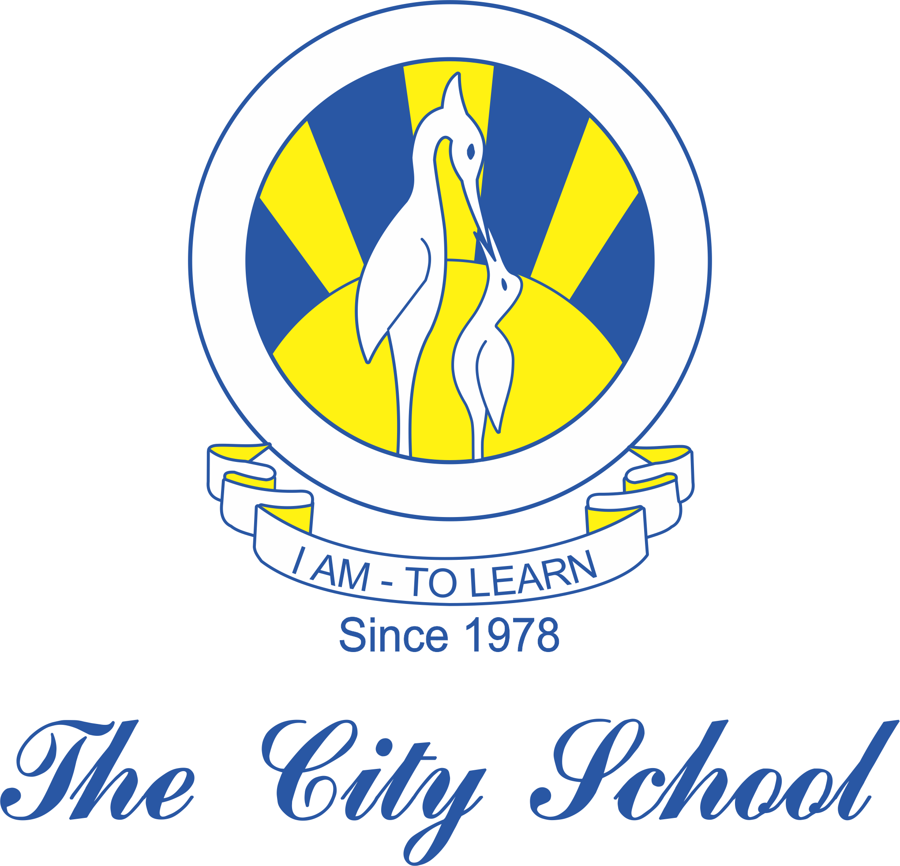
North Nazimabad Boys Campus
Geography 2018-2019
SYLLABUS FOR CLASS 9:
- The Land of Pakistan.
- The Natural Topography including drainage.
- Climate.
- Natural Resources- An issue of sustainability Water.
- Forests.

