The City School
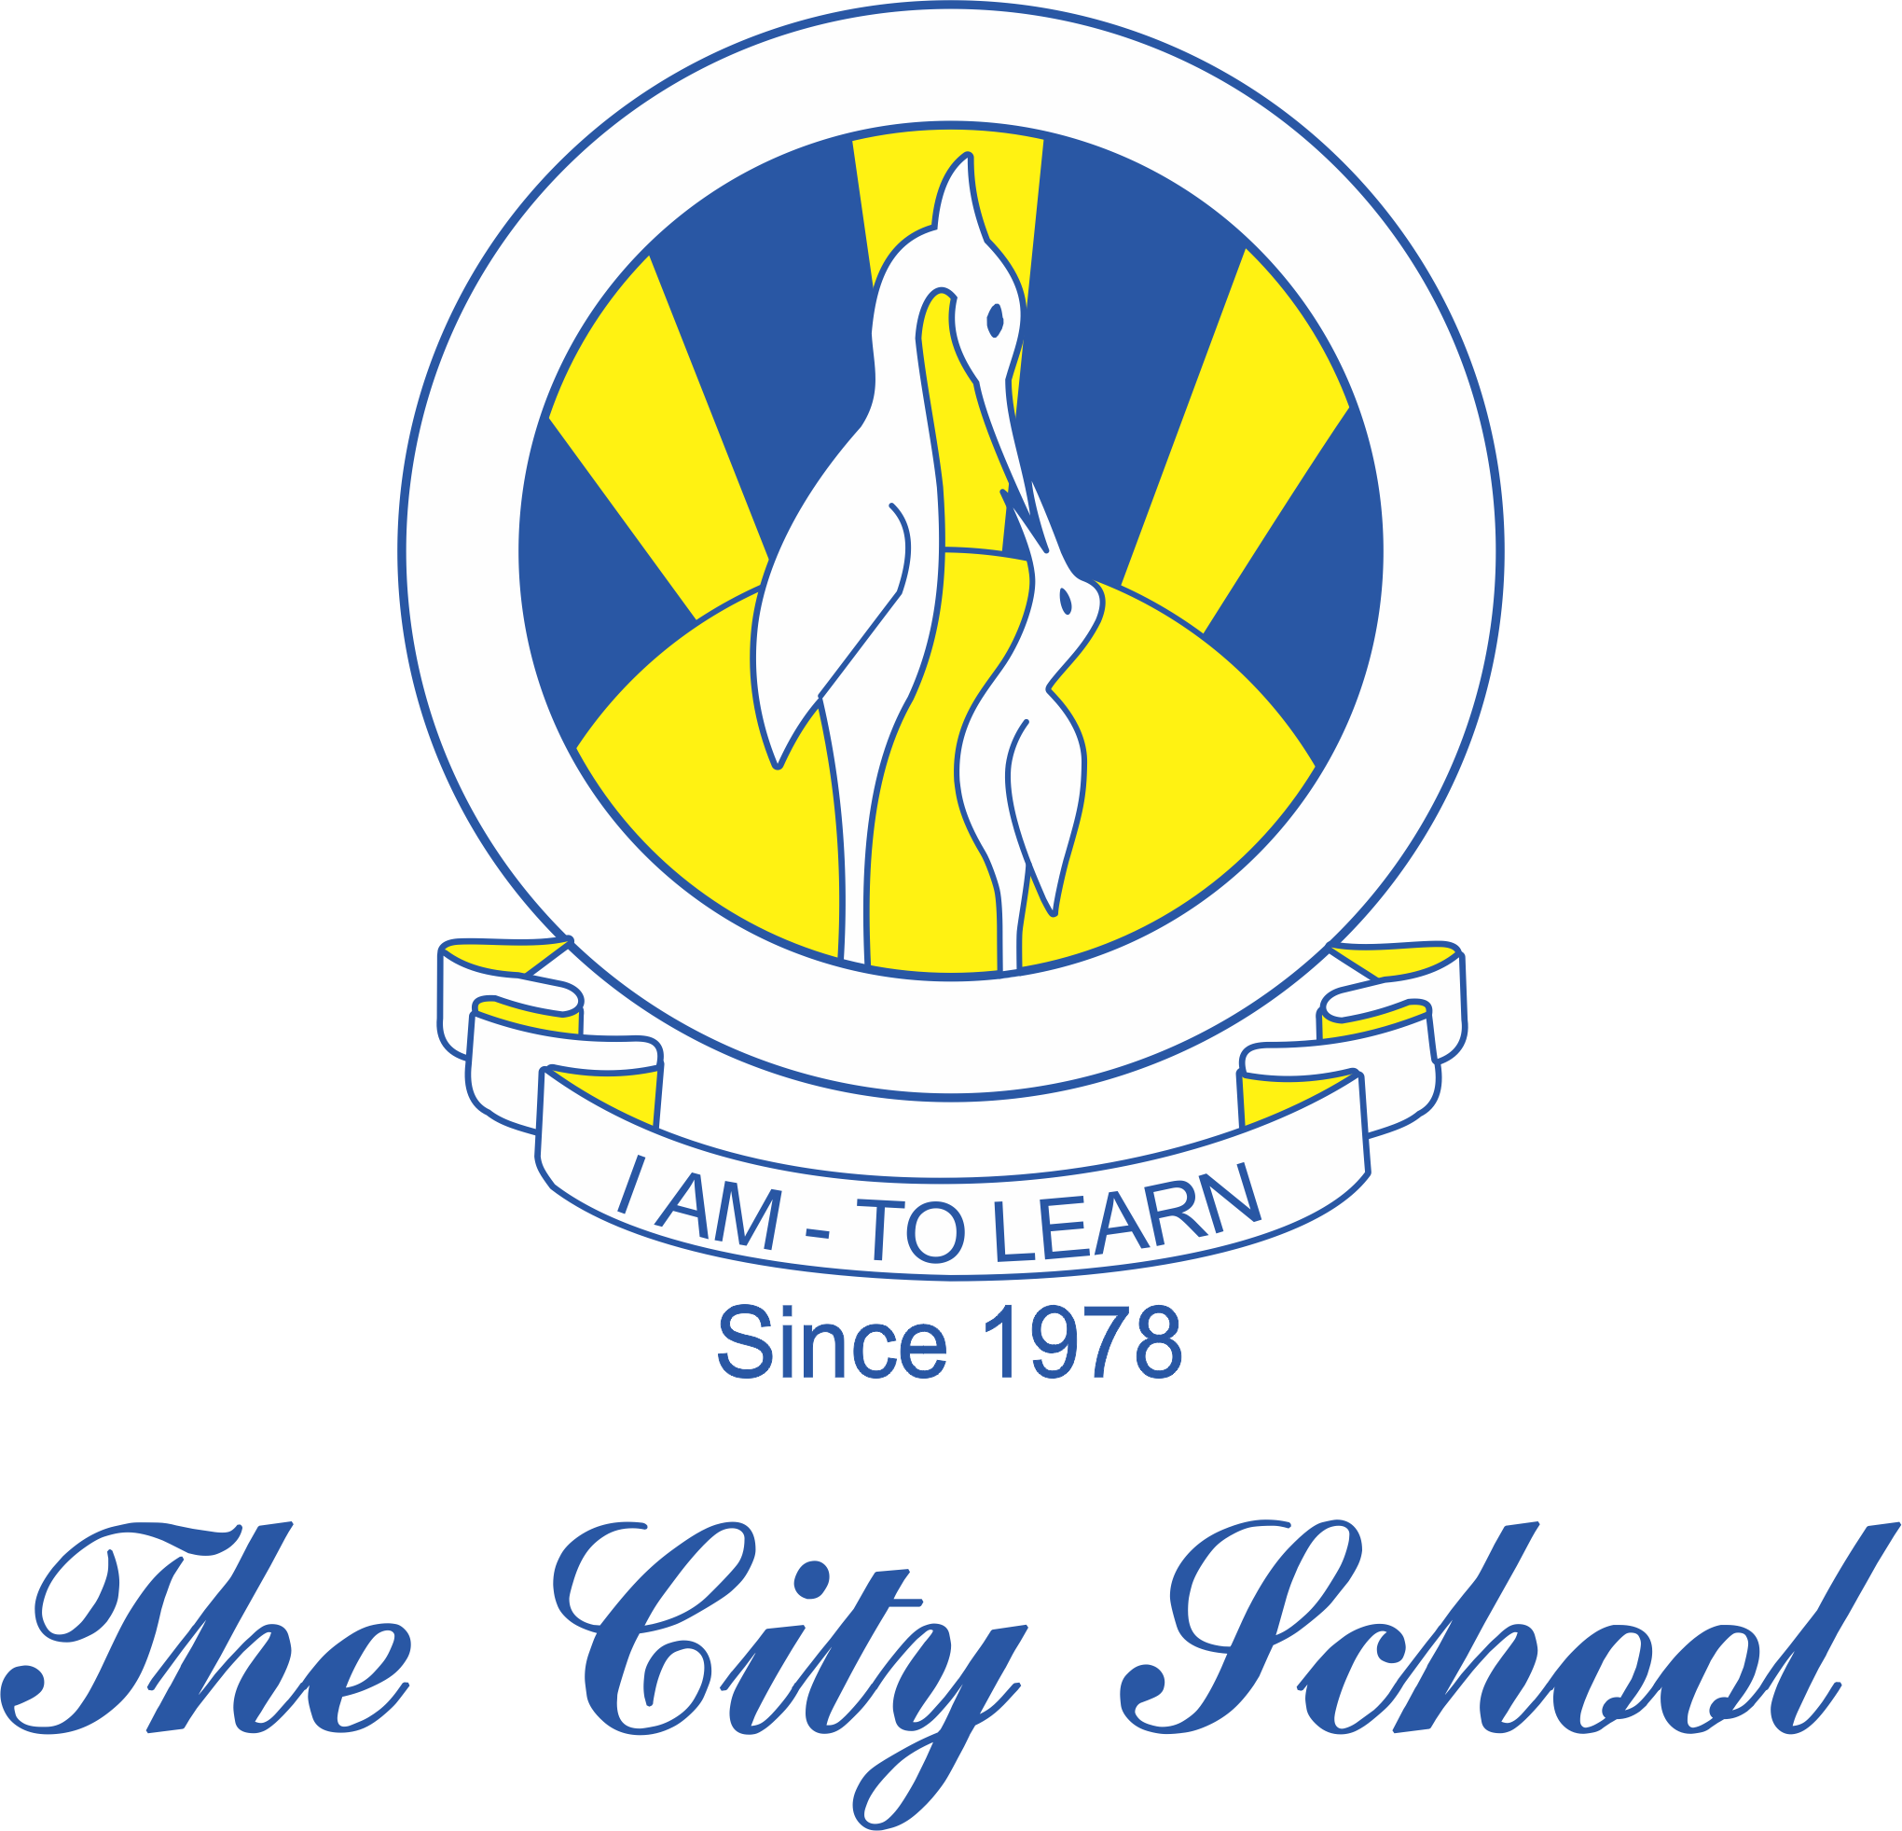
History Class 9
Syllabus 1st Term

Term I
Unit/Topic
Introduction to Pakistan Studies – Paper 1
Cultural and Historical Background to Pakistan Movement
Religious thinkers
Decline of Mughal Empire
War of Independence
Work of Sir Syed Ahmad Khan
Languages (Urdu & other regional languages)
Revision
The Emergence of Paksitan 1906 - 1947
Development of Pakistan Movement
Khilafat Movement
Pakistan Movement 1927 - 1939
Problems/Solutions facing the sub-continent 1940 - 1947
Contributions of Jinnah, Iqbal and Rahmat Ali
Revision

