The City School
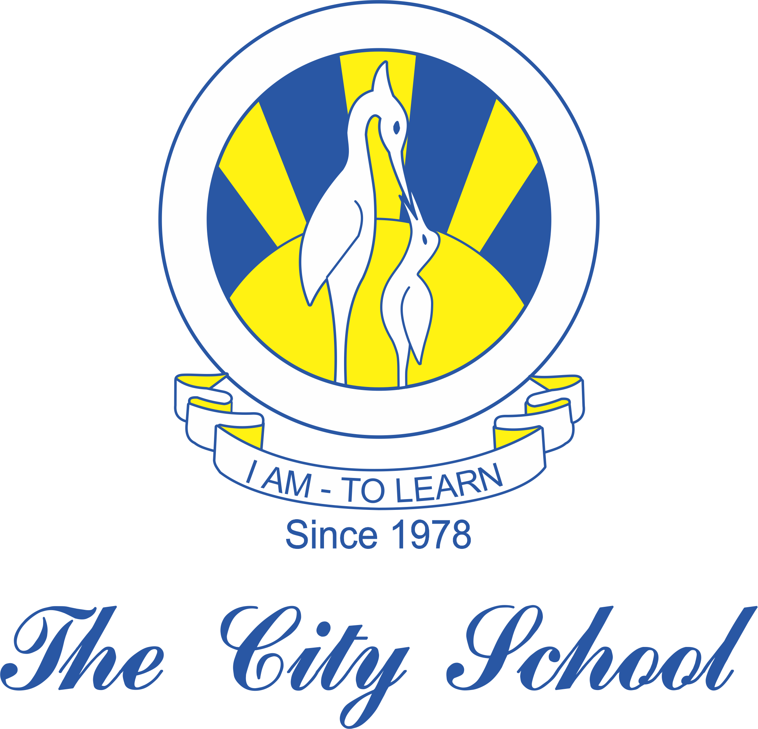
North Nazimabad Boys Campus
Syllabus for Grade 9
Physics
1st Term

1)Physical quantities,units and measurement
2) kinematics
3) Mass,weight and density
4)Dynamics

