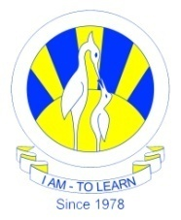
The City School
North Nazimabad Boys Campus

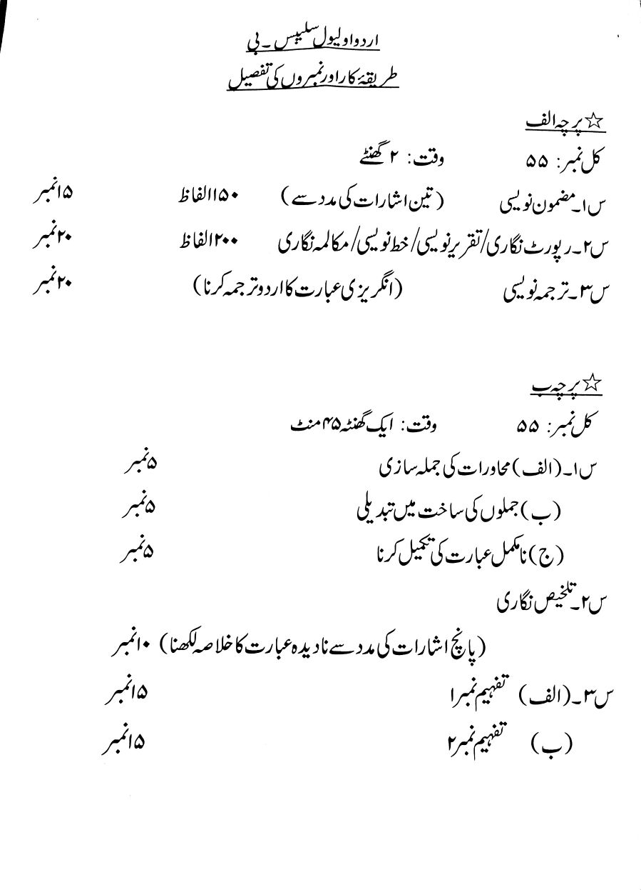
Class : 9
Subject : Urdu

