The City School
North Nazimabad Boys Campus
Pakistan Studies (History) 2059/01
Worksheet No.1 Term 2 (2018) Class: 9
Q1. This question is about India in the nineteenth century 1. Study the sources carefully and then answer the questions which follow.
Full accounts of the earlier scenes of the recent revolt in the Bengal army have now reached us. Several regiments have broken out into open mutiny, murdered their officers and entered into direct rebellion against the British government. At present revolt seems to be confined to the army of Bengal, the largest and most important of the three presidencies, and only about 8000 men have taken part. Everywhere else, according to reports received, all is quiet and the native army is true to its duty.
An account of the events of 1857, written in an English newspaper in June 1857.
Source B
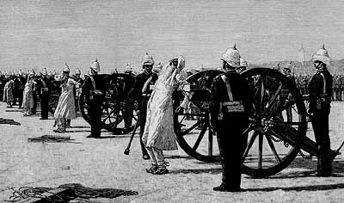

- According to Source A how widespread was the ‘revolt’? (3)
- What does the Source B tells is about British attitudes towards the uprising? (5).
- Why did the war break out in 1857? (7)
- How successful was Sir Syed Ahmad Khan in restoring the reputation of the Muslims in the eyes of the British in the years after the war? (10)

