BLOG WORKSHEET
CHEMISTRY CLASS 9

Teacher Name: Uzma Amer Class: 9 Chemistry Date: 23rd Oct’18

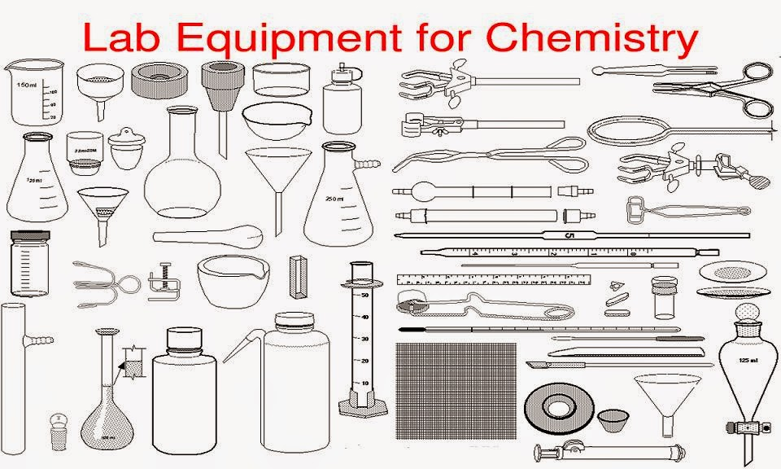
- Identify at least five equipments and write down their names:
- Describe the uses of those equipments:
Q.2 (a) Define the following terms:
- Kinetic Energy
- Relative molecular mass
- Electron negativity
- Ionizing Energy

(b)Draw the electronic structure of both a sodium ion and a chloride ion.[2]

Sodium ion Chloride ion

